Chapter Nine

Evgeny Steiner

In the Eye of the Beholder: Ugliness, Beauty and Exoticism in the Orientalist Quest for Otherness

In this chapter I will investigate the meaning of the often misinterpreted term “Orientalism” and offer a new understanding of it with the help of the methodology of contextual analysis and an interdisciplinary approach based on placing Oriental studies in the global perspective. Thus, the aetiology of the Western 19th century will acquire an additional facet: the encounter of the Occidental mind with Far Eastern art and other forms of cultural expression. The following text can be viewed as part of my on-going major project on European Orientalism and the cultural foundation of the search for non-Western forms of thought and representation (literary and artistic) that constituted the larger part of modernity in Europe (Russia included).

In recent decades, the word “Orientalism” has been linked to the theory of Edward Said, and through this association this established and respected term acquired negative connotations among many of those who rather uncritically embraced post-colonial theory. Since then, serious scholars in the field of Oriental studies have denounced Said’s teaching, and we do not need to discuss it any further. However, we can admit that in one respect Said was right (although he was not the first to make such an obvious point): studies of cultures other than the researcher’s own are almost inevitably marked by the presuppositions and even subconscious prejudices of the researcher’s own culture.
This chapter offers an understanding of 19th century Orientalism as a European form of the quest for cultural difference and for moulding the notion of “otherness”. In this respect, the current chapter follows the tenor of Urs App’s The Birth of Orientalism. Built on different, than his, material (fine and literary arts) and discussing a later period (the 19th century), the chapter shares App’s conviction that Orientalism was born not of the ill-will of the nineteenth-century Western colonialists, but of major changes in the religious and ideological mindset of the Age of Enlightenment. To this picture I add an aesthetic dimension. This dimension was most vividly revealed in the Japonaiserie, or Japonisme, of the last third of the 19th century. Indeed, if one were asked to name a country whose art and culture had the most significant influence on the formation of the new Western art at the end of the 19th and the beginning of the 20th century, the answer would be Japan! Not France, with its pioneers of the renovation of the artistic language of the Occidental world, from Impressionists to the succeeding radicals, the Fauvists-Cubists et al. Not Russia, with its classics of Abstractionism and coryphaei of Constructivism. It was in fact Japan because, without the adaptation of the basic formal principles of its art, the new Western art would have been different. In a sharp and laconic form, this understanding had already been expressed at the end of the 19th century by Lois Gonse, one of the first connoisseurs and propagandists of Japanese art: “A drop of their blood has mixed with our blood and no power on earth can eliminate it.” Japanese principles of composition, such as asymmetry, imbalance, local colours, linearity, flatness, seriality etc., became the markers of the new Western artistic modalities, although none of these occurred immediately. The first contacts between European sensibilities and Japanese tastes were quite disappointing, if not outright demonstrations of the clash of cultures.
I will begin with a little-known episode of a tragicomic encounter of a Russian naval officer, Vasilii M. Golovnin (1776-1831), with Japanese art. It occurred in 1812 during Golovnin’s twenty-five-month period of captivity in Japan imposed for accidentally entering this closed country.

“I must not omit one very laughable circumstance, the real cause of which we were unable to divine. Our meals were superintended by an old officer, sixty years of age. He behaved very civilly to us, and frequently consoled us with the assurance that we should be sent back to Russia. One day he brought to us three portraits of Japanese ladies, very richly dressed. We supposed that he meant merely to show them to us, and we were about to return them to him, when he desired us to keep them. We refused, but he insisted that we should accept them. We asked what use they could be to us; and he replied that we might amuse ourselves by looking at them when the time hung heavily on our hands. We then asked whether we were in a situation to be amused by the sight of such beauties. Indeed, the figures were so wretchedly designed that they were calculated only to excite aversion and ridicule.”

After the Japanese officer left, Golovnin and his cellmates gave the pictures to their Japanese interpreter and said jokingly that they would not mind getting “the fair originals to amuse us.”
This old translation is rather mild. Literally, Golovnin’s text could be translated as: “And, I should add, they have been depicted in such a repulsive manner, that they could not possibly produce any feelings, besides laughter and repugnance – at least in Europeans.” Here, a disclaimer is due: Captain Golovnin was Russian but he was not boorish – he received an excellent European education and served for about five years in the British Royal Navy under the command of Admiral Nelson. And I should emphasize that his less than favourable feelings were caused precisely by the pictures, but absolutely not by their denotations: elsewhere in his Memoirs, Golovnin wrote about the prettiness and attractive beauty of women from the houses of love. (Evidently, the Japanese authorities finally provided their inmates with “the fair originals.”) The attitude of Golovnin to Japanese aesthetics can be clearly seen from the following excerpt from his Memoirs. Being a man of his time, he believed that “in painting, in architecture, sculpture, engraving, music and, probably, in poetry they are far behind of all of Europeans.”
Now let us look at the pictures that were probably shown to the prisoners. Those were the years of the flourishing of the colour woodblock prints in the bijinga genre (“pictures of beautiful women”) of such famous artists as Utamaro, Eisen, Eizan and others.

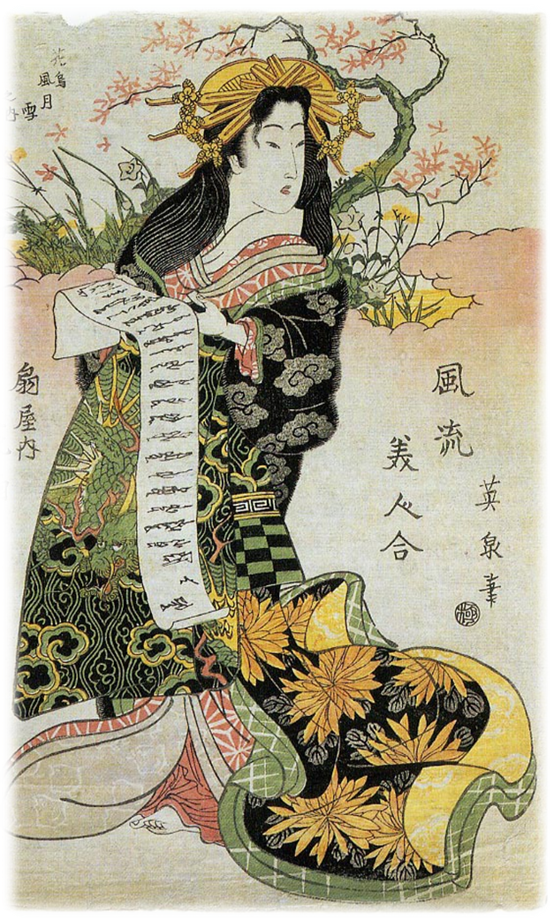
Fig. 9-1. Eisen.Hanaogi of Ogiya House. 1820s. Woodblock print.

There is no need to describe in greater detail the exquisite poetic images of geishas and the various types of courtesans immortalized by these masters. However, before we consider the problem of a major cultural misapprehension, we should mention the reason why these pictures were brought to the prisoners in the first place. The answer is simple: the print depictions of glamorous courtesans were widely used in Japan at that time as affordable and effective substitutes for real women. In other words, they often served for men’s solitary pleasure as masturbation aids. Additionally, erotically charged images (sometimes very sexually explicit – and called shunga (“spring pictures”) in this case) were traditionally used by warriors as spirit-lifting material before a battle. Secreted in the armour, they were considered lucky charms.
However, how these pictures were used in their authentic cultural context is not the point here. The point is that Europeans not only failed to find them attractive and suggestive but also, to the contrary, reacted with “laughter and repugnance.” This was the first but not the only instance of the early encounters of European taste with Japanese prints. In the 1830s, these pictures were for the first time publicly exhibited in the West, in The Hague’s Cabinet of Curiosities, but they failed to elicit any noticeable reaction. One of the pre-eminent British scholars of Japanese art, Jack Hillier, wrote:

These early arrivals appear to have made little or no impression on those who saw them: they represented an exotic and alien art no more likely to be understood than pre-Columbian sculpture would have been understood in the Regency-period England.

European society was not yet ready for the aesthetical perception of such a radically different visual language – and the foundations of the occidental artistic paradigm were quite solid and had no need of an exotic complement of this kind. To better understand this, we can recall the Chinoiserie style known as early as the 17th century and highly popular by the middle of the 18th. However, this popularity extended almost exclusively to Chinese (or pseudo-Chinese) subjects and motives (and not to the way of their representation), which added some exoticism to the Rococo language of representation.
The situation began to change about half a century after the Golovnin incident. Those very pictures caused an uproar in Europe – first in Paris and soon after in other European capitals – and inspired Japonisme as well as the aesthetic revolution of Impressionism and Art Nouveau. As Klaus Berger, author of one of the first serious analytical books on Japonisme, wrote, “Japonisme was a shift of Copernican proportions, marking the end of European illusionism and the beginning of the modern.”
What had changed during these years? – The answer, in short, is the mode of perception provoked by the search for otherness. With the evident impasse in classical European aesthetics, the notion of finding the Other and the Different came to the forefront of modern artistic and, to a certain degree, literary thought. Here it will be useful to recall the notion of Derrida’s différance. This presumes not only an acceptance of the different and dissimilar, but also an understanding that this is the internal difference, or the Different and/or the Other that exists within – when “Internal difference—the way in which an entity, an institution, or a text is at odds with itself.” This immanent presence of the Other was always present to a greater or lesser extent in European culture. Japonisme may not have been unique, typologically speaking, as a cultural trend but it was the most radical implementation of the revolutionizing textual strategy in 19th century art. The enthusiasm for Japanese aesthetics appeared to be the final and most serious wave of the 19th century European Orientalism – among the waves into which Europe would occasionally dive when it needed to feed the Other within itself and give the language to this internal Other.

At the turn of the 19th century, the wave of Orientalism amongst Romantics was inspired by the Napoleonic wars (the Egyptian campaign, primarily), the rise and fall of the Empire and the exhaustion of Classicism alongside the last beams of Enlightenment. The situation was aggravated by the deep dissatisfaction with the European intellectual and political atmosphere after the Congress of Vienna. Additionally, the Romanticist mindset was marked by one peculiar feature, which for the most part (but not exclusively) affected French Romantics. They belonged to the generation that was brought up by the women while their fathers fought in all corners of Europe and the eastern Mediterranean. They grew up feminized, overly sensitive and dreaming about tough, virile heroes. One way of finding such heroes was by discovering (or rather reinventing) their own past in the idealized Middle Ages, with their knights, chivalrous devotion to ladies, and folklore (as opposed to civic Graeco-Roman or religious Biblical) subjects. The other way of inventing a hero was to attempt to find him in the present, but in foreign lands.
Such a hero was found, rather puzzlingly, in a mythologized image of the “proud Arab” – prancing on his hot stud (and presumably a stud himself) with his naked yatagan in picturesque flowing robes, or indolently smoking hashish surrounded by his odalisques (see paintings by Delacroix, Chassériau, Delaroche, Ary Scheffer et al.). The image of a brutal man, the master of submissive women, was especially alluring in the context of the nascent feminism and emergence of women such as Georges Sand, who dared to conduct herself in a way that was traditionally reserved for men.

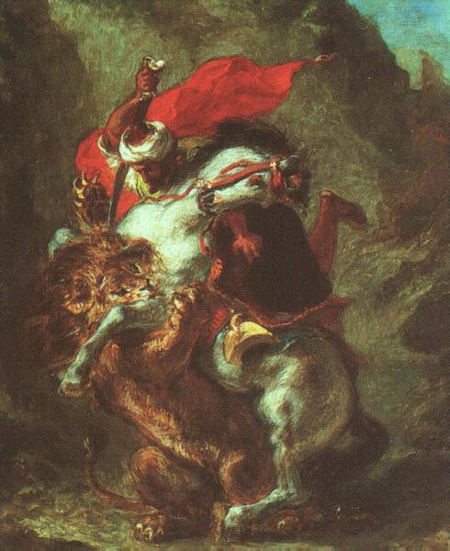

Fig. 9-2. Eugene Delacroix. Arab Horseman Attacked by Lion. 1849-50. Art Institute of Chicago, Chicago.

Sex and (pseudo)Oriental exoticism quite naturally met in such a popular phenomenon as Oriental rooms in French (and not only French) brothels. These were excellent places in which to fulfil the Oriental fantasies of Europeans in these Romantic and Post-Romantic times. In visiting such places, Europeans could make a quick and ludic version of a journey to the East and impersonate a tough and virile man surrounded by complaisant concubines. Every self-respecting bordello in France included one of several Oriental rooms: Arabian, Turkish, Chinese or, later, Japanese, decorated in vaguely ethnic style and furnished with appropriately (un)clad girls. Historical and/or cultural authenticity was not required; the goal was to represent an abstract idea of the Orient, or perhaps not even an Orient as such, but simply a non-Occident. Very often in the art of epigones of Romanticism in the middle and the latter half of the 19th century, odalisques and harem houris were depicted as non-Oriental-looking women. The models sported blonde or red hair and fair skin, and were often paramours of the artists’ clients or of the artists themselves. This could serve as a decoration for the theme of female slave and was a sublimation of a desire for the possession of a woman. (See numerous compositions by Gerome, Fabio Fabbi, George Rochegrosse et al.) Less and less feasible in European society, this imaginary Orient was constructed as a paradise of sexualized delights, a world where sensual dreams could be fulfilled. Thus, Orientalism was, to a large extent, a way of solving specifically Western problems and complexes by means of positioning a woman as a sexual object (and masking it in exotic decorations).
Stylistically speaking, the Orientalism of the Romantics was a major departure from the Classicist norms, but it did not generate a different aesthetic modality. The formal elements of the visual (or literary) language of the new Near or Middle Eastern subjects were not incorporated into the European artistic mainstream, as there was not much to borrow.
When, in the middle of the century, it became rather evident that this romantic image had not provided European art and culture with a real, deep novelty and freshness but had instead slipped into a trite and middlebrow (at best) salon, this sort of Orientalism left behind, in Parisian advanced artistic circles, perhaps nothing more than hashish. This had been brought to Europe after the Egyptian Campaign and had become, around the middle of the century, the means of acquiring a new spiritual experience in the Club of the Hashishins (Club des Hachichins), founded in 1844 by a doctor Jacques-Joseph Moreau. Its members (Delacroix and Baudelaire inter alia) would gather at the digs of Ferdinand Boissard de Boisdenier at Hotel Lauzun, dressed in Arabian (or, rather, pseudo-Maghrebin) costumes, and proceed to eat a dawamesk, a pistachio-colored hashish paste (from little Japanese plates, if we are to believe Theophile Gautier), augmenting the experience by smoking the substance. In the puffs and spirals of smoke they saw outlandish, twisted and convoluted women.

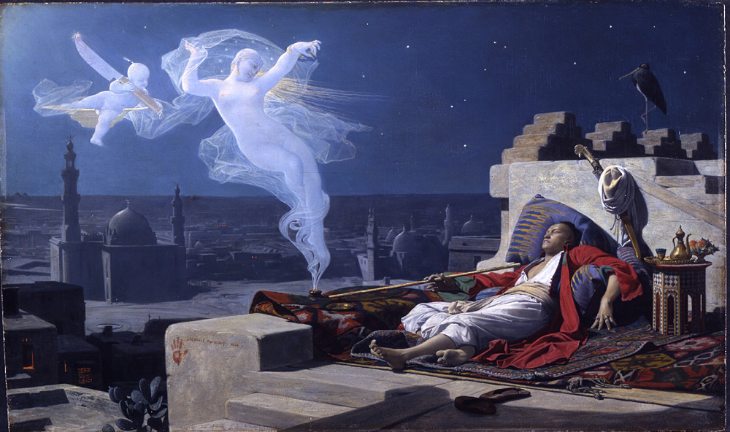

Jean Lecomte du Nouy. The Dream of a Eunuch. 1874. Cleveland museum of Art.

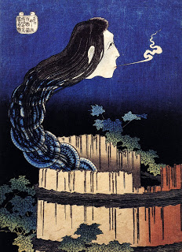

Hokusai. The Ghost from the Well. Woodblock print.

At the time of the death of the last Romantic artist (Delacroix: 1863) and the publication of Baudelaire’s essay The Painter of Modern Life (1863), the first Japanese images of twisted, swan-necked and ethereally slim female figures started to appear in Paris: the first pictures of the beauties from the Japanese brothels had arrived on the Parisian art scene. Soon afterwards, the first beauties themselves were shown in Europe: the Japanese government dispatched three geishas to the Paris Exhibition of 1867, causing a furor (or at least creating quite a stir). It is not by chance that, for the first collectors of Japanese prints, the favourite subjects were the images of courtesans and of Kabuki actors (where male actors playing female roles – onnagata – were practically undistinguishable from women).

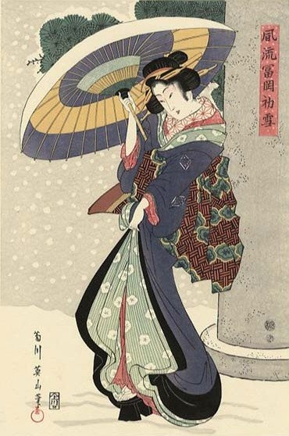

Eizan. First Snow. Woodblock print.

Because of the specific cultural and historical peculiarities, the great majority of images of women in Japanese woodblocks were of geishas and courtesans. Europeans of the 19th century knew very little about that fact. A story involving Van Gogh is very telling in this respect. It is well known that he was extremely fond of Japanese art; he collected Japanese prints and occasionally copied them. Thus, he once copied a popular composition of Hiroshige with a plum tree. As he had some space left on the left- and right-hand sides of his canvas (his canvas was squarer than Hiroshige’s elongated sheet), he added some inscriptions in Japanese characters that he had copied from a certain leaflet that he had picked up, most probably in Siegfried Bing’s shop. The characters are written rather clumsily but correctly enough to read the name and the address of the Daikokuya brothel in Edo’s Yoshiwara licensed quarter. But this and other similar quarters were not simply places for satisfying physiological needs. More than sex as such, the refined atmosphere of eroticized aesthetic pastimes was greatly desired. And here, the Japanese experience was, perhaps, most artistically and poetically developed, although it was by no means unique. Take, for example, Parisian cafes of the belle époque. In the 1880s, certain establishments, known as brasseries à femmes, were very popular. The drinks were served by exotically dressed (or, rather, undressed) waitresses, whose main source of income was not waiting on tables but beds. To appreciate the visual idea of this, it is sufficient to recall Edoard Manet’s A Bar at the Folies Bergére (1882, Courtauld Gallery) – the famous café (later a music hall) Folies Bergère (Reckless Shepherdess). His languorous and doleful girl at the bar counter looks like a French reincarnation of Harunobu’s elegiac – and procurable – girls from tea houses.
The Parisian artistic or literary crowd of the late Romantic and early Prosaic epoch also looked for difference in the lifestyle epitomized by the figure of the flaneur or boulevardier. This type of carefree man-about-town was an important part of the aesthetic revolution of Manet and Impressionists, who strove to become artists “of modern life” and wanted to belong to the official system that was not particularly willing to accept them. This is one of the reasons why these artists felt an innate affinity with Japanese pictures of “the floating world” (ukiyo-e). Artists and authors of the floating world reflected the way of life called asobi. This Japanese word is difficult to translate for it means not only “play” or “merrymaking” as bilingual dictionaries say, but also careless strolls, aimless hanging around, revelry, flirtation and amorous adventures. Japanese prints were highly charged with this atmosphere, and this sensibility, alongside their formal ways of expression, emanated from them.
Beginning with Impressionists, especially the advent of Art Nouveau, the artists appropriated Japanese postures, gracefulness, and flatness – the very categories that were desired by the Romantics but remained mere puffs of smoke, unattainable for representation. Soon after the 1867 Exhibition, a “secret society” called Jinglar was established (or “Société Japonaise du Jinglar”) with Felix Bracquemond, the discoverer of Hokusai’s Manga, Philippe Burty (it was he who coined the word Japonisme), Zacharie Astruc (a leading figure in early criticism on Japanese art), Alphonse Hirsch, Jules Jacquemart, Carolus-Duran, Fantin-Latur, Marc-Louis-Emmanuel Solon and other Japonistes as founding members. They donned kimonos and sipped sake alongside Jinglar. These dinners were sometimes attended by Théophile Gautier and other former members of the Hashishins Club. The fad for Japanese art and all things Japanese was so omnipresent that it became the source of satire. Alexandre Dumas-fils’ play Francillon (1887) contains the following dialogue:

Henri: Moi, mademoiselle, je vous demanderai la recette de la salade que nous
avons mangés ce soir ici. Il paraît qu’elle est de votre composition.
Annette: La salade japonaise.
Henri: Elle est japonaise ?
Annette: Je l’appelle ainsi.
Henri: Pourquoi ?
Annette: Pour qu’elle ait un nom; tout est japonais maintenant.
(la scène 2 de l’acte I)

In fact, the advent of Japonisme heralded a tectonic shift in formal characteristics of European visual art. It also enhanced the repertoire of subjects – inspired by the popular themes of ukiyo-e prints, images of women taking a bath or making their toilette had become popular since the advent of the Impressionists (Degas et al.). From this perspective, let us examine Manet’s famous Nana (1877), as it contains the whole gamut of various japonesque traits, both evident and clandestine.

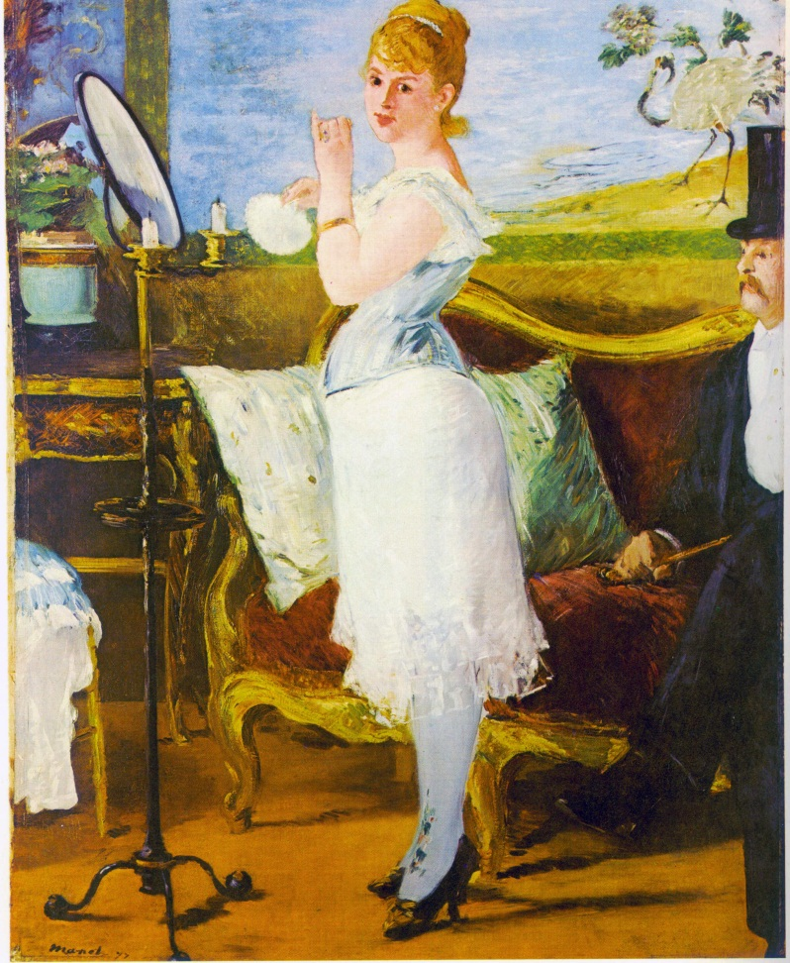

Eduard Manet. Nana. 1877

The evident one - a Japanese (or pseudo-Japanese) screen in the background - is, like most evident things, not particularly interesting. Much more important are the implicit and, perhaps, subconscious features. On the subject level, it is the depiction of a woman demimondaine, a kept courtesan. The characters in this walk of life were, as I have already mentioned, the most popular subjects of Japanese woodblocks. She is shown half-dressed in front of an oval mirror – like dozens of Japanese geishas at their toilette. Another motive that finds its excellent counterpart in the pictures of the floating world is the figure of a gentleman in a top hat sitting at the right and watching, rather indiscreetly, her intimate process of beautification and dressing. The voyeur figure is omnipresent in erotic Japanese prints, adding an aura of presence at a private spectacle. Even more important for our survey of japonesque stylistic is the fact that the figure of a man is cut in half by the edge of the canvas. Such a mode was extremely popular in Japanese art, where it was normal to omit half of a figure in a narrow elongated composition. Finally, we should pay attention to a rather unusual S-shape silhouette of Nana – her head is turned slightly back, her high bosom protrudes forward, her back is almost unsavourily bent, her belly juts out, and her voluminous derriere oscillates excessively in the opposite direction. As curvaceous as a woman of pleasure could be, this attempt to portray her almost as a sinusoid was rather unusual for traditional European tastes; on the other hand, it made her a close cousin of Japanese beauties, who are, in their ukiyo-e images, often composed of perfect S-shapes. (see, for instance, images by Eizan or Eisen) These S-like forms were picked up by the younger Manet’s comrades-in-art: in the same year of 1877, Claude Monet painted a composition La Japonaise, a figure of a lady (his wife Camille) clad in a kimono and in a characteristic Japanese twist. Later, this highly unnatural treatment of the body would be rendered grotesque by Alphonse Mucha – see his poster for the Alfred de Musset drama Lorenzaccio with an exquisitely (but still rather laughably) elongated Sarah Bernhardt (1896).
Other formal and stylistic features acquired by the late nineteenth-century art via Japonisme are quite evident and require but a quick enumeration. These include the rejection of the classical well-balanced composition, with a centre and equal left and right flanks, in favour of the use of asymmetry. A typical example of asymmetry based, most probably, on subconscious inspiration, is Monet’s Haystack (Museum of Fine Arts, Boston, 1891), which, compositionally speaking, closely resembles Hokusai’s print Red Fuji from the series 36 Views of Mt. Fuji (1830-33). These two works are also good examples of another feature that, although known before, came to the fore at that time as a direct japonesque artistic quality: seriality. Thinking in series, collections and groupings was an innate characteristic of the Japanese aesthetic mind, where a full portrait of any event, scenery or psychological condition was never single and monumental but, rather, consisted of a few (sometimes numerous) instantaneous sketches and glimpses. The Impressionists, craving to represent (or, better to say, realize) not an object but a fleeting and concrete impression of one that was changing in time, light and atmospheric conditions, naturally adapted the seriality device. Examples include Monet’s series Haystacks (twenty-five canvases, 1890-91), Rouen Cathedral (about thirty, finished in 1894), Houses of Parliament (1900-05) and others.
Close to asymmetry, one finds another artistic feature: fragmentation. Rather than the full object, only part of it is depicted, giving the viewer an opportunity to engage in a more active mode of perception by imagining the rest. Most frequently in such compositions, about half of a figure is cut off by the edge of the canvas, and sometimes an important object can be partially obscured by something placed in front of it. Examples include the previously discussed Nana or Monet’s early canvas Boulevard des Capucines (State Pushkin Museum of Fine Arts, Moscow, 1873). Two figures of Parisian dandies at the far right watch the crowd on the boulevard in front of them. Here, yet another formal device compatible with the work of Japanese artists can be seen: the placing at the fringe of a foreground a relatively small object that appears much bigger than the distant broad vistas. Amongst Japanese artists, Hiroshige was perhaps the principal proponent of this type of composition (see his series One Hundred Famous Views of Edo, 1857-59, such as the print Mannen Bridge in Fukagawa with a turtle occupying the same place in the composition as the two men in Monet’s work). Another version of fragmentation, or of employing a principle of pars pro toto, can be seen in the representation of some rather unexpected detail in lieu of the whole. The same Hiroshige drafted a Ryogoku Bridge in Edo showing nothing but its characteristic abutment. The same compositional scheme was later used by Modernist artists, from James Whistler in his Old Battersea Bridge (1872-75) to Anna Ostroumova-Lebedeva’s print The Chained Bridge (1903).
One of the most important stylistic features of the new modernist aesthetic (especially in Art Nouveau) was the rejection of the classical, post-Renaissance system of halftones, or valeurs. The flatness with local colours came in and, to emphasize it, black contour lines began to appear. This linearity was one of the basic devices of Japanese art – both prints and paintings. European artists found that it resonated with their new world vision and adopted it. These Japanese features are clearly discernible across the whole variety of genres, formats and techniques – from posters to paintings to book illustrations. One of the most interesting artists in this respect was Ivan Bilibin. Some of his works, being illustrations of Russian fairy tales, look like close stylistic relatives of the prints of Hokusai.

Conclusion

Within a few decades during the nineteenth century, the perception of Japanese art in Europe changed from ridicule and repulsion to a mass fad and a serious study for absorption and creative appropriation. Less dramatic and deep but still spectacular infatuation with Near and Middle Eastern subjects and motifs traversed the path from revolutionary (in paint and spirit) Romanticism to erotically charged yet, at best, middlebrow salon. What was the common denominator of this appellation and the fascination with various notions of the East?
Perhaps the most fruitful and heuristically interesting way of looking at this problem would be contextualize it in two steps: the first would be to acknowledge the internal depletion of the old classical European intellectual and aesthetic tradition; the second would be the search for repletion of Occidental oikumene in the East. This allows me to suggest that European Orientalism in arts and letters was a multifaceted expression of globalization. In the guise of Orientalism, this pre-postmodern globalization appeared as the beginning of the systemic crisis of the Occidental civilization that grew into the feeling of the limits of its own self-sufficiency (on the cultural, artistic, religious and philosophical, as well as economic, levels). The West needed its Other. For the role of this Other, different Orients were auditioned, with each generation going farther and more radically into geographic or cultural space in their quest for Otherness. In a sense, this European intellectual Morgenlandfahrt (Journey to the East) can be likened to the American pioneers’ fervour in pushing the frontier to the West. The following stages can be distinguished in this Drang nach Osten (I use this German expression, known from 1849, metaphorically).
The early stage of Orientalism was Romantic and Academic: it was largely exotic Oriental (almost exclusively Near Eastern and Arab) motives and subjects depicted with the help of Western pictorial idioms. In other words, the traditional European formal language had not been basically changed in terms of composition, the treatment of space, colour and verisimilitude. In other words, the novelty was sought in the realm of non-European subjects rather than in the non-European ways of representation.
The next wave – the Japonisme of Impressionism and Art Nouveau – was a much more advanced transcultural phenomenon. It can justly be called a tectonic shift – when not only motives or subjects, but also formal means of expression were borrowed, mutatis mutandis, from the East. This source of inspiration came from a dramatically different culture with its own well developed visual artistic traditions. The way of seeing and the modes of representation exploited by Japanese masters of the floating world struck a sympathetic chord in European painters of modern life.
The new century and new generation of innovative artists and authors turned into more aesthetically radical things. In the guise of Fauvism and Cubism came the urge for primitivism of the Avant-garde and Surrealism. The sophisticated forms of the nineteenth-century Japonisme were no longer sufficiently different or ugly for the common perception. Picasso and other Cubists found the source of enrichment of their visual paradigm in African art. (cf. Picasso’s Les Demoiselles s’Avignon (Museum of Modern Art, 1907) with artefacts of his own collection of African art) Later, in the 1920s, Surrealists expanded this source of non-European inspiration to Meso-American and Oceanic tribal art. The appropriation of basic features of African and tribal art brought the Avant-garde discourse to the ultima Thule of aesthetic Orientalism based on cultural and geographic differences.
Still later, after the Second World War, the farther marginalization of the Western artistic discourse was inspired and fed by the language of expression of various liminal groups inside Western normative society. Particularly popular sources of aesthetic novelty were “naïve art” (Art Brut) or the art of mentally challenged persons (Outsider art).
All this taken together and brought into aesthetical perspective and common denomination can be seen as successive and increasingly accelerating stages in the broadening (shattering and at the same time in-feeding) of the European cultural paradigm. Thus, Orientalism can be viewed as the Ur-phenomenon of globalization, or the process of making the West less Western. On the other hand, this process paved the way to globalization of the Western worldview and cultural practices, already heterogenic and well adapted for further cross-fertilization.
The clarification of the cultural and historical processes delineated above will not only cleanse the term “Orientalism” of the politically motivated rhetoric of some radicals, who repeat the outdated Saidian clichés, but will also lead the way to a better understanding of the current globalization.

About the author

Evgeny Steiner has two doctoral degrees: in Japanese culture and Russian Avant-garde. He taught Japanese and Russian art and culture and conducted research in universities in Moscow, Jerusalem, Tokyo, Yokohama, New York, Manchester and London. He is the recipient of numerous awards and fellowships including those from The Pew Trust, National Endowment for the Humanities, Leverhulme Trust, The Wingate Scholars, Japan Foundation etc. Currently Evgeny is a professorial research associate of the Japan Research Centre at SOAS, University of London, and professor at the National Research University ‘Higher School of Economics’ (Moscow). He published about ten books and numerous articles.

App, Urs. The Birth of Orientalism. Philadelphia: University of Pennsylvania Press, 2010.
Gonse, Lois. Le Japon artistique, 1888, #1.
Golovnin, Vasilii. Memoirs of a captivity in Japan: during the years 1811, 1812 and 1813. London: Henry Colburn and Co, 1824, vol. 1, p. 224.
Ibid., p. 225.
[Golovnin V.M. ] Vasilii Mikhalovich Golovnin's Notes About the Captivity in Japan in 1811, 1812 and 1813. St. Petersburg, 1851, Part. 1, pp. 131-142.
Ibid., part 3, p. 18.
See well-documented research on this subject: Screech, Timon. Sex and the Floating World: Erotic Images in Japan 1700-1820. London: Reaktion Books, 1999 (2nd edition 2009).
See Yamamoto Yukari. “Traditional Uses of Shunga” In Shunga: Sex and Pleasure in Japanese Art. Ed. by Timothy Clark et al. London: The British Museum, 2013, p. 298.
Hillier, Jack. The Japanese Print: A New Approach. Rutland: Charles E Tuttle Co, 1960, p. 2.
Berger, Klaus. Japonismus in der westlichen malerei: 1860-1920. Munich: Prestel Verlag, 1980 (Transl. Berger, Klaus. Japonisme in Western Painting from Whistler to Matisse. Cambridge: Cambridge UP, 1992, pp. 1-2.)
McKenna, Andrew. "Derrida, Death and Forgiveness"// First Things, March of 1997, # 71. p.34.
See Greene, Gina. “Reflections of Desire: Masculinity and Fantasy in the Fin-de-Siècle Luxury Brothel”. Nineteenth-Century Art Worldwide. Vol. 7, issue 1, Spring 2008. (electronic edition: http://www.19thc-artworldwide.org/component/content/article/39-spring08/spring08article/108-reflections-of-desire-masculinity-and-fantasy-in-the-fin-de-siecle-luxury-brothel
It is interesting to mention that Dr. Moreau was a specialist in what the French call “l’alienation mentale”, or insanity. In a way, it was exactly what was the new artistic quest for: an alien experience.
Dawamesk often contained cannabis as a hallucinogenic substance mixed with cinnamon, nutmeg, cardamon and sugar.
See Gautier, Theophile. Le Club des Haschischins. First published in Revue des Deux Mondes, 1846, t. 13. See also Euvres de Théophile Gautier. Paris: Alphonse.Lemerre, 1897, p. 471..
I am tempted to mention that after many years since I first came up with this idea (it was in the guest lecture “Ukiyo-e: Japanese Prints and Western Myths” in New York Studio School, New York, April 4, 2001, the videotape is available in the School’s archives), I saw a painting of Jean Lecomte du Nouy with an ethereal twisted figure of a houri going out of a pipe of an intoxicated smoker.
Strictly speaking, a geisha is not a prostitute per se: she is a female entertainer for hire for personal pleasure or private parties. (There were also mail entertainers – the word geisha is translated as “a person of arts” without gender indication.) But quite often, a geisha’s entertainment function could overlap with that of a paid sexual worker. And, vice versa, many refined Japanese courtesans from the top-scale houses of love were exquisite entertainers, not only in bed (or rather futon).
See more in: Barrows, Susanna, “Nineteenth-Century Cafés: Arenas of Everyday Life”, in Pleasures of Paris: Daumier to Picasso, catalog of the exhibition. Boston: Museum of Fine Arts, 1991. p. 24.
See a poetic description of a flaneur in Baudelaire’s Le Peintre de la Vie Moderne (1863) and the scholarly analysis of this phenomenon in Clark, Timothy. The Painting of Modern Life: Paris in the Art of Manet and his Followers. NY: Knopf, 1985.
Dumas-fils, Alexandre. Francillon. In Théatre complet avec préface inédites. Paris: Calmann Lévy, 1898. T. 7, p. 270. Translation: Henri: And I, mademoiselle, would like to ask the recipe of that salad that we had tonight. It seems to be of your own composition. Anette: Japanese salad. Henri: It is Japanese? Annette: This is how I call it. Henri: But why? Annette: Because this is its name. Everything is Japanese now.
Hesse, Hermann. Die Morgenlandfahrt. Berlin: S. Fischer Verlag, 1932.
Stepan, Peter. Picasso’s Collection of African & Oceanic Art. NY-London: Prestel Publishing, 2007.
See Bellier, Alfred, ed. Collection Andre Breton et Paul Eluard: Sculptures d'Afrique d'Amerique d'Oceanie. Paris: Drouot, 1931.
Other facets of the global dichotomy of Orientalism/Occidentalism not covered here has been discussed in a conference “Orientalism/Occidentalism: Languages of Culture vs. Languages of Description” that I organized in 2010. See the resulting volume: Evgeny Steiner, ed. Orientalism/Occidentalism: Languages of Culture vs. Languages of Description. Moscow: Institute for Cultural Research, 2012.

