Revolutions and democracy.

Can democracies stop violence?

Ustyuzhanin V.
Korotaev A.
Annotation: In recent years, the question of what form a revolutionary uprising will take — armed or unarmed — has been raised more and more often. This is because, as shown by numerous studies, revolutionary nonviolence can explain why the uprising failed or succeed to lead to democracy. In the recent decades the likelihood of revolution being nonviolent appears to have significantly increased, but it is still not clear why this tendency is observed. Moreover, there are only a few quantitative cross-national studies on this topic, in which the authors tried to explain the apparent pattern. However, none of them considered political factors separately. This paper tests the hypothesis that a country's level of democracy can inhibit the spread of revolutionary violence. By applying logistic regression to the NAVCO database, we analyze 400 episodes and conclude that, in general, the more democratic the political system, the more likely the revolution take a nonviolent form. Nevertheless, the various revolutionary events could be of a rather different nature, and it is further shown that the level of democracy matters only for sociopolitical revolutions, while for separatist revolutions it does not play a significant role. In other words, democracy can stop effectively violence only in revolutionary episodes caused by sociopolitical (but not ethno-nationalist) grievances.
Key-words: democracy, violent revolutions, nonviolent revolutions, discrimination, sociopolitical revolutions, separatism.

Inroduction
In their recent book The Narrow Corridor, renowned political economists Daron Acemoglu and James Robinson pose the following question: How do states come to democracy? What path do they have to take (Acemoglu & Robinson, 2019)? The most cardinal method is revolution, but the experience of the 20th century shows that most revolutions attempting to impose democracy failed and ended in the establishment of an equally or even more authoritarian regime. However, the situation since the beginning of the 21st century has changed: now the collapse of the old regime quite often leads to the establishment of democracies compared to the previous century. But what does this transition have to do with it? Why do some revolutions lead to democracies and others to dictatorships?
Research in recent years has shown that revolutionary uprisings have significantly different results depending on what form they take – armed/violent or unarmed/nonviolent (Butcher & Svensson, 2016; Pischedda, 2020; Rasler et al., 2022; Stephan & Chenoweth, 2008). More specifically, it was found that nonviolent revolutions are significantly more likely to lead to stable democracy than violent ones (Ackerman & Karatnycky, 2005; Butcher & Svensson, 2016; Celestino & Gleditsch, 2013; Chenoweth & Stephan, 2011; Johnstad, 2010; Kim & Kroeger, 2019; Rasler et al., 2022).
In other words, to answer the previous question about dictatorships and democracies we have to understand why revolutions can be violent or nonviolent. Several quantitative cross-national studies have appeared on the factors of why revolutionary actions take violent (armed) or nonviolent (unarmed) forms (Butcher & Svensson, 2016; Dahlum, 2019; Ustyuzhanin et al., 2022). However, the results of these authors are not congruent. Thus, Dahlum (2019) find that the level of democracy is significantly and negatively associated with nonviolence during revolutionary campaign. Meanwhile, Butcher & Svensson (2016) demonstrate a significant curvilinear relationship between the level of democracy and the risks of nonviolent revolutions, but find no significant relationship between democracy and the risks of violent revolutions. Thus, the conclusions from these papers remain ambiguous, and existing researches do not provide a convincing answer the question whether transition from autocracy to democracy is increasing or decreasing the likelihood of revolutions taking violent or nonviolent form.

Democracy and revolutions
In general, the idea that democratic and inclusive institutions reduce possible violence is not new. Relatively long ago, Karl Popper said that he calls “the type of government that can be eliminated without violence "democracy", and the other "tyranny"” (Popper, 1949, p. 90). Note, that the elimination of certain type of government without violence is actually a nonviolent revolution. Conclusions of many contemporary researchers are quite similar: the likelihood of peaceful protest, which is the central component of the nonviolent revolutionary repertoire (Lawson, 2019), in democracies is higher than in autocratic regimes (Caren et al., 2017; Chenoweth & Ulfelder, 2017; Colon-Rios & Hutchinson, 2012; Dahl et al., 2020; R. Inglehart & Welzel, 2005; Pischedda, 2020; Walter, 2006). Nevertheless, majority of these authors tend to consider rather consolidated democracies, but do not take partial democracies and anocracies into account, whereas most contemporary states are neither consolidated democracies nor full autocracies that is they are mostly anocracies of various types. It is important to note that consolidated democracies facilitate mass mobilization, but inhibit any revolutionary overthrow of the government, even nonviolent revolutionary change of power. For instance, it is possible that large maximalist protests lead to radical change of the ruling elite, but through elections rather than through a revolution as was the case in Greece in 2015. In fact, there was a revolutionary situation without a revolution, when the mechanisms of Greek consolidated democracy were able to prevent a real revolutionary uprising (Ardagna & Caselli, 2014; Evripidou & Drury, 2013; Karyotis & Rüdig, 2018; Vogiatzoglou, 2017) by allowing the radical opposition (SYRIZA) to legally come to power. Nevertheless, such conclusion is not valid for partial democracies. For instance, revolutions such as the 2013-2014 Ukrainian Revolution (Euromaidan) or the 2018 Armenian Velvet Revolution demonstrate that revolutions may well overthrow democratically elected presidents. However, taking into account the reasoning of the reviewed authors, we claim that even partial democracies and autocracies are less prone to a violent type of revolution than full autocracies that is preliminary illustrated just by the Armenian and Ukrainian cases where revolutions occurred, but were nonviolent. In general, there is a good reason to believe that even a small movement from full to partial autocracy should lead to noticeable reduction of the risks that revolution would take a violent form.
There are several reasons for this relationship. Foremost, it is easier for dissatisfied citizens to present their demands to the government or to mobilize in a democracy where the institutional structure is designed to include the masses in governance (Nam, 2007). This is reflected in the fact of the relatively high level of freedoms in non-authoritarian regimes, that, therefore, are unlikely to, firstly, repress demonstrators due to their limited opportunity for repressions (Pischedda, 2020; Walter, 2006) and, secondly, to perceive a disagreement as a threat (Davenport, 1999). Thus, Henderson (1991) empirically shows that democracy is the most important predictor that repression is extremely unlikely, which stems from their “responsiveness”. Indeed, democratic process is based on compromise, taking into account the interests of a large number of people and group of interests that can use unpopular methods of their opponent such as repression to win elections and remove an incumbent leader or elite. On the other hand, a higher level of political repression on the part of authorities provokes violence on the part of protestors that entails an increased likelihood of violent/armed insurrection due to the impossibility of using nonviolent/unarmed tactics (Regan & Norton, 2005), while in regimes with the relatively high level of freedoms the likelihood of non-violent tactics increasing (Massoud et al., 2019). Hence, the more authoritarian the regime, the more intensively it uses violence to suppress protest. The harsher this repression and use of violence, the more likely it is that revolutionary action will take a violent form.
Moreover, the most democratic regimes can be called, following Meyer and Tarrow (1998), “social movement societies”, because they have institutionalized the right to protest, which is perceived as an inalienable and legitimate form of political participation. Colon-Rios and Hutchinson (2012, p. 593), relying on Alexis de Tocqueville, claim that “there is no need in a true democracy to invent the end of revolution as it becomes a continuing and integral part of democratic arrangements themselves”. Such “right of revolution” that becomes a constitutional norm leads to peaceful demonstrations, because of the unnecessity of violence as such for the solution.
Developing the “legal argument” further, we can say that the mass of the people has a kind of “constitutional majority” or “constitutional power”, and thus the right to regime transformation (Colon-Rios & Hutchinson, 2012). In other words, in the case of mass grievance and the taking to the streets, the legislature will essentially be obliged to make significant concessions or to withdraw at the next election, giving way to the opposition. The most remarkable thing is that in such a case there can be no violence – there is no need for it. “The right to revolution” is recognized by all parties to the conflict and is notoriously successful by recruiting a critical mass of protesters (Chenoweth & Stephan, 2011; DeNardo, 1985), so that no institution is immune to change (Unger, 1987). Thus, the aim of the demonstrators will be to use “population-intensive tactic”, i.e., spread information and to attract new supporters, rather than to attempt the violent overthrow of the regime. Such a democratic mechanism, of course, does not exist in authoritarian states, where the majority of the population has no real representation, which changes the tactics of the protesters. In other words, from the perspective of the so-called “theory of constitutional force”, people can “overthrow the regime” through peaceful protests, but not through violence. In authoritarian regimes, the logic is more likely to be the opposite. It is important to note that even if such a “right to revolution” is not fully institutionalized in partial democracies and anocracies, it will be implied formally, which gives protesters hope for a successful outcome of nonviolent tactics.
Summarizing, democracy itself does not lead to a decrease in discontent, but opens the way for its expression through peaceful mass mobilization in the polls and on the streets (Dahl et al., 2020), not with a gun in the hand. Moreover, any democratization of a regime leads to reduction of probability that during revolutionary uprising violence will be used because protestors hope that by “population-intensive tactic” they can reach the success, and government will not use repression extremely intensively.
Thus, the main reason why more democratic regimes are less prone to violence during revolutions is the possibilities to mass mobilization. In anocracies and democracies there are institutional channels which allow people to go on the streets and hope for success due to sensitivity of their governments, while in autocracies opportunities to the chances of being heard by the authorities are much lower than even in anocracies. In other words, the overall utility of nonviolent methods in full autocracies tends to zero, because success is unlikely (Pischedda, 2020; Walter, 2006), and the costs are very high due to the retaliatory actions of the state – repressions. Hence, violent methods and an attempt to overthrow authoritarian regime with arms are often perceived by dissenters as the only option (Carey, 2006).

Discrimination and revolutions
However, it would be wrong to assume that the level of freedoms is determined only by the electoral procedures. The inclusiveness of institutions is also determined by the degree of involvement of all citizens, not just majority, in governance. In other words, even if a country has formalized democratic institutions, but a part of the population is deprived of the right to govern or does perceive itself as excluded from governing, it is fair to assume that the probability of violence will be quite high. This can be attributed to the fact that their perception and choice of tactics of disagreement is similar to the one as if they were in an authoritarian state.
Confirmation of such connection can be found in most work on the theory of civil wars, which can be considered an extreme form of violent revolutionary mobilization. Numerous studies argued that the probability of an armed uprising is positively related to ethnic discrimination (Besançon, 2005; Buhaug & Lujala, 2005; Gurr, 2000; Regan & Norton, 2005; Wimmer et al., 2009), i.e., an exclusion of a part of population from governance and, therefore, from resources and their distribution. Thus, discriminated population are more likely to choose armed tactics, because: first, they usually have lack of the capacity for successful non-violent rebellion due to dominant ethnic groups own most of the resources and use the state to limit minority access to various assets that are necessary for successful peaceful protest (such as education or high-paying jobs) (Besançon, 2005). Moreover, discriminated groups have limited opportunities to attract supporters (Pischedda, 2020) and, as a result, to gain the critical mass that is necessary for success of nonviolent tactics (Beissinger, 2022; Chenoweth & Stephan, 2011). This point about the strong positive link between the size of the dissenting group and the choice of nonviolent tactic was partially confirmed in the work by Dahl et al. (2020).
On the other hand, the costs of collective violent action for discriminated groups are lower, because: (1) there are stable social ties and trust among members of the oppressed group; (2) the opportunity costs to them are small because the welfare of the discriminated group is usually low, and its members generally have little accumulated investment in human capital. Consequently, their possible benefit from the success of a violent campaign outweighs any risk of losing their small capital (Sambanis, 2001), which is not the case for the rest of the population, which has much to lose.
Democracy, discrimination and separatist movements
Against this background it is important to note that various revolutionary events could be of a rather different nature. Many authors point out that it is necessary to distinguish different types of conflicts and revolutions in particular, because an overgeneralization can mislead regarding their analysis. Thus, Omer Yair and Dan Miodownik show by the example of civil wars, which can be regarded as an extreme form of violent revolutions (Beissinger, 2022), that empirical inconsistencies with the theory are largely due to “collapsing all civil wars into one group instead of theorizing about and studying factors that are more likely to affect one type of war but not another” (Yair & Miodownik, 2016, p. 26). They emphasize that it is important to distinguish between ethnic revolutions and non-ethnic, sociopolitical revolutions. These types have very different causes: ethnic conflicts, for example, are much less explained by economic factors (Sambanis, 2001) or age structure (Cincotta & Weber, 2020; Yair & Miodownik, 2016) than others.
Thus, in countries where the level of democratic institutions is low and the degree of discrimination is high, the revolution is more likely to take an armed form. However, it is important to bear in mind that the correlation between the democracy of the regime and the absence of discrimination is not quite high (r = -0.25, see fig. A1, for details about data, see materials and methods section), but even truncated democratic procedures presuppose a priori the inclusion of most citizens in the political system. Therefore, the goals of discriminated groups are not more about regime change, but rather about self-determination (Cederman et al., 2013; Wimmer et al., 2009). In other words, when analyzing revolutionary events it is necessary to consider separatist/national-liberation revolutionary actions separately in order, on the one hand, not to downplay the impact of democratic institutions and, on the other hand, not to exaggerate the impact of discrimination on the protesters' choice of tactics – armed or unarmed. So, our hypothesizes can be formulated as follows:
H1: The more democratic the institutions, the less likely social and political (non-separatist) revolutions are to take an armed form.
H2: The greater the proportion of the population that is discriminated against, the greater the likelihood for separatist/national-liberation revolutionary actions to take an armed form.
H3: The level of democracy has small effect on the choice of tactic during separatist/national-liberation revolutionary actions.

Materials and methods

Methodology and empirical strategy
As the main method of analysis, we use binary logistic regression to determine the effects of independent variables and their interaction with each other. Moreover, we introduce region fixed effects due to the fact our data have a panel view, where the unit of observation is a country-year. In other words, each country measured repeatedly over time, but not every state has experienced a revolution, so we include a regional effect rather than a country effect, which, as Dahlum (2019) has shown, should better control models for uncounted variables. Also, as will be shown below, many of the control variables in our models are in one way or another part of one big process – modernization, which gives rise to the problem of multicollinearity. If we include all the modernization variables in one model, we cannot get real estimates of the coefficients because of “bloated” standard errors, so we use the principal component analysis to create a “modernization” variable.

Dependent variable
We rely on the information provided by the Nonviolent and Violent Campaigns and Outcomes (NAVCO) 1.3 (Chenoweth and Christopher 2020), which identifies 622 revolutionary events/“campaigns” from 1900 to 2019. It describes numerous instances of violent and nonviolent revolutionary protests for the purpose of regime change, national self-determination, or important social change (e.g., the end of apartheid). Based on the hypotheses of our study, we will divide revolutions into separatist/national-liberation revolutions, which combines the goals of “self-determination” and “secession” in the classification of the used database, and sociopolitical (non-separatist) revolutions with goals of regime change and/or important social change (but without the goal of national self-determination).
As a dependent variable, we take another value from the same database – whether the revolutionary movement was armed/violent or not. This is a binary variable, where “1” designates unarmed revolutionary actions and “0” designates armed revolutionary episodes. At the same time, Chenoweth and Shay (2020, p. 6) specifically note that “campaigns are primarily nonviolent when the vast majority of participants are unarmed, and when they use mostly nonviolent practices to confound, impede, and challenge the regime and its supporters. Campaigns are primarily violent when most participants use force, especially armed force, to target regimes and their supporters”.

Independent variable and controls
As the first independent variable, we take the index of electoral democracy from the V-Dem database, that “is formed by taking the average of, on the one hand, the weighted average of the indices measuring freedom of association, clean elections, freedom of expression, elected officials, and suffrage and, on the other, the five-way multiplicative interaction between those indices” (Coppedge et al., 2021, p. 43), and it scales from 0 to 1. V-Dem provides us with the most comprehensive information on the level of democracy from 1900 to the present for most of the world.
The second independent variable is the proportion of the discriminated population from the Ethnic Power Relations (EPR) database, which gives the following description of this variable: “group members are subjected to active, intentional, and targeted discrimination by the state, with the intent of excluding them from political power. Such active discrimination can be either formal or informal, but always refers to the domain of public politics (excluding discrimination in the socio-economic sphere)” (Vogt & Rüegger, 2021, p. 6).
In addition, we take these variables with a lag of one year because they may be subject to strong changes during the revolution/“campaign” itself.
We include several control variables that were found as strong factors associated with the revolutionary violence/nonviolence. First of all, one may mention higher GDP per capita and urbanization (Inglehart and Welzel 2005; Grinin and Korotayev 2016; Korotayev, Bilyuga, and Shishkina 2018; Beissinger 2022). For instance, Inglehart and Welzel (2005) claim that the explosive growth of wealth (using proxy through GDP per capita) is also generating a growing need for self-expression including political participation; and the expansion of markets and trade has always been a crucial factor in reducing violence due to the demand for nonviolent communication (Inglehart, Puranen, and Welzel 2015). So, higher well-being is associated with higher nonviolent protest activity, because economic development and the natural expansion of the middle class have led to a greater public interest in expanding political and civil liberties (Chenoweth and Ulfelder 2017; Massoud, Doces, and Magee 2019). Researchers find robust evidence that GDP per capita is positively associated with nonviolent protests and negatively with violent destabilization (Dahl et al., 2020; Gleditsch & Rivera, 2017; Korotayev, Bilyuga, et al., 2018; Korotayev et al., 2017; Korotayev, Vaskin, et al., 2018; Wimmer et al., 2009) and civil wars (Hegre & Sambanis, 2006). This relationship is accounted for by the point that high well-being dramatically increases opportunity costs for protesters: people have bigger accumulated investments, and the risk of losing everything outweighs all possible benefits. So, if the pre-conflict state equilibrium provides people with a small level of utility, the marginal utility of each increase in benefits from regime change will be higher, which pushes people to risk giving up their usual life (Besançon, 2005; Sambanis, 2001). Moreover, the elites of rich countries can actively use various redistributive policies or co-opt the opposition elite to mitigate general discontent, which is possible due to soft resource constraints (Wimmer et al., 2009). Thus, we have to introduce the GDP per capita as the proxy for well-being. We use GDP per capita, PPP (constant 2017 international $) from the World Bank (The World Bank, 2022). However, this variable is available only from 1990 that reduces our time period significantly. So we expanded this variable by combining information from the World Bank with the database of Mark Beissinger (Beissinger 2022, see appendix 3). In doing so, we converted everything to 2017 international dollars and we expanded the time period to 1900-2019. Worth noting, we take natural logarithm of GDP per capita in order to normalize it.
The level of urbanization is also relevant. For example, mass mobilization is more likely in the most urbanized and complex societies with dispersed social power (Gleditsch & Rivera, 2017), where a high concentration of the population and human capital helps disaffected groups find a larger audience (Butcher and Svensson 2016; Chenoweth and Ulfelder 2017; Dahl et al. 2020). It is also important to note that in urbanized areas there is a high likelihood of peaceful protests, whereas, at the periphery radical groups choose another method of disagreement – violent actions (Buhaug & Lujala, 2005; Dahl et al., 2020; Korotayev et al., 2020, 2021; Sawyer et al., 2022). For our urbanization variable, we take the share of the population that lives in urban areas. These data are from the United Nations Population Division (UNPD) World Urbanization Prospects database (United Nations Population Division, 2021). Nevertheless, the time period of this original variable is also strongly restricted, and we merged it with Mark Beissinger’s data (Beissinger 2022, see appendix 3).
A recent study by Cincotta and Weber (2020) demonstrates that violent revolutions are significantly more likely in countries with a very high proportion of the youth in the total adult population of this society – the so-called ‘youth bulge’. This finding is very congruent with other research on demographic structural factors of revolutions. This relationship is associated with the fact that young people are easier to engage in violent revolutionary actions because, as “most young people have fewer responsibilities for families and careers, they are relatively easily mobilized for social or political conflicts. Youth have played a prominent role in political violence throughout recorded history, and the existence of a ‘youth bulge’ (an unusually high proportion of youths 15 to 29 relative to the total adult population) has historically been associated with times of political crisis” (Goldstone, 2002, pp. 11–12; Weber, 2019). Thus, the higher the proportion of young people in the population, the higher the likelihood of violent destabilization and the lower stability of the regime (Cincotta & Doces, 2012; Cincotta & Weber, 2020; Farzanegan & Witthuhn, 2017; Korotayev et al., 2022). We operationalize “youth bulge” through the median age of the population as Cincotta and Weber did. This variable is provided by the United Nations Population Division (UNPD) World Population Prospects database (UNDP, 2022).
Moreover, we introduce another strong factor – education that has a pacifying effect, because it increases the level of human capital, reduces the relative costs of organizing protests leading to an increase in the likelihood of peaceful revolutionary protests (Brancati 2014; Korotayev, Sawyer, and Romanov 2021), and makes violence unacceptable on the personal level, instilling in people a tendency to tolerance (Jenkins & Wallace, 1996). In general, it is confirmed by empirical studies: researchers find that the mean years of schooling is positively and significantly associated with the level of peaceful protests (Brancati, 2014; Butcher & Svensson, 2016; Korotaev et al., 2020; Korotayev, Bilyuga, et al., 2018; Korotayev et al., 2021; Kostelka & Rovny, 2019; Machado et al., 2011; Sawyer & Korotayev, 2022). But at the same time, it is negatively associated with the likelihood of a civil war, which appears as an extreme form of violent revolutionary conflict (Barakat & Urdal, 2009; Collier, 2004), or violent riots (Sawyer & Korotayev, 2022). Moreover, in the paper by Ustyuzanin et. al. (2022) education is demonstrated as the key predictor of why the revolution takes violent or nonviolent form. Thus, mean years of schooling strongly reduce the risks that revolutionary action will take an armed form.
It has also been found that the size of the population itself is a powerful predictor of both revolutionary protests in general (Chenoweth and Ulfelder 2017; Besançon 2005; Butcher and Svensson 2016; Dahl et al. 2020) and protests in particular (Korotaev et al. 2020; Hegre and Sambanis 2006; Korotayev, Sawyer, and Romanov 2021), while anti-government demonstrations are a major component of the revolutionary repertoire of unarmed revolutionary demonstrations (Lawson, 2019). This variable is presented in thousands by the Cross-National Time-Series (CNTS) Data Archive (Banks, Arthur S., Wilson, Kenneth A., 2021), and we introduce its natural logarithm in order to normalize it and to understand how the difference in population affects not in thousands, but in orders of magnitude.

Principal component analysis and modernization
As one can see from figure A2 (see appendix), there is strong multicollinearity between the variables from the “modernization” group (log per capita GDP, urbanization, median age, mean years of schooling), and not really high with democracy. All correlations between them are significant and mostly greater than 0.6. For example, GDP and urbanization are significantly correlated with Pearson’s r as high as 0.8, while GDP and median age are significantly correlated with r of 0.78. In other words, there is an extremely close relationship between variables, which does not allow us to include all the factors considered in one model, because in this case the standard errors will be extremely high, which will not allow to estimate the coefficients and understand the direction of the relationship (Farrar & Glauber, 1967; Mansfield & Helms, 1982).
One of the most proven methods of dealing with multicollinearity that does not involve throwing variables out of the analysis is principal component analysis (PCA) (Abdi & Williams, 2010; Bro & Smilde, 2014). In our case it is particularly well suited, because the modernization factors are all connected in a common direction, and therefore can be interpreted and evaluated in a single principal component.
Thus, from the principal component analysis (where log per capita GDP, urbanization, median age and mean years of schooling are scaled), first of all, we can see that the first component explains on average more than 80% of the variance (see fig. A3), which allows us to insert only this variable, quite reasonably assuming that it absorbs everything that we in this paper consider as “modernization”, and call it as “modernization index”. In addition, as we assumed, all the modernization variables have the same pairing (fig. A4), and, interestingly, the same contribution (fig. A5), which allows us to interpret it with models.

Results
In this section, we first present the results of logistic regression with different controls and fixed effects across all revolutionary events to examine how the levels of democracy and discrimination relate to the revolutionary violence and nonviolence. Afterwards, there are models with a limited sampling of revolutionary events: first, only sociopolitical episodes, and then only separatist ones. Moreover, each group of models is followed by: (1) predicted probabilities plots of nonviolence during revolutionary campaigns, where the joint effects of democracy and discrimination are shown; and (2) average marginal effects analysis. Overall, we find robust evidence that democracy is one of the strongest pacifying factors – but only for sociopolitical revolutionary events, because during separatist campaigns it has no significant effect on the revolutionary nonviolence.

All revolutionary events
Table 1 shows results from logistic models where the outcome is whether NAVCO’s revolutionary campaign was nonviolent. The main explanatory variables are the level of electoral democracy (t-1) and share of discriminated population (t-1).
As might be expected, based on our theoretical research, democracy is indeed positively and significantly associated with the nonviolent type of any revolutionary campaigns in the vast majority of models while discrimination is negatively associated with revolutionary nonviolence but the significance of these correlations is well below any acceptable thresholds.
Thus, in M1, which presents a pairwise regression, it is seen that the level of electoral democracy (t-1) significantly (at the level p <0.01) affects the protesters' choice of nonviolent tactic. After introduction of the share of discriminated population (t-1) and population in M2 and M3, democracy is still significantly (at the same level) related to revolutionary nonviolence while discrimination is negatively, but insignificantly associated with dependent variable. Moreover, its effect is too small in comparison with democracy. For instance, in the M3, the odds of a revolutionary event taking on an unarmed form are reduced by a bit more than twice (i.e., we calculate odds ratio from the model) if the entire population is discriminated, relative to no discrimination at all. At the same time, the odds of revolutionary nonviolence are increased by full democracy by almost 14 times in comparison with full autocracy.
In the further models, the variables from the “modernization” group are added in turn to the already ruminated democracy and discrimination. As one can see from M4, after the introduction of modernization PC democracy lose its significance (in M4 it is still marginally significant at the p = 0.1392 level). At the same time, it is difficult to explain this by multicollinearity between the modernization index (PC1 factors score) and V-dem index of electoral democracy. Thus, using VIF analysis, the coefficient for democracy is just 2.18, while many authors consider the critical level to be 10 or 20 (see, e.g., Craney and Surles 2002). Thus, we can conclude that such a multidimensional phenomenon as modernization is a really strong factor and more significant than democracy. Nevertheless, in subsequent models we introduce modernization variables in a different way and see that democracy regains its effect. All modernization variables have a significant and unidirectional positive effect on revolutionary nonviolence. The greater GDP per capita, urbanization, median age or mean years of schooling, the greater the likelihood of unarmed tactics during the campaign.

Table 1. Nonviolent campaign/ revolution on democracy and discrimination (for all revolutionary events).
 | Dependent variable:
 | Nonviolent (=1) vs. violent (=0) form of revolutionary event
 | M1 | M2 | M3 | M4 | M5 | M6 | M7 | M8
Democracy(t-1) | 3.304*** | 2.652*** | 2.621*** | 1.192 | 1.912*** | 1.665** | 1.837*** | 0.747
 | (0.614) | (0.652) | (0.658) | (0.761) | (0.695) | (0.713) | (0.701) | (0.773)
Discrimination (t-1) |  | -0.743 | -0.760 | -0.752 | -0.809 | -0.569 | -0.980 | -0.481
 |  | (0.729) | (0.732) | (0.799) | (0.752) | (0.744) | (0.776) | (0.794)
Population (ln) |  |  | 0.027 | -0.111 | 0.023 | 0.007 | 0.011 | -0.065
 |  |  | (0.081) | (0.099) | (0.083) | (0.085) | (0.087) | (0.099)
Modernization index (PC1 factors score) |  |  |  | 0.606***
 |  |  |  | (0.119)
Urbanization |  |  |  |  | 0.025***
 |  |  |  |  | (0.007)
Median age |  |  |  |  |  | 0.124***
 |  |  |  |  |  | (0.030)
GDP per capita (ln) |  |  |  |  |  |  | 0.765***
 |  |  |  |  |  |  | (0.153)
Mean years of schooling |  |  |  |  |  |  |  | 0.342***
 |  |  |  |  |  |  |  | (0.060)
Constant | -1.036*** | -0.756*** | -1.005 | 1.682* | -1.772** | -3.010*** | -6.761*** | -0.746
 | (0.222) | (0.257) | (0.787) | (0.992) | (0.831) | (0.970) | (1.421) | (0.962)
Region Fixed-Effects | Yes | Yes | Yes | Yes | Yes | Yes | Yes | Yes
Observations | 409 | 387 | 387 | 341 | 386 | 376 | 386 | 343
Log Likelihood | -251.434 | -235.178 | -235.121 | -187.838 | -227.178 | -217.348 | -220.569 | -184.291
Akaike Inf. Crit. | 514.868 | 484.355 | 486.243 | 393.677 | 472.356 | 452.697 | 459.138 | 386.581
Note: | *p<0.1; **p<0.05; ***p<0.01

On Figure 1 average marginal effects (AME) of variables from M4 from table 1 are presented. We consider this particular model because it has one of the lowest AIC (393.677) relative to the other models (which suggests better quality), and also takes into account all the variables of modernization at once (because it contains PC). In the following analysis, we will consider models with this set of variables for the sake of comparison. In short, this graph shows how, on average, increasing each variable by 1 unit affects the probability that revolutionary event will take nonviolent form with 95% confidence intervals (in appendix one can find standardized AME, but in the core paper we present simple AME because of our variables of interest – index of electoral democracy and the share of discriminated population – has similar continuous scale from 0 to 1). Figure 1 demonstrates that democracy has strong effect on the probability of nonviolence during the revolutionary campaign. However, it crosses the decisive boundary (at zero) that separates negatives from positives, suggesting that it is insignificant because, with some probability, its effect could be reversed. At the same time, discrimination reduces the probability of non-violence, but its effect is totally insignificant.

Figure 1. Average marginal effects of variables on nonviolence of revolutionary episodes (for all revolutionary campaigns [M4, table 1]).
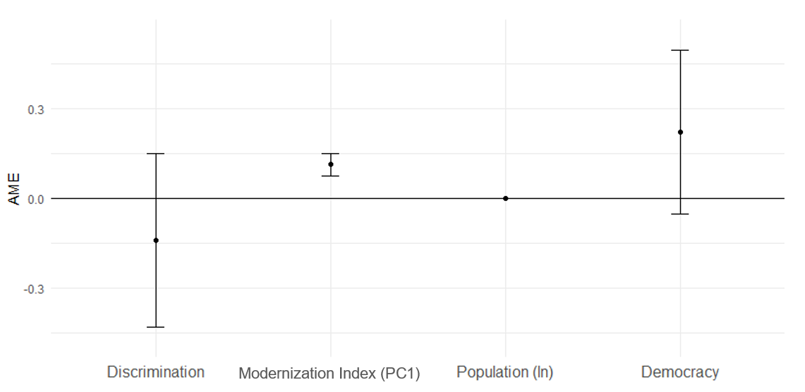
Figures 2A and 2B display the predicted probability of revolutionary nonviolence with the depicted effects of democracy and discrimination, where a particular variable takes on only a few values. This is necessary to understand how each variable affects the probability of a nonviolent revolution occurring when the others variables are constant. The graphs visualize M4 from Table 1, and show the 95% confidence intervals when the control variables are fixed as their means (the regional effect is also taken into account exactly the same way). As one can see from Figure 2A, which shows the effect of democracy on the probability of revolutionary nonviolence for different shares of the discriminated population, the index of electoral democracy has positive, relatively strong but insignificant effect on dependent variable. Meanwhile, discrimination has much smaller and totally insignificant effect on it, greatly inflating confidence interval. Figure 2B shows the same: the most impact on probability of revolutionary nonviolence has democracy (though this impact is statistically insignificant), while discrimination has a negative effect, but it is much weaker and totally insignificant statistically.

Figure 2A. The predicted probability of revolutionary nonviolence with democracy and discrimination as independent variables (for all revolutionary campaigns [M4, table 1]).
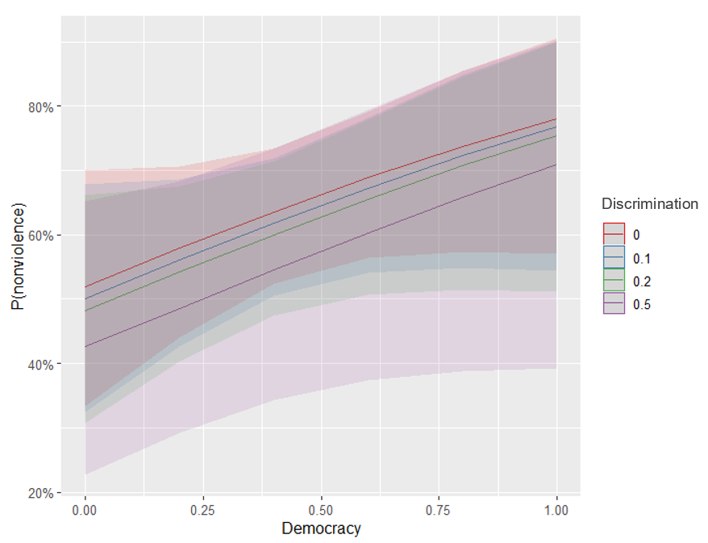

Figure 2B. The predicted probability of revolutionary nonviolence with democracy and discrimination as independent variables (for all revolutionary campaigns [M4, table 1]).
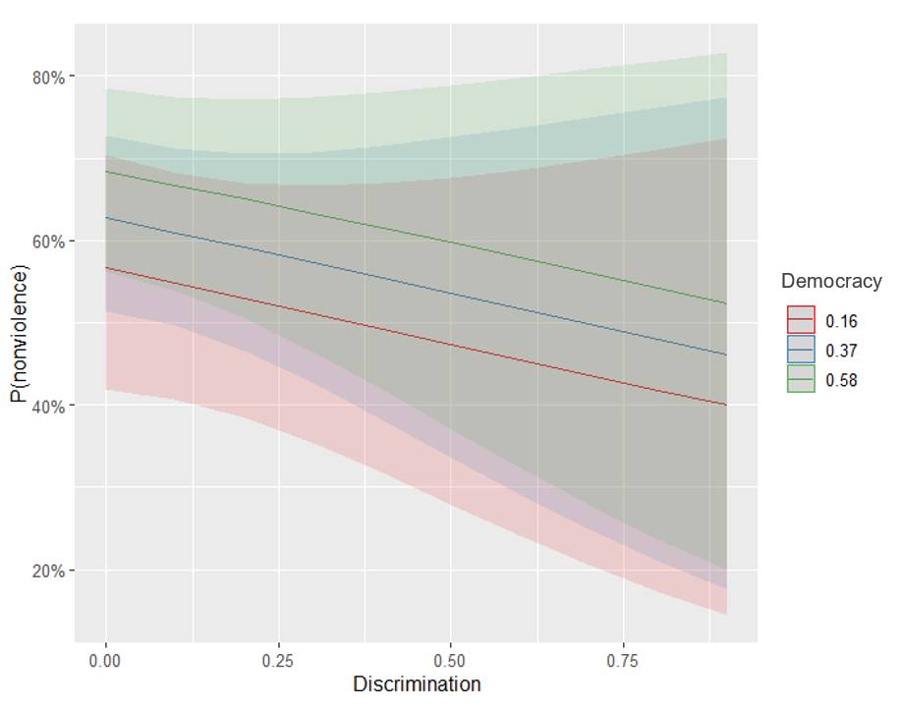

Sociopolitical revolutionary events
Table 2 shows results from logistic models where the outcome is whether NAVCO’s sociopolitical revolutionary campaign was nonviolent. The main explanatory variables are again the level of electoral democracy (t-1) and share of discriminated population (t-1).
As might be expected, based on our theoretical research, democracy is the strongest predictor and significant in all models, which was not the case in the analysis of all revolutionary episodes (Table 1). Moreover, in contrast with the previous analysis of all revolutionary events, discrimination now is totally insignificant and, in several models, has positive effect on revolutionary nonviolence (M2, M4, M6) that is explained by a too large confidence interval which cross the zero.
Also worthy of special attention is M4, where the modernization index (PC1) has been introduced. In contrast with the similar model from Table 1, democracy does not lose its significance even here, which once again proves its importance in the case of sociopolitical revolutions.
Table 2. Nonviolent campaign/ revolution on democracy and discrimination (for sociopolitical revolutionary events).
 | Dependent variable:
 | Nonviolent (=1) vs. violent (=0) form of revolutionary event
 | M1 | M2 | M3 | M4 | M5 | M6 | M7 | M8
Democracy(t-1) | 3.930*** | 3.390*** | 3.262*** | 1.816* | 2.624*** | 2.080** | 2.498*** | 0.786*
 | (0.758) | (0.822) | (0.829) | (0.942) | (0.873) | (0.921) | (0.886) | (0.971)
Discrimination (t-1) |  | 0.016 | -0.023 | 0.016 | -0.018 | 0.221 | -0.209 | -0.032
 |  | (0.788) | (0.792) | (0.869) | (0.818) | (0.821) | (0.849) | (0.862)
Population (ln) |  |  | 0.173* | 0.043 | 0.149 | 0.123 | 0.111 | 0.201
 |  |  | (0.100) | (0.120) | (0.103) | (0.110) | (0.109) | (0.144)
Modernization index (PC1 factors score) |  |  |  | 0.655***
 |  |  |  | (0.143)
Urbanization |  |  |  |  | 0.023***
 |  |  |  |  | (0.008)
Median age |  |  |  |  |  | 0.213***
 |  |  |  |  |  | (0.047)
GDP per capita (ln) |  |  |  |  |  |  | 0.802***
 |  |  |  |  |  |  | (0.183)
Mean years of schooling |  |  |  |  |  |  |  | 0.282***
 |  |  |  |  |  |  |  | (0.074)
Constant | -0.919*** | -0.751** | -2.358** | 0.235 | -2.857*** | -5.645*** | -7.925*** | -2.961**
 | (0.262) | (0.304) | (0.987) | (1.214) | (1.020) | (1.322) | (1.652) | (1.375)
Region Fixed-Effects | Yes | Yes | Yes | Yes | Yes | Yes | Yes | Yes
Observations | 333 | 314 | 314 | 288 | 313 | 306 | 313 | 213
Log Likelihood | -190.467 | -173.711 | -172.213 | -141.951 | -167.088 | -151.692 | -160.484 | -119.168
Akaike Inf. Crit. | 392.934 | 361.421 | 360.427 | 301.901 | 352.175 | 321.385 | 338.969 | 256.336
Note: | *p<0.1; **p<0.05; ***p<0.01

Figure 3 illustrates average marginal effects (AME) of variables on probability of nonviolence during sociopolitical revolutionary event from M4 from Table 2. As can be seen, democracy is significant and strongly and positively associated with revolutionary nonviolence, while the effect of discrimination is about zero. Making comparisons with the effect from the model including all episodes (see Fig. 1), we can see that the effect of democracy on the probability of non-violence has increased greatly: from about 0.2 to 0.3.
Figure 3. Average marginal effects of variables on nonviolence of revolutionary episodes (for sociopolitical revolutionary campaigns [M4, table 2]).
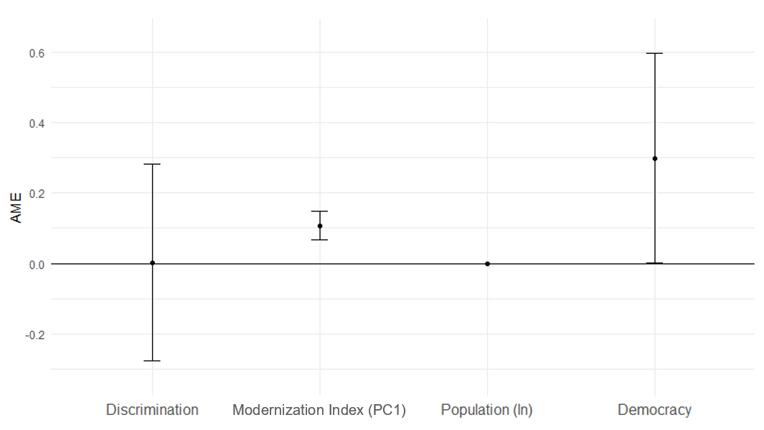
Figures 4A and 4B are very different from those in the case of analysis of all revolutionary episodes (Fig. 2A and 2B). Thus, the share of discriminated population literally has no effect on the revolutionary violence/nonviolence dichotomy. Figure 4A shows that the lines of different levels of discrimination are layered on top of each other, showing an essentially identical, zero effect of this variable on probability. At the same time, the lines themselves have a fairly strong slope, which shows the importance of democracy. Figure 4B displays a similar picture, but from a different point of view: as the share of discriminated population increases, there is no change in the probabilities because the lines are parallel and have no slope. At the same time, the differences in the distances of the different lines along the probability axis reflect an important effect of the level of democracy on sociopolitical revolutions. All these findings strongly support our first hypothesis.
Figure 4A. The predicted probability of revolutionary nonviolence with democracy and discrimination as independent variables (for sociopolitical revolutionary campaigns [M4, table 2]).
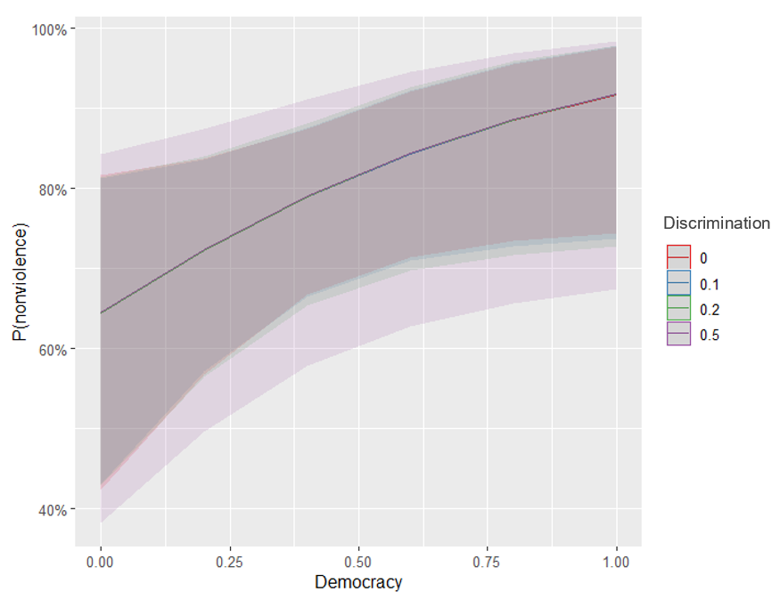

Figure 4B. The predicted probability of revolutionary nonviolence with democracy and discrimination as independent variables (for sociopolitical revolutionary campaigns [M4, table 2]).
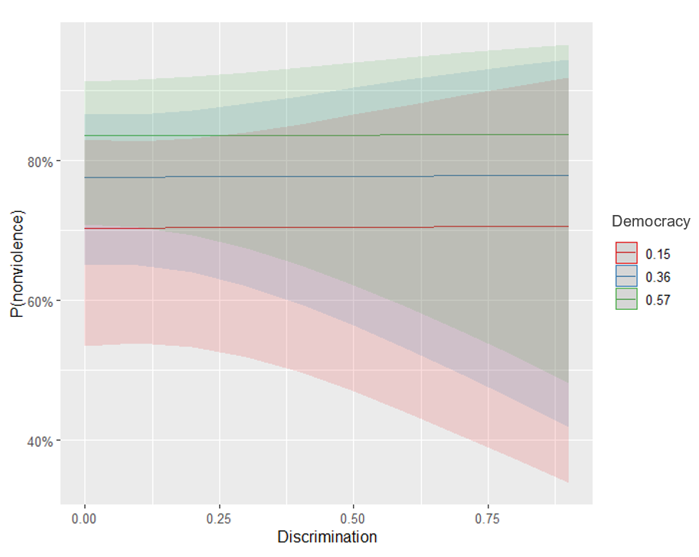

Separatist revolutionary events
Table 3 shows results from logistic models where the outcome is whether NAVCO’s ethno-separatist revolutionary campaign was nonviolent. Once again, the main explanatory variables are the level of electoral democracy (t-1) and share of discriminated population (t-1).
As might be expected, based on our theoretical research, democracy has no significant effect in all models except pairwise, which was not the case in the analysis of sociopolitical revolutionary episodes (table 2). Worth noting, in M4, M5 and M8 democracy has negative effect on revolutionary nonviolence but is explained by large confidence interval and has no real information about association between this factor and dependent variable (to be more precise, it shows complete insignificance).
What is more interesting, in contrast with the previous analyses of sociopolitical and all events (Tables 2 and 1 respectively), discrimination now is the most significant and important factor. In majority of models, it is significant at p <0.1 level, but in the other models it is marginally significant at p<0.13 level (M2, M4, M8) that is due to small number of observations (the database only includes about 70 ethno-separatist revolutionary events). It should be also emphasized that if the modernization index (PC1) variable is marginally significant and has a positive effect, its individual components are not always significant. While GDP per capita, urbanization, and mean years of schooling behave in the predicted direction and have a significant effect on the probability of revolutionary nonviolence, the median age (quite in congruence with the findings of Yair and Miodownik (2016) and, especially, Cincotta and Weber (2020)) appears to be a completely insignificant factor and, moreover, is negatively related to the dependent variable, which again can be explained by poor significance.
Table 3. Nonviolent campaign/ revolution on democracy and discrimination (for separatist revolutionary events).
 | Dependent variable:
 | Nonviolent (=1) vs. violent (=0) form of revolutionary event
 | M1 | M2 | M3 | M4 | M5 | M6 | M7 | M8
Democracy(t-1) | 2.661* | 1.601 | 1.220 | -0.043 | -0.634 | 0.625 | 0.093 | -0.703
 | (1.575) | (1.660) | (1.743) | (2.264) | (2.062) | (1.929) | (1.956) | (2.417)
Discrimination (t-1) |  | -6.080⸶ | -6.259* | -9.300⸶ | -8.045* | -6.707* | -7.702* | -9.236⸶
 |  | (3.862) | (3.769) | (6.093) | (4.789) | (4.061) | (4.675) | (6.080)
Population (ln) |  |  | 0.225 | -0.158 | 0.304 | 0.202 | 0.249 | -0.102
 |  |  | (0.255) | (0.296) | (0.271) | (0.257) | (0.256) | (0.304)
Modernization index (PC1 factors score) |  |  |  | 0.532⸶
 |  |  |  | (0.336)
Urbanization |  |  |  |  | 0.044*
 |  |  |  |  | (0.023)
Median age |  |  |  |  |  | -0.013
 |  |  |  |  |  | (0.068)
GDP per capita (ln) |  |  |  |  |  |  | 0.647⸶
 |  |  |  |  |  |  | (0.481)
Mean years of schooling |  |  |  |  |  |  |  | 0.274*
 |  |  |  |  |  |  |  | (0.165)
Constant | -2.112*** | -1.336** | -3.364 | 1.698 | -5.563** | -2.690 | -8.608* | -0.222
 | (0.579) | (0.659) | (2.409) | (2.910) | (2.825) | (2.757) | (4.626) | (2.948)
Region Fixed-Effects | Yes | Yes | Yes | Yes | Yes | Yes | Yes | Yes
Observations | 76 | 73 | 73 | 53 | 73 | 70 | 73 | 53
Log Likelihood | -37.661 | -34.630 | -34.228 | -27.003 | -32.104 | -32.878 | -33.282 | -26.833
Akaike Inf. Crit. | 87.323 | 83.260 | 84.456 | 72.005 | 82.208 | 83.756 | 84.563 | 71.666
Note: | *p<0.1; **p<0.05; ***p<0.01

Figure 5 displays average marginal effects (AME) of M4 model from the regression table above. One can see that the share of discriminated population has the strongest effect on probability of nonviolence of ethno-separatist revolutionary episodes, while average marginal effect of the index of electoral democracy is about zero.
Figure 5. Average marginal effects of variables on nonviolence of revolutionary episodes (for separatist revolutionary campaigns [M4, table 3])).
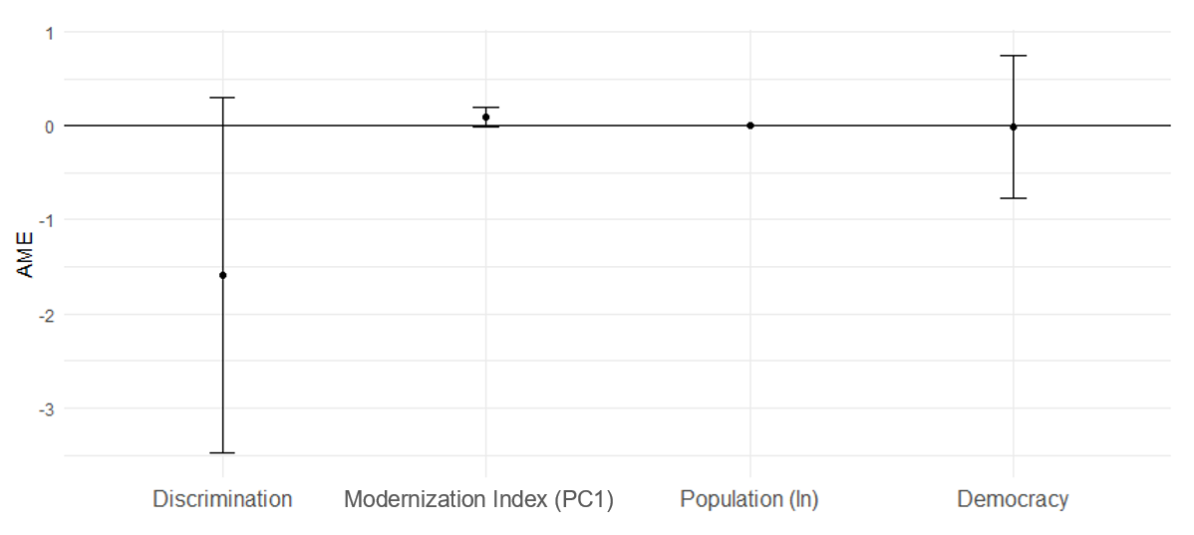
The same result can be seen in Figures 6A and 6B where predicted probabilities of nonviolence during separatist revolutionary movements are presented (however, we had to remove the confidence intervals because the democracy variable has a significance level greater than 0.9 and the resulting intervals are difficult to visualize and perceive). It is clearly shown that the index of electoral democracy is totally insignificant and has no effect on revolutionary violence/nonviolence. In Figure 6A one can see that all lines are parallel to the axis, they have no slope and, therefore, no obvious effect. Thus, for a given levels of discrimination, it does not matter what the index of electoral democracy will be. In general, the same can be concluded from Figure 6B. Thus, the different lines corresponding to different levels of democracy are superimposed on each other, which shows the absence of any effect of democracy on the probability of nonviolence in the case of separatist revolutionary episodes. Nevertheless, we can clearly see a strong effect of discrimination, when the slope of the lines is rather steep. Interestingly, as the share of discriminated population increases from 0% to roughly 50%, we see an extremely steep slope, indicating a galloping reduction in the probability of revolutionary nonviolence during separatist episode as discrimination rises to this point. Once it reaches the about 50% mark, the rate of decline in the probability decreases, eventually reaching zero. All these findings strongly support our second and third hypotheses.
Figure 6A. The predicted probability of revolutionary nonviolence with democracy and discrimination as independent variables (for separatist revolutionary campaigns [M4, table 3]).
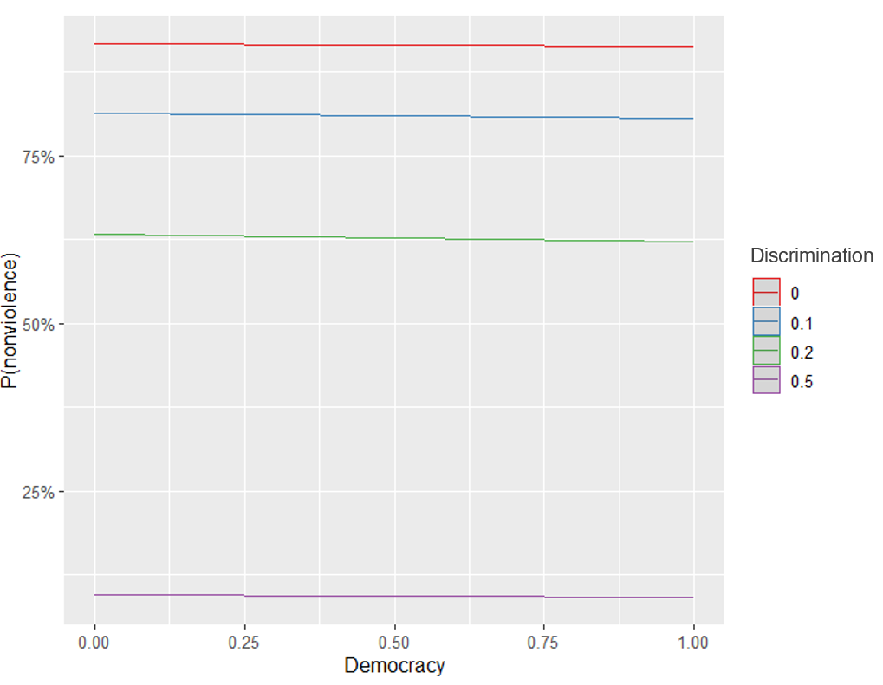
Figure 6B. The predicted probability of revolutionary nonviolence with democracy and discrimination as independent variables (for separatist revolutionary campaigns [M4, table 3]).
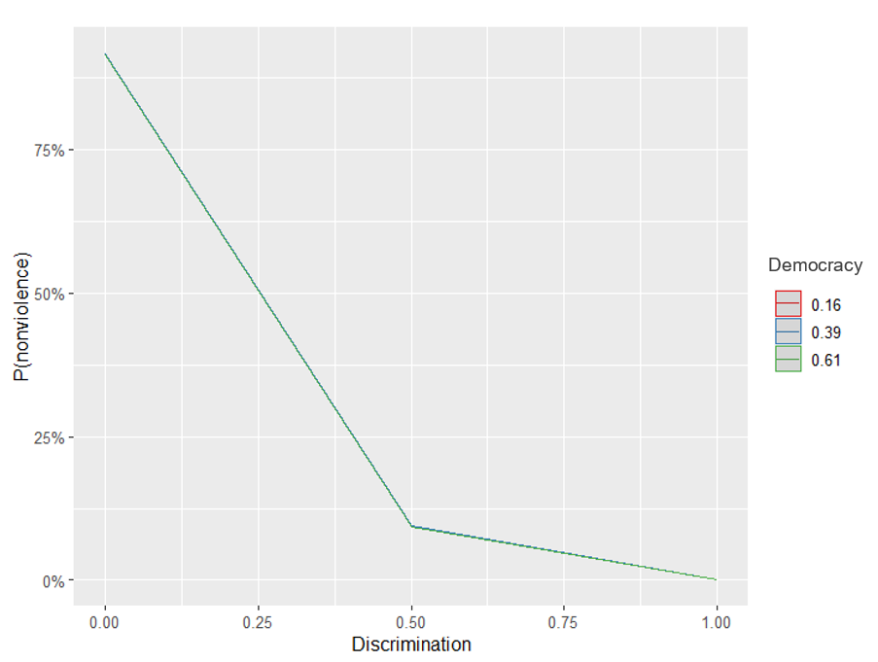
To sum up, when analyzing all the revolutionary events taken together, one should keep in mind that the share of the discriminated population and the level of democracy are completely different self-sufficient variables. Thus, if democracy is mostly significant, but its effect is not high in the analysis of all revolutionary movements (see Table 1), while discrimination is totally insignificant, it is only from the fact that cardinally different types of revolutions are mixed where the number of sociopolitical revolutionary events far exceeds the number of ethno-separatist revolutionary episodes. However, if we divide revolutionary uprisings into ethno-separatist and sociopolitical ones, the situation changes significantly: for ethno-separatist revolutionary events the discrimination turns out to be an undoubtably strong and significant negative predictor of revolutionary nonviolence, whereas democracy turns out to be totally insignificantly. On the other hand, as regards the sociopolitical revolutionary episodes, while the discrimination continuous to be insignificant, the democracy turns out to be not only significant, but also rather strong and positive predictor of revolutionary nonviolence.

Conclusion and Discussion
In the late 20th and early 21st centuries, some researchers assumed that the global spread of democracy would end the era of revolutions (Fukuyama, 1989; Goodwin, 2001, 2003; Halliday, 1999; Nodia, 2000; Snyder, 1999) because “the ballot box has been the coffin of revolutionaries” (Goodwin, 2003, p. 67). In other words, the level of democracy was supposed as key factor in stopping both revolutions and violence during revolutionary struggles. Meanwhile, the experience of 21st century shows that revolutions can occur even in partial democracies. Hence, the question how democracy affects the nonviolence remains open, which is especially important because most countries in the world today are full autocracies, partial autocracies or partial democracies.
Our analysis suggests that the level of democracy is indeed a significant and powerful predictor of whether a revolution will take a nonviolent form. However, this applies only to sociopolitical, not ethno-separatist revolutions that is congruent with the conclusion of other researchers, where economic or demographical factors cannot explain ethno-national revolutionary episodes while accounting quite well for the sociopolitical ones (Cincotta & Weber, 2020; Sambanis, 2001; Yair & Miodownik, 2016). Above all, this can be linked to the fact that “separatists’ core grievances, centred around their identity and the lack of political autonomy granted to their identity group” (Cincotta & Weber, 2020, p. 85), but not in such structural factors as economic development and age structure or transparency of electoral process. Thus, for ethno-separatist revolutions, where the goal of the protesters is not a regime change, but autonomy or secession (Cederman et al., 2013; Wimmer et al., 2009; Yair & Miodownik, 2016) the most important factor in determining whether a revolution will take a violent or nonviolent form is discrimination, and democracy is not even a significant factor.
On the other hand, it appears appropriate to pay attention to another pattern we have found: even a slight democratization leads to a reduction in the risk that a revolution will take a violent form. Indeed, the higher the level of democracy, the greater the likelihood of revolutionary nonviolence. Meanwhile, if a revolution takes a nonviolent form, it has a greater chance of success and the establishment of a more democratic regime (Ackerman & Karatnycky, 2005; Celestino & Gleditsch, 2013; Chenoweth & Stephan, 2011; Johnstad, 2010; Kim & Kroeger, 2019; Rasler et al., 2022). This suggests the existence of a positive feedback between democratization and revolutionary nonviolence. Thus, democratization leads to revolutionary nonviolence, which, in turn, leads to even greater democratization. In fact, this mechanism might contribute to the explanation of the overall global trend towards democratization (that can be quite confidently traced in the recent centuries notwithstanding the recent “democratic regression” [Abushouk, 2016; Diamond, 2021; Huntington, 1993, 1997; Lührmann & Lindberg, 2019; Sarıhan, 2012; Skaaning, 2020]), but it requires further elaboration.
Moreover, in this paper we introduce generalized “modernization index” and demonstrate that the likelihood that a revolutionary episode will take a nonviolent form is significantly influenced by it. Modernization is a strong and stable predictor of revolutionary nonviolence: the more developed society is (e.g., more wealthy, more educated, more urbanized, and older), the higher the probability that the uprising will be bloodless. Furthermore, one might conclude that the level of modernization of society increases the chances of both sociopolitical and separatist revolution adopting a nonviolent form. However, in the case of ethno-separatist revolutions the modernization factor is still overshadowed by discrimination. Therefore, it is clearly impossible to explain the revolutionary nonviolence by a single, also generalized factor.

References
Abdi, H., & Williams, L. J. (2010). Principal component analysis. Wiley Interdisciplinary Reviews: Computational Statistics, 2(4), 433–459.
Abushouk, A. I. (2016). The Arab Spring: A fourth wave of democratization? Digest of Middle East Studies, 25(1), 52–69.
Acemoglu, D., & Robinson, J. A. (2019). The Narrow Corridor: How Nations Struggle for Liberty. Penguin UK.
Ackerman, P., & Karatnycky, A. (2005). How freedom is won: From civic resistance to durable democracy. New York, Freedom House.
Ackerman, P., & Kruegler, C. (1994). Strategic nonviolent conflict: The dynamics of people power in the twentieth century. Praeger publishers.
Ardagna, S., & Caselli, F. (2014). The political economy of the Greek debt crisis: A tale of two bailouts. American Economic Journal: Macroeconomics, 6(4), 291–323.
Banks, Arthur S., Wilson, Kenneth A. (2021). Cross-National Time-Series Data Archive. see https://www.cntsdata.com/
Barakat, B., & Urdal, H. (2009). Breaking the Waves? Does Education Mediate the Relationship Between Youth Bulges and Political Violence? The World Bank, Policy Research Working Paper Series.
Beissinger, M. (2022). The Revolutionary City: Urbanization and the Global Transformation of Rebellion. Princeton University Press.
Besançon, M. L. (2005). Relative Resources: Inequality in Ethnic Wars, Revolutions, and Genocides. Journal of Peace Research, 42(4), 393–415. https://doi.org/10.1177/0022343305054086
Brancati, D. (2014). Pocketbook Protests: Explaining the Emergence of Pro-Democracy Protests Worldwide. Comparative Political Studies, 47(11), 1503–1530. https://doi.org/10.1177/0010414013512603
Bro, R., & Smilde, A. K. (2014). Principal component analysis. Analytical Methods, 6(9), 2812–2831.
Buhaug, H., & Lujala, P. (2005). Accounting for scale: Measuring geography in quantitative studies of civil war. Political Geography, 24(4), 399–418. https://doi.org/10.1016/j.polgeo.2005.01.006
Butcher, C., & Svensson, I. (2016). Manufacturing Dissent. Journal of Conflict Resolution, 60(2), 311–339. https://doi.org/10.1177/0022002714541843
Caren, N., Gaby, S., & Herrold, C. (2017). Economic Breakdown and Collective Action. Social Problems, 64(1), 133–155. https://doi.org/10.1093/socpro/spw030
Carey, S. C. (2006). The dynamic relationship between protest and repression. Political Research Quarterly, 59(1), 1–11.
Cederman, L.-E., Gleditsch, K. S., & Buhaug, H. (2013). Inequality, grievances, and civil war. Cambridge University Press.
Celestino, M. R., & Gleditsch, K. S. (2013). Fresh carnations or all thorn, no rose? Nonviolent campaigns and transitions in autocracies. Journal of Peace Research, 50(3), 385–400.
Chenoweth, E., & Christopher, W. S. (2020). List of Campaigns in NAVCO 1.3. Harvard Dataverse.
Chenoweth, E., & Shay, C. W. (2020). NAVCO 1.3 Codebook. Harvard Dataverse.
Chenoweth, E., & Stephan, M. J. (2011). Why civil resistance works: The strategic logic of nonviolent conflict. Columbia University Press.
Chenoweth, E., & Ulfelder, J. (2017). Can Structural Conditions Explain the Onset of Nonviolent Uprisings? Journal of Conflict Resolution, 61(2), 298–324. https://doi.org/10.1177/0022002715576574
Cincotta, R., & Doces, J. (2012). The age-structural maturity thesis. Political Demography, 98–116.
Cincotta, R., & Weber, H. (2020). Youthful Age Structures and the Risks of Revolutionary and Separatist Conflicts. 1–53.
Collier, P. (2004). Greed and grievance in civil war. Oxford Economic Papers, 56(4), 563–595. https://doi.org/10.1093/oep/gpf064
Colon-Rios, J., & Hutchinson, A. C. (2012). Democracy and revolution: An enduring relationship. Denv. UL Rev., 89(3), 593–610.
Coppedge, M., Gerring, J., Knutsen, C. H., Lindberg, S. I., Teorell, J., Alizada, N., Altman, D., Bernhard, M., Cornell, A., & Fish, M. S. (2021). V-Dem Dataset v11. 1.
Craney, T. A., & Surles, J. G. (2002). Model-dependent variance inflation factor cutoff values. Quality Engineering, 14(3), 391–403.
Dahl, M., Gates, S., Gleditsch, K., & Gonzalez, B. (2020). Accounting for numbers: Group characteristics and the choice of violent and nonviolent tactics. Economics of Peace and Security Journal.
Dahlum, S. (2019). Students in the Streets: Education and Nonviolent Protest. Comparative Political Studies, 52(2), 277–309. https://doi.org/10.1177/0010414018758761
Davenport, C. (1999). Human rights and the democratic proposition. Journal of Conflict Resolution, 43(1), 92–116.
DeNardo, J. (1985). Power in Numbers: The Political Strategy of Protest and Rebellion. Princeton University Press. https://books.google.ru/books?id=FI6PQgAACAAJ
Diamond, L. (2021). Democratic regression in comparative perspective: Scope, methods, and causes. Democratization, 28(1), 22–42.
Evripidou, A., & Drury, J. (2013). This is the time of tension: Collective action and subjective power in the Greek anti-austerity movement. Contention, 1(1), 31–51.
Farrar, D. E., & Glauber, R. R. (1967). Multicollinearity in regression analysis: The problem revisited. The Review of Economic and Statistics, 92–107.
Farzanegan, M. R., & Witthuhn, S. (2017). Corruption and political stability: Does the youth bulge matter? European Journal of Political Economy, 49, 47–70. https://doi.org/10.1016/j.ejpoleco.2016.12.007
Fukuyama, F. (1989). The End of History? The National Interest, 16, 3–18. JSTOR.
Gleditsch, K. S., & Rivera, M. (2017). The Diffusion of Nonviolent Campaigns. Journal of Conflict Resolution, 61(5), 1120–1145. https://doi.org/10.1177/0022002715603101
Goldstone, J. A. (2001). Toward a fourth generation of revolutionary theory. Annual Review of Political Science, 4(1), 139–187.
Goldstone, J. A. (2002). Population and security: How demographic change can lead to violent conflict. Journal of International Affairs, 3–21.
Goodwin, J. (2001). No other way out: States and revolutionary movements, 1945-1991. Cambridge University Press.
Goodwin, J. (2003). The renewal of socialism and the decline of revolution. In The Future of Revolutions: Rethinking Radical Change in the Age of Globalization (pp. 59–72). Zed Books.
Grinin, L., & Korotayev, A. (2016). Revolution and democracy: Sociopolitical systems in the context of modernisation. Central European Journal of International and Security Studies, 10(3), 118–139.
Gurr, T. R. (2000). Peoples versus states: Minorities at risk in the new century. US Institute of Peace Press.
Halliday, F. (1999). Revolution and World Politics: The Rise and Fall of the Sixth Great Power. Duke University Press. https://books.google.ru/books?id=3jCkXQRhHMgC
Hegre, H., & Sambanis, N. (2006). Sensitivity Analysis of Empirical Results on Civil War Onset. Journal of Conflict Resolution, 50(4), 508–535. https://doi.org/10.1177/0022002706289303
Henderson, C. W. (1991). Conditions Affecting the Use of Political Repression. Journal of Conflict Resolution, 35(1), 120–142. https://doi.org/10.1177/0022002791035001007
Huntington, S. P. (1993). The third wave: Democratization in the late twentieth century (Vol. 4). University of Oklahoma press.
Huntington, S. P. (1997). After twenty years: The future of the third wave. Journal of Democracy, 8(4), 3–12.
Inglehart, R. F., Puranen, B., & Welzel, C. (2015). Declining willingness to fight for one’s country. Journal of Peace Research, 52(4), 418–434. https://doi.org/10.1177/0022343314565756
Inglehart, R., & Welzel, C. (2005). Modernization, cultural change, and democracy: The human development sequence. Cambridge university press.
Jenkins, J. C., & Wallace, M. (1996). The generalized action potential of protest movements: The new class, social trends, and political exclusion explanations. Sociological Forum, 11(2), 183–207. https://doi.org/10.1007/BF02408364
Johnstad, P. G. (2010). Nonviolent democratization: A sensitivity analysis of how transition mode and violence impact the durability of democracy. Peace & Change, 35(3), 464–482.
Kadivar, M. A., & Ketchley, N. (2018). Sticks, Stones, and Molotov Cocktails: Unarmed Collective Violence and Democratization. Socius, 4, 2378023118773614. https://doi.org/10.1177/2378023118773614
Karyotis, G., & Rüdig, W. (2018). The three waves of anti-austerity protest in Greece, 2010–2015. Political Studies Review, 16(2), 158–169.
Kim, N. K., & Kroeger, A. M. (2019). Conquering and coercing: Nonviolent anti-regime protests and the pathways to democracy. Journal of Peace Research, 56(5), 650–666.
Korotaev, A., Slav, M., Zinkina, J., & Romanov, D. M. (2020). Urbanization, birth rate, urban youth and forecasting of structural and demographic risks of socio-political destabilization. In A. Korotaev & L. E. Grinin (Eds.), Systematic monitoring of global and regional risks (pp. 317–370). Uchitel.
Korotayev, A., Bilyuga, S., & Shishkina, A. (2018). GDP Per Capita and Protest Activity: A Quantitative Reanalysis. Cross-Cultural Research, 52(4), 406–440. https://doi.org/10.1177/1069397117732328
Korotayev, A., Romanov, D. M., Zinkina, J., & Slav, M. (2022). Urban Youth and Terrorism: A Quantitative Analysis (Are Youth Bulges Relevant Anymore?). https://doi.org/10.1177/14789299221075908
Korotayev, A. V., Sawyer, P. S., & Romanov, D. M. (2021). Socio-Economic Development and Protests: A Quantitative Reanalysis. Comparative Sociology, 20(2), 195–222.
Korotayev, A. V., Scott, P. S., Grinin, L. E., Romanov, D. M., & Shishkina, A. R. (2020). Socio-economic Development and Anti-government Protests in Light of a New Quantitative Analysis of Global Databases. Sotsiologicheskiy Zhurnal = Sociological Journal, 26(4), 61–78. https://doi.org/10.19181/socjour.2020.26.4.7642
Korotayev, A., Vaskin, I., & Bilyuga, S. (2017). Olson-Huntington Hypothesis on a Bell-Shaped Relationship Between the Level of Economic Development and Sociopolitical Destabilization: A Quantitative Analysis. 16(1), 9–49. https://doi.org/10.17323/1728-192X2017-1-9-49
Korotayev, A., Vaskin, I., Bilyuga, S., & Ilyin, I. (2018). Economic Development and Sociopolitical Destabilization: A Re-Analysis. Cliodynamics, 9(1), 59–118.
Kostelka, F., & Rovny, J. (2019). It’s Not the Left: Ideology and Protest Participation in Old and New Democracies. Comparative Political Studies, 52(11), 1677–1712. https://doi.org/10.1177/0010414019830717
Lawson, G. (2019). Anatomies of revolution. Cambridge University Press.
Lührmann, A., & Lindberg, S. I. (2019). A third wave of autocratization is here: What is new about it? Democratization, 26(7), 1095–1113.
Machado, F., Scartascini, C., & Tommasi, M. (2011). Political Institutions and Street Protests in Latin America. Journal of Conflict Resolution, 55(3), 340–365. https://doi.org/10.1177/0022002711400864
Mansfield, E. R., & Helms, B. P. (1982). Detecting multicollinearity. The American Statistician, 36(3a), 158–160.
Massoud, T. G., Doces, J. A., & Magee, C. (2019). Protests and the Arab Spring: An Empirical Investigation. Polity, 51(3), 429–465. https://doi.org/10.1086/704001
Meyer, D. S., & Tarrow, S. (1998). A movement society: Contentious politics for a new century. Rowman & Littlefield Publishers.
Nam, T. (2007). Rough days in democracies: Comparing protests in democracies. European Journal of Political Research, 46(1), 97–120. https://doi.org/10.1111/j.1475-6765.2006.00645.x
Nodia, G. O. (2000). The end of revolution? Journal of Democracy, 11(1), 164–171.
Pischedda, C. (2020). Ethnic Conflict and the Limits of Nonviolent Resistance. Security Studies, 29(2), 362–391. https://doi.org/10.1080/09636412.2020.1722854
Popper, K. R. (1949). Prediction and prophecy and their significance for social theory. Proceedings of the Tenth International Congress of Philosophy, 1, 82–91.
Rasler, K., Thompson, W. R., & Bou Nassif, H. (2022). The Extent of Military Involvement in Non-Violent, Civilian Revolts and Their Aftermath. In Goldstone J., Grinin L., Korotayev A. (eds.) Handbook of Revolutions in the 21st Century: The New Waves of Revolutions, and the Causes and Effects of Disruptive Political Change. Springer. https://doi.org/10.1007/978-3-030-86468-2_29
Regan, P. M., & Norton, D. (2005). Greed, Grievance, and Mobilization in Civil Wars. Journal of Conflict Resolution, 49(3), 319–336. https://doi.org/10.1177/0022002704273441
Sambanis, N. (2001). Do Ethnic and Nonethnic Civil Wars Have the Same Causes? Journal of Conflict Resolution, 45(3), 259–282. https://doi.org/10.1177/0022002701045003001
Sarıhan, A. (2012). Is the Arab Spring in the Third Wave of Democratization? The Case of Syria and Egypt. Turkish Journal of Politics, 3(1).
Sawyer, P. S., & Korotayev, A. V. (2022). Formal Education and Contentious Politics: The Case of Violent and Non-Violent Protest. Political Studies Review, 1–24. https://doi.org/10.1177/1478929921998210
Sawyer, P. S., Romanov, D. M., Slav, M., & Korotayev, A. V. (2022). Urbanization, the youth, and protest: A cross-national analysis. Cross-Cultural Research, 56(2–3), 125–149.
Skaaning, S.-E. (2020). Waves of autocratization and democratization: A critical note on conceptualization and measurement. Democratization, 27(8), 1533–1542.
Snyder, R. S. (1999). The end of revolution? The Review of Politics, 61(1), 5–28.
Stephan, M. J., & Chenoweth, E. (2008). Why Civil Resistance Works: The Strategic Logic of Nonviolent Conflict. International Security, 33(1), 7–44. https://doi.org/10.1162/isec.2008.33.1.7
The World Bank. (2022). The World Bank databank: World Development Indicators. https://databank.worldbank.org/
UNDP. (2022). United Nations, Department of Economic and Social Affairs, Population Division. World Population Prospects 2019, Online Edition. Rev. 1. https://population.un.org/wpp/Download/Standard/Population/
Unger, R. M. (1987). Social Theory: Its Situation and Its Task. Cambridge University Press.
United Nations Population Division. (2021). World Urbanization Prospects Database. United Nations. https://population.un.org/wup/.
Ustyuzhanin, V., Grinin, L., & Korotaev, A. (2022). Education and Revolutions. Why do some revolutions take up arms while others do not? Politeia-Journal of Political Theory, Political Philosophy and Sociology of Politics, 104(1), 50–71.
Vogiatzoglou, M. (2017). Turbulent flow: Anti-austerity mobilization in Greece. In Late neoliberalism and its discontents in the economic crisis (pp. 99–129). Springer.
Vogt, M., & Rüegger, S. (2021). The Ethnic Power Relations (EPR) Core Dataset, Codebook Version 2021. 1–7.
Walter, B. F. (2006). Building Reputation: Why Governments Fight Some Separatists but Not Others. American Journal of Political Science, 50(2), 313–330. https://doi.org/10.1111/j.1540-5907.2006.00186.x
Weber, H. (2019). Age structure and political violence: A re-assessment of the “youth bulge” hypothesis. International Interactions, 45(1), 80–112. https://doi.org/10.1080/03050629.2019.1522310
Wimmer, A., Cederman, L.-E., & Min, B. (2009). Ethnic Politics and Armed Conflict: A Configurational Analysis of a New Global Data Set. American Sociological Review, 74(2), 316–337. https://doi.org/10.1177/000312240907400208
Yair, O., & Miodownik, D. (2016). Youth bulge and civil war: Why a country’s share of young adults explains only non-ethnic wars. Conflict Management and Peace Science, 33(1), 25–44.

Appendix
Figure A1. Scatter plot between index of electoral democracy (V-Dem) and the share of discriminated population (with lag) with Pearson correlation.
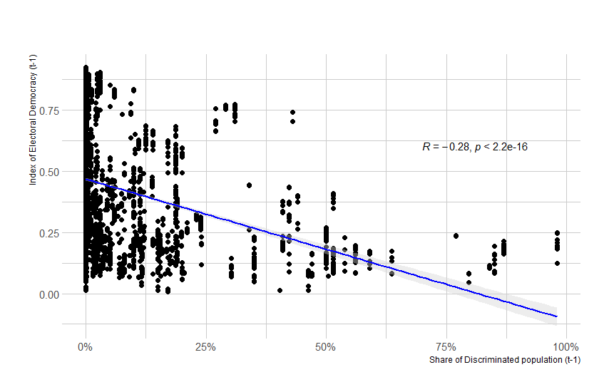

Figure A2. Correlogram of main modernization control variables with Pearson correlation.
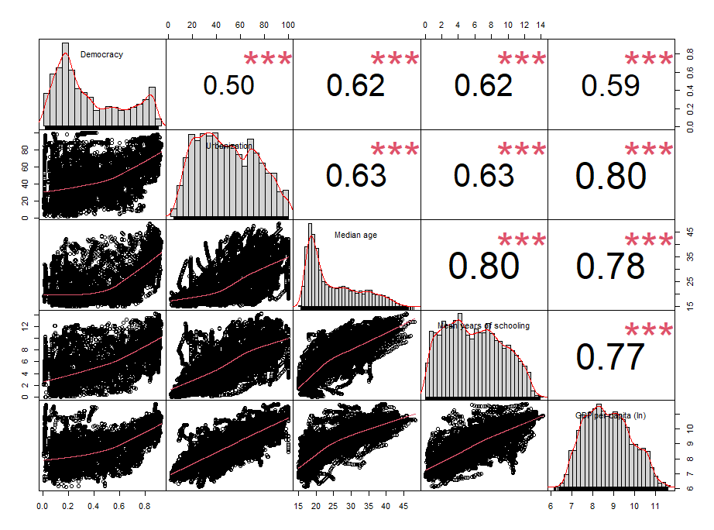
Figure A3. Variances of different modernization PC.
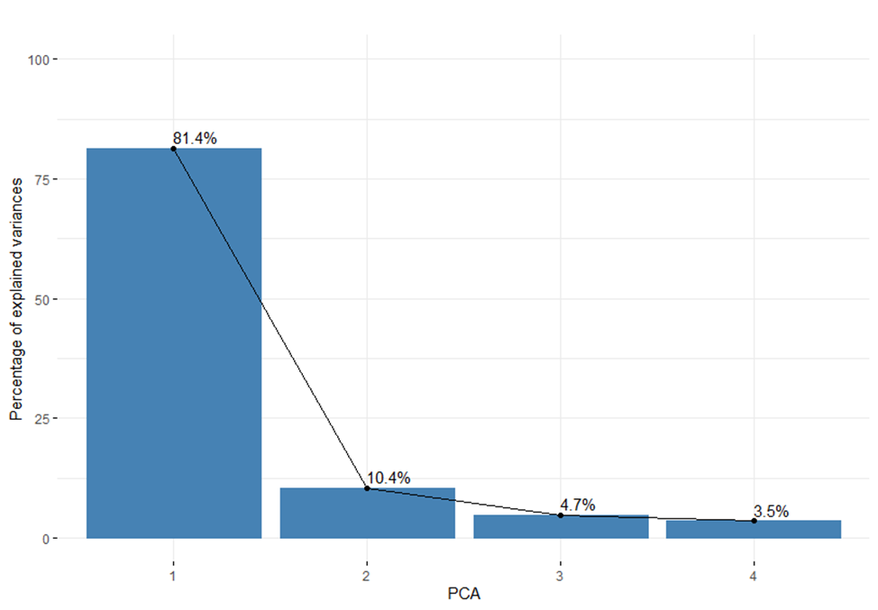
Figure A4. Dimensions of variables within PC1 and PC2.
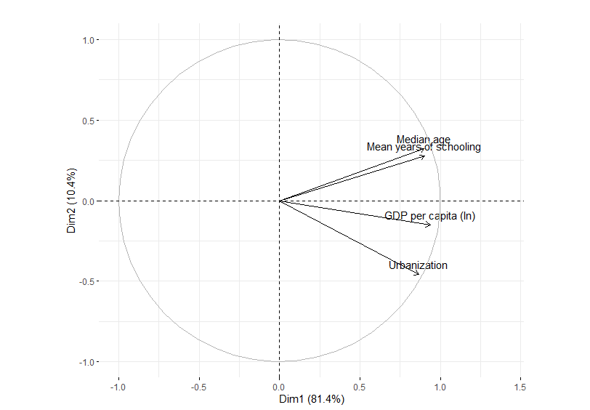
Figure A5. Contributions of variables within PC1.
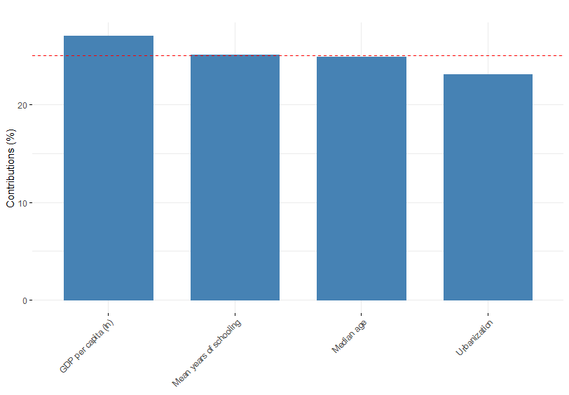
Figure A6. Average standardized marginal effects of variables on all revolutionary campaigns (M4, table 1).
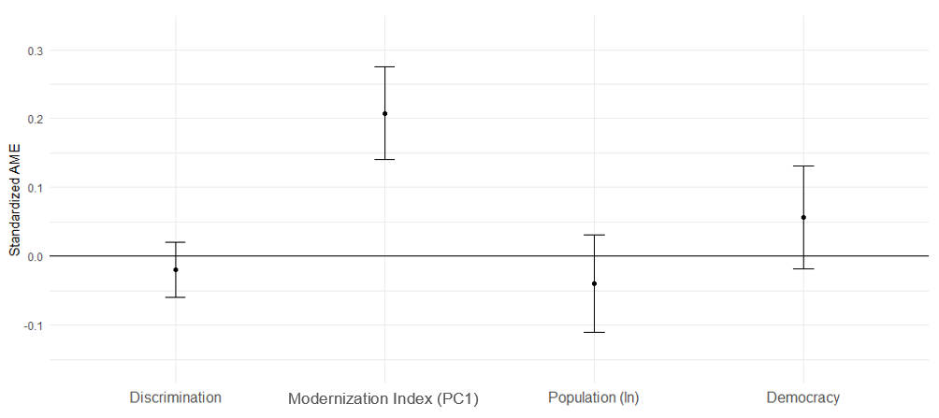
Figure A7. Average standardized marginal effects of variables on sociopolitical revolutionary campaigns (M4, table 2).
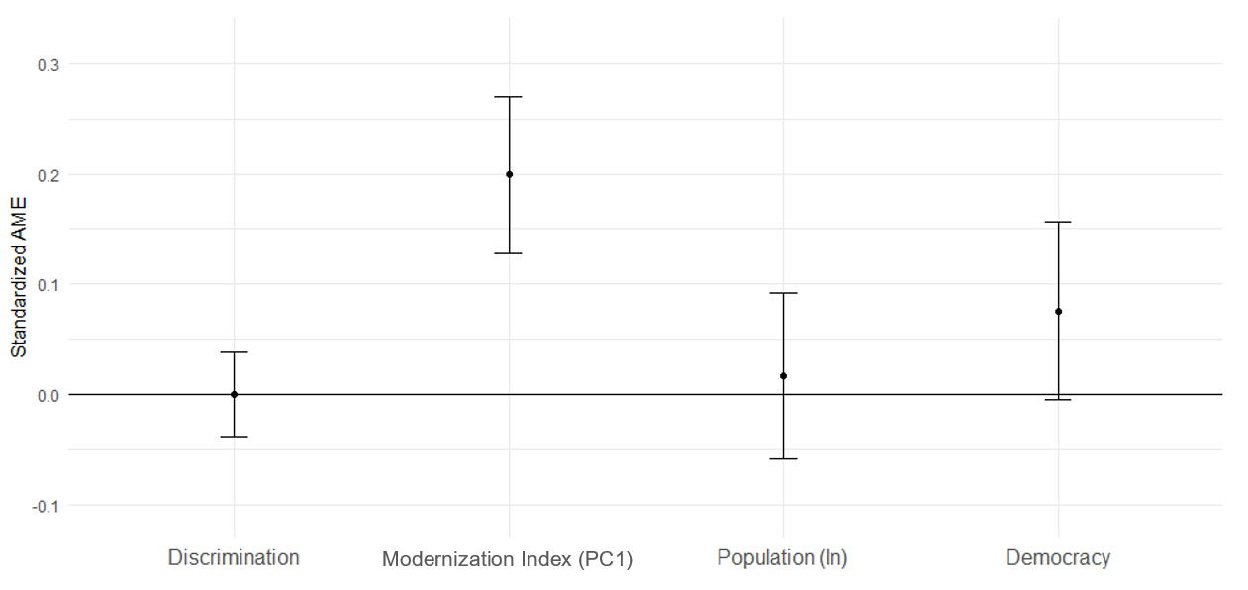

Figure A8. Average standardized marginal effects of variables on sociopolitical revolutionary campaigns (M4, table 3).
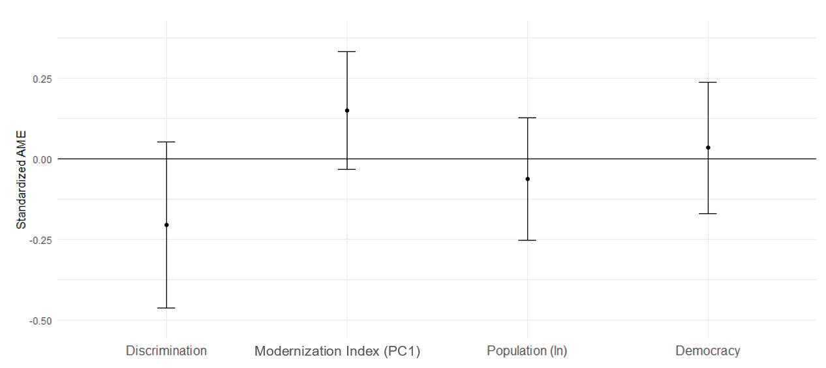

Note that most of these authors prefer to denote revolutions as “maximalist campaigns”. Following Ackerman and Kruegler (1994, pp. 10–11). Chenoweth and Stephan (2011, p. 14) define “campaign” as “a series of observable, continual, purposive mass tactics in pursuit of a political objective.” What is more, the above mentioned studies consider campaigns “with goals that are perceived as maximalist (fundamentally altering the political order); …we deliberately choose campaigns with goals commonly perceived to be maximalist in nature: regime change, antioccupation, and secession” (Chenoweth & Stephan, 2011, p. 68). Thus, the abovementioned works study “series of observable, continual, purposive mass tactics in pursuit of fundamentally altering the political order: regime change, antioccupation, and secession”. Let us recollect that in this chapter (as well as in this book as a whole) we rely on such definitions of revolution as “a revolution is a collective mobilization that attempts to quickly and forcibly over-throw an existing regime in order to transform political, economic, and symbolic relations” (Lawson, 2019, p. 5); “anti-government (very often illegal) mass actions (mass mobilization) with the following aims: (1) to overthrow or replace the existing government within a certain period of time; (2) to seize power or to provide conditions for coming to power; (3) to make significant changes in the regime, social or political institutions” , or “an effort to transform the political institutions and the justifications for political authority in a society, accompanied by formal or informal mass mobilization and noninstitutionalized actions that under-mine existing authorities” (Goldstone, 2001, p. 142). Thus, we find that “maximalist campaigns” are just nothing else but revolutions (including national liberation ones); hence, the abovementioned works actually study revolutions (rather oddly denoted as “campaigns”). This point is further supported by the fact that Chenoweth’s database of Nonviolent and Violent Campaigns and Outcomes (NAVCO) designates as “campaigns” all the indisputable revolutions since 1900 – including Russian revolutions of 1905–1907 and 1917, Constitutional Revolution in Iran, Xinhai Revolution in China, Mexican Revolution of 1910–1917 and so on (Chenoweth & Christopher, 2020). Thus, the results of the abovementioned studies on the outcomes of “maximal-ist campaigns” turn out to be perfectly relevant for our understanding of the out-comes of revolutions.
Or, to be more exact, “unarmed” form. In fact, Kadivar and Ketchley (2018) quite convincingly show that the participants in the majority of the so-called “nonviolent maximalist campaigns” resorted to violence on a fairly serious scale (here one can recall, for example, the Egyptian revolution of 2011 or the Ukrainian revolution [“Euromaidan”] of 2013–2014, which Chenoweth and Shay (Chenoweth & Christopher, 2020) quite confidently qualify as “nonviolent maximalist campaigns” ), in connection with which they, with good reason, believe that it is wrong to call such revolutionary events “non-violent”, suggesting rather to designate them as “unarmed”. However, in this paper we will still continue denote unarmed uprisings as “nonviolent” because this way are denoted in the database which we use.
One more paper of Chenoweth & Ulfelder (2017) showed that the level of civil liberties significantly affects the likelihood of non-violent revolutionary uprisings, without determining the direction of the relationship. Worth noting, democracy variable in this research turned out to be an insignificant factor. Finally, Ustyuzhanin et. all (2022) do not consider a democracy at all in their analysis.
Note that we omit the regional variables so as not to unduly strip the graphs.

