Brain Functional Connectivity across Modes of Abstract Reasoning
Aleksandra Miasnikova^{1*}, Mikhail Baklushev²,Olga Martynova^{1,3},Gleb Perevoznyuk⁴
¹Institute of Higher Nervous Activity and Neurophysiology of Russian Academy of Science, 5A Butlerova St., 117485, Moscow, Russia
²Mental Hospital Preobrazhenie, Novodanilovskaya nab., d.4, str. 2, 117105, Moscow, Russia
³Centre for Cognition and Decision Making, National Research University Higher School of Economics, 20 Myasnitskaya, 101000, Moscow, Russia
MSU, Faculty of Fundamental Medicine, 31-5 Lomonosovsky Prospekt, 117192, Moscow, Russia (e-mail: gotlibb@gmail.com).

*corresponding author: Aleksandra Miasnikova (5A Butlerova St., 117485, Moscow, Russia, phone: +7 915 004 71 84; e-mail: asmyasnikova83@gmail.com)
Funding: *Research was supported by the Russian Academy of Sciences.

Abstract

Among advanced cognitive functions, abstract reasoning plays an especially important role. abstract reasoning is closely associated with abstract reasoning and probably underlies the understanding of other individuals' thoughts, intentions and problem solving. Although extensive research into neuronal correlates of abstract reasoning has been done, physiological underpinnings of the phenomenon remain unclear. In the present study we investigated neurophysiological differences accompanying abstract reasoning. Seventeen healthy volunteers participated in EEG-recording session when they defined a general rule underlying a group of presented words (D for direct association) or a loose relation based on the presence of a feature connecting the words (L for latent association). They could also decide that there was no association between presented words (N for non-related stimuli). Functional connectivity patterns and associated phase locking values in theta-alpha (~4-6 Hz and ~8-12 Hz) frequency bands were restored and validated across the conditions D, L, N. The results indicate that statistically significant distinct frontal and temporal phase interactions in theta-alpha frequency bands are associated with each condition reflecting ways of the abstract generalization.

Keywords: abstract reasoning, functional connectivity, cross-frequency coupling, phase-to-phase coupling, EEG

I. INTRODUCTION

The ability to detect relations among objects, ideas, or situations is believed to be a precondition of higher order thinking [Alexander, P. Jablansky, S., Trakhman S., et al., 2016]. This ability is closely related to abstract reasoning and probably underlies adaptive behavior which is based on generalization of rules to a novel environment [Kayser A., D’Esposito M., 2013]. Abstract reasoning refers to manipulating relations among presentations [Dumontheil, I., 2014] rather than stimulus features. A few cognitive processes require a particular higher order of abstraction when manipulating current task-related information. Such processes include deductive reasoning [Monti et al., 2007), analogical reasoning [Green et al., 2006, Krawczyk et al., 2010a], problem solving [Goel and Grafman, 1995. Recently there has been a paradigmatic shift in the psychology of reasoning encouraging to reconsider the nature of abstract reasoning [Elqayam, Shira & Over, D., 2013]. To address this issue, we developed an experimental paradigm which can be traced down to Zeigarnik's school of pathopsychology [Nikolaeva V.V.,2011]. Dr. Bluma Zeigarnik with her colleagues examined the ability of patients to deduce a general attribute which underlies the heterogeneity of presented stimuli [Morrison et al., 2004]. Such tests are used as diagnostic tools aiming at identifying schizophrenia [Nikolaeva V.V.,2011]. Certain thought and language disorders, such as “derailments” and “loosening of associations,” typical of schizophrenia are probably connected with the impaired ability to filter out irrelevant associations [S. Moritz, et al., 2001, Orosz A., 2008]. In the present study, we applied different abstract models such as direct and indirect relations [Zeigarnik, 1972] to investigate neurophysiological correlates of abstract reasoning.
We focused on brain functional connectivity as a neuronal index of cognitive processes composing abstract reasoning. Neural connectivity analysis represents the optimal level of description of neurocognitive processes, integrating their genetic, structural, neurochemical, and bioelectrical underlying factors [Chaieb L., 2015]. Neuronal connectivity in EEG presumably encompasses a range of within and cross-frequency interactions integrating distant populations of neurons [Palva M., Palva S., Kaifa K., 2005, Siebenhühner et al., 2016], underlying various motor, perceptual and cognitive tasks [Womelsdorf T., 2014]. Synchronization of neuronal oscillations is believed to maintain such interactions [Palva M., Palva S., 2018]. Phase to phase frequency synchronization is considered to be the essential form of neuronal coupling since it could support spiking propagation between neuronal populations [Guetig R., 2014]. Phase coupling probably represents genuine interactions because it may coordinate phase coupling of fast and slow oscillations [Siebenhühner et al., 2016].
In this study, we applied a newly developed technique to restore the time courses of synchronized neuronal activity along with their topography [Volk D., et al., 2018]. We focused on the theta and alpha frequency bands. There is numerous evidence that different cross-frequency coupling types are associated with various functional roles. Thus, interactions between alpha and theta band oscillations in frontocortical areas and its modulation appear to play a crucial role in higher cognitive functions [Palva M., Palva S., 2018], such as working memory [Chaieb L., 2015], memory integration and attentional processes [Sauseng P., Klimesch W., 2008]. It has been shown that long-range alpha-band phase synchronization accompanies attentional and working memory processing [Palva J. M., Palva S., 2011]. Importantly, the frontal midline EEG theta band (4–8 Hz) activity reflects increasing cognitive demand [Berger, B. et al., 2015], in particular, higher memory load [Boonstra TW, Powell TY, Mehrkanoon S, Breakspear M., 2013]. It accompanies cognitively demanding tasks, such as mental calculation [Gärtner M., Grimm S., Bajbouj M., 2015]. Midfrontal theta activity could also reflect action regulation, including error monitoring and learning [Luu P, Tucker DM, Makeig S., 2004]. It has been shown that theta band is involved in motor tasks [Brauns I., Teixeira S., Velasques B., et al., 2014]. According to modeled data, EEG alpha and theta oscillations reflect cognitive and memory performance [Klimesch, W., 1999]. Referring to our choice of frequency bands there is evidence that memory processing is characterized by central theta at retention and higher frontal alpha at retrieval [Johannesen J., Bi J., Jiang R., Kenney J., Chen MC., 2016]. Also, there is converging evidence of centroparietal functional coupling at low and fast frequencies during visuomotor task [Babiloni C., Brancucci A., Vecchio F., et al, 2006].
Using Zeigarnik' concept and cross-frequency coupling approach to brain functional connectivity derived from EEG data, the present study investigated functional networks with regard to the ability of participants to infer a general principle underlying the heterogeneity of presented stimuli. In order to deduce the general principle participants had to filter out irrelevant associations while retaining only relevant ones. For this purpose, we designed three conditions when a general principle (D) or a central feature (L) was present and when there was no relation between the presented words (N). We hypothesized that there were distinct functional networks associated with each condition, correspondingly. To prove the hypothesis, we restored statistically significant frontal and temporal phase interactions in theta-alpha frequency bands. We obtained and evaluated their topographies along with the Phase Locking Values (PLVs) across the conditions.

II. MATERIALS AND METHODS

A. Participants

Seventeen healthy right-handed volunteers (08 men and 09 women; mean age ± standard deviation [SD] = 28 ± 5.15 years; age range = 21–38 years) participated in the study at the Institute of Higher Nervous Activity and Neurophysiology of the Russian Academy of Sciences (IHNA RAS). All participants had MSc degrees or were medical students. They had normal or corrected-to-normal visual acuity, no mental or neurological recordings. This study was carried out following the recommendations of the ethics committee at IHNA. All participants gave written informed consent in accordance with the Declaration of Helsinki.

B. Procedure

Participants were comfortably seated in a dimly lit room with acoustic and electrical isolation. Participants were instructed to attend to the middle of the screen, keep their upper limbs relaxed and avoid unnecessary movements and eyeblinks during EEG recordings. Stimuli were presented at a 17-inch screen at a distance of 106 cm, using the Presentation software package (v. 12.1; Neurobehavioral Systems, San Francisco, CA, USA). Before the main experimental session (25 min), we recorded a baseline EEG for two minutes at rest with the eyes open, then two more minutes with closed eyes.

C. Experimental paradigm

Participants were instructed to discriminate between the three types of association with regard to presented words.
In D condition the words represented a concept exemplified in concrete or abstract nouns belonging to a specific semantic category. The semantic categories for this type of association included fruits and vegetables, natural objects, means of transportation, body parts, items of furniture, social ranks [See Supplementary section].
In L condition the words represented an abstract or concrete idea. For example, the idea of shiny was exemplified by the words blade, moon, silver and coin.
In N condition the words were unrelated, such as flame, cave, kindness, world.
The participants were administered all three conditions within a single session. Every condition involved 50 experimental trials. Each trial began with a 500 ms presentation of a fixation cross in the middle of a blank screen. Then a sequence of four words was presented. The different trials involved exemplars from one of the semantic category. Each of the semantic categories was used once. The participants were instructed to press the relevant button on a PC keypad depending on the type of association (D, L, and N) they thought the word group was characterized. The presentation order of each type of task was randomly selected for each trial. The target responses were: left button for D, middle button for L, right button for N. No time limitations required for the task solving.

D. EEG data acquisition and preprocessing

The EEG was recorded with an EEG–amplifier Encephalan–EEGR–19/26, Medicom MTD, Russia, from 19 scalp electrodes according to the International 10/20 System. An electrode placed between Fz and Cz was used as the ground. Horizontal and vertical electrooculograms (EOG) were recorded with bipolar electrodes placed above the right eye and below the left eye. Electrode impedance was kept below 5 kOhm for all electrodes. The sampling rate was equal to 500 Hz. For the offline analysis, the EEG data were sampled at 250 Hz. Signals were re-referenced off-line to the average activity of all electrodes. Ocular artifacts were removed either manually or using the Medicom software algorithm. The EEG signals were band-pass filtered (0.5–40 Hz). The continuous EEG recording was epoched starting from the stimulus onset and finishing upon the button click. The average duration of an epoch was equal to 3 seconds for D, 4 seconds for L and N conditions. We removed EEG data from further analysis when the participant misclassified the stimuli. We also excluded the last 0.5 s. of the recordings, which could relate to the motor response of a participant [Luck S., 2014]. We concatenated the epochs associated with each condition separately upon excluding channels with highly correlated recordings (Spearman's correlation, rho > 0.85, statistically significant). As a result, we obtained D epochs of up to about 2 minutes, L and N epochs of about 3 minutes, for each participant, correspondingly. We augmented the data to increase the power of statistical inference [Schirrmeister R., 2017]. First, for every participant we permuted the epochs three times which resulted in 3 “new” recordings. Then, we used the spectral properties of the recordings estimated by means of Fast Fourier Transform (FFT). The most pronounced reference signal was detected in the 4 to 6 frequency range. Consequently, we used 4,5 or 6 Hz as base frequencies when restoring the synchronous components [See next section]. As a result, we applied the method for generalized cross-frequency decomposition (GCFD) for each recording 3 times, slightly varying the base frequency. The overall rise in the amount of data was ninefold.
Data preprocessing and analysis was implemented in MATLAB R2018a.

E. Cross-frequency phase coupling analysis and validation

We applied the GCFD to each D, L, N recording for every participant individually. The method reconstructs the time courses of synchronized neuronal components along with their topographies [Volk D., 2018]. In order to define the base frequency we used the spectral properties of the concatenated EEG recordings which we measured by means of FFT. We found the most pronounced power peak in the theta (4-6 Hz) and a less articulated peak in the alpha (8-12 Hz) frequency range. Therefore, we defined p:q = 1:2 where p and q reflect the frequency ratio of the synchronous signals in search. We chose the base frequency from the theta range (~4-6 Hz) and restored the most synchronized components at 4, 5, 6 Hz and 8, 10, 12 Hz, respectively. We maximized signal-to-noise ratio of the reference and fir signals, respectively, by means of the Spatial Spectral Decomposition technique [Nikulin V., Nolte .G, Curio G., 2011]. We used 5 largest components of the signals in order to reduce the dimensionality of the EEG data in both frequency ranges of interest with the same settings as in [Volk D., 2018, Section 2.9]. Subsequently, we implemented permutation tests [Hesterberg T., Moore D. S., et al., 2005] to remove statistically insignificant output. The procedure was exactly as in [Volk D., 2018, section 2.9.3].
Computations were fitted to the outermost layer of the realistic the Montreal Neurological Institute head model [Evans AC. et al., 1994] in order to visualize the result.

F. Statistical analysis

Before statistical analyses we tested spatial patterns for normal distribution by using the Kolmogorov-Smirnov procedure. The results of the test indicate that nor the theta topographies D, L, N nor the relevant alpha spatial patterns are from a standard normal distribution: h=1, p = 0, h=1, p = 1.2705e-314, h=0, p = 0.7301, correspondingly. Therefore, subsequent analysis was carried out using non-parametric techniques. Thus, to explore linear dependencies between the patterns associated with D, L, N conditions we applied non-parametric Spearman's correlation. To test the patterns for differences among all three conditions we applied the non-parametric Friedman's test for dependent groups. The type of association K, L, N was considered an independent variable, and related topographies became a dependent variable. K, L, N conditions were treated as within-subject factors. According to the null hypothesis, the patterns related to different conditions came from the same sample. If p-values were less than 0.05 we inferred that the null hypothesis was to be rejected at 5% significant level. The result for Friedman’s test p = 3.8114e-11 indicated that the type of association among words affected the topography. Having D patterns = 140, L patterns = 116, N patterns = 149 after augmentation and filtering out statistically nonsignificant output we also carried out the paired-sample t-test to determine whether there is a significant difference between the means of the patterns related to different conditions, pairwise. The results were in accordance with those we obtained from Friedman's test, Thus, D versus N conditions: h = 1, p = 7.7272e-06, D versus L conditions: h = 1, p = 0.0143, L versus N conditions: h = 1, p = 7.2318e-12. We visualized median patterns with regard to each condition Fig.2. We computed the median topographies for each condition and measured the Mahalanobis distance between the median topographies pairwise to estimate the power effect [Obiakor F., 2007]. We conducted statistical analysis for the computed phase locking values (PLVs). The medians, ranges, maximal and minimal values for the PLVs with regard to the three conditions are in Fig.3.

III. RESULTS

We were looking for three strongest oscillatory components for both theta and alpha frequency bands. The atlas presenting statistically significant theta-alpha interactions in all individuals and for each condition can be found in Supplementary Section.

A. Topographies associated with each of the three types of abstract reasoning

First, we explored linear dependencies between the obtained topographies associated with the conditions. We found no statistically significant correlations between D, L, N patterns. Thus, Spearman’s correlation between D and N patterns was non-significant, that of L and N was close to zero, D and L conditions with rho = 0.05, rho = 0.0898, respectively.
Friedman's test resulted in the statistically robust differences among the three conditions: p = 4.9307e-10]. T-test confirmed the output of Friedman's test [p = ]. According to Mahalanobis distance, D and L patterns were closer, and a more significant distance appeared to be between each of them and N pattern: DN = 5.7563, DL = 2.8447, LN = 5.0617. Being much higher than one the distance implies that the patterns do not overlap [Del Giudice M., 2017]. Fig.2 shows clear differences between the D, L and N median patterns, which confirm our statistical inferences. For D condition the largest values were obtained at Fp1, T5, T4, C4 electrodes for the theta signal and at T4, T6, F4, Fp1 channels for the alpha signal, respectively. For L condition the largest values were computed at T6, C4, F4, P3 electrodes for the theta signal and at T4, T6, F4, Fp1 electrodes for the alpha signal, correspondingly. For N condition the largest values were received at T7, Fp1, F3, T5 electrodes for the theta signal and at Fp1, C4, T5, F8 channels for the alpha signal, respectively. We found 18% less statistically significant L patterns and 6% more N patterns comparing to the amount of D patterns.

Fig.1 An example of individual patterns for the three conditions. From left to right: direct association (D), latent association (L), non-related stimuli (N). The upper row represents the reference signal in the theta frequency range, the bottom row illustrates the fit signal in the alpha range. The patterns are averaged over the base frequencies from 4 Hz to 6 Hz.
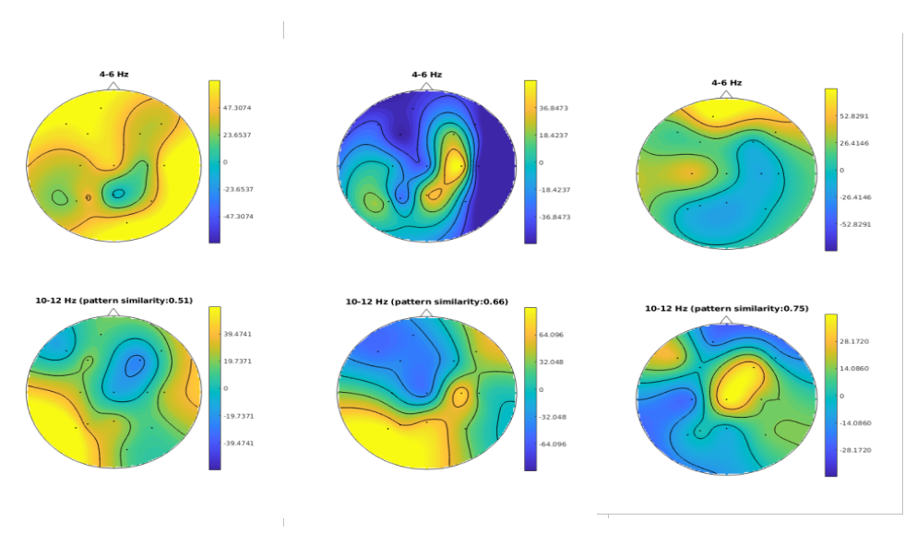

Fig.2 Median spatial patterns for the three conditions. From left to right: direct association (D), latent association (L), non-related stimuli (N). The upper row represents the reference signal in the theta frequency range, the bottom row illustrates the fit signal in the alpha range.
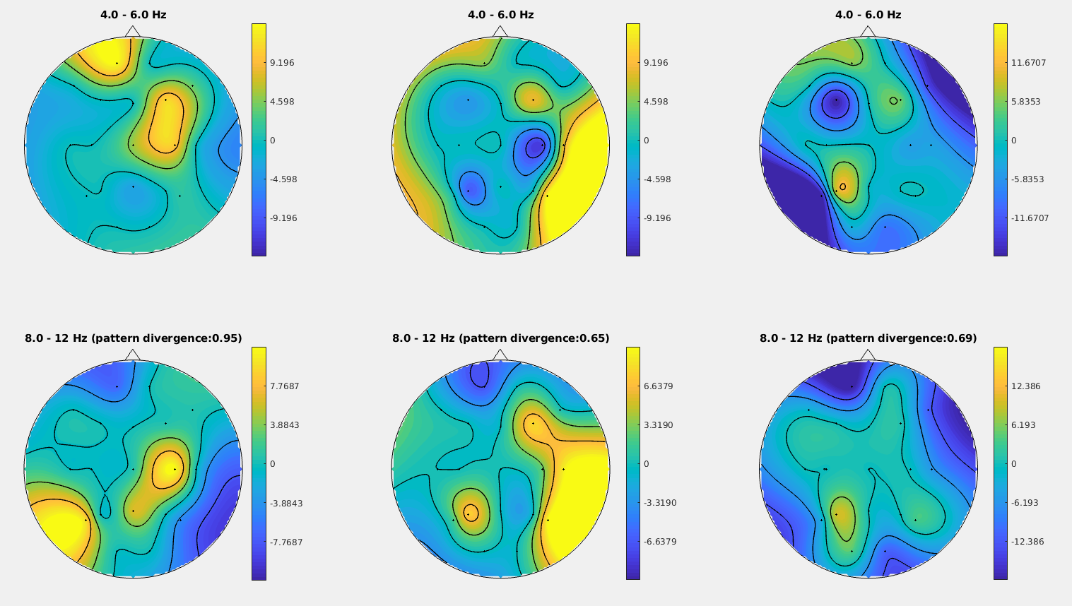

Fig.3 Phase Locking Values for the three conditions. From left to right: direct association (D), latent association (L), non-related stimuli (N).
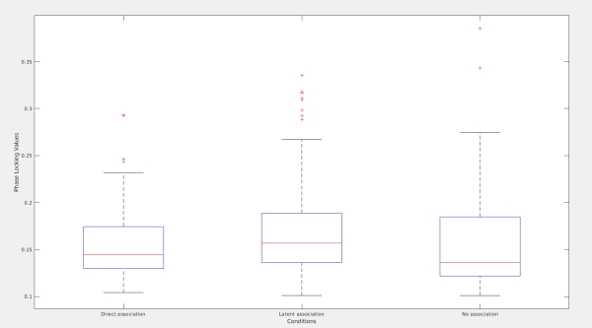

B. Synchronization between signals in the theta and alpha range

The second set of analyses was aimed at the evaluation of the strength of synchronization measured as phase locking values between the reference signal in the theta and the fit signal in the alpha range. Synchronization is observed when a PLV is greater than zero. From

Mean PLVs for the three conditions were: 0.1467 for D, 0.1568 for L, 0.1439 for N condition, respectively, all PLV observations being statistically significant. Less conservative estimate based on the normality of PLV distribution gives us following means and their 95% confidence intervals: for D condition 0.1583+/-0.0085, for L condition 0.1733+/-0.0096, for N condition 0.1609+/-0.0082.
There was no statistically significant correlation between D and N, L and N conditions, respectively. We found a low correlation as of Spearman’s rho = 0.25 between D and L phase locking values.
We found statistically significant differences among the three conditions when applied Friedman’s test to the PLV values: p = 0.0019, significance level of 0.05.
As expected, the range of PLVs varies, depending on the condition. Thus, direct associations yield less range of PLVs that those of latent association and no association conditions. The PLV samples were skewed in the direction of greater values as it can be seen in Fig.3.

IV. DISCUSSION

In the present study, we investigated the role of cross-frequency phase synchrony between networks of faster and slower neuronal oscillations in abstract reasoning. The ability to deduce an abstract relation, which underlies a word group, was tested using three conditions modeling the presence of a general attribute of semantic category (D), the presence of a feature unifying the words (L), the absence of any relationship among the words (N). We expected that phase interactions in EEG signals would differ in three conditions reflecting specific cognitive processes behind abstract reasoning. Therefore, for each condition, we carried out the cross-frequency phase coupling analysis in the theta and alpha (~4-6 Hz and ~8-12 Hz) frequency range over the whole scalp. We restored statistically significant patterns of functional connectivity via the GCFD method [Volk et al., 2018]. We assumed that the obtained functional networks are statistically different and represent each addressed condition related to abstract reasoning. Therefore, we carried out statistical analysis to explore relations between the restored spatial patterns. We found robust statistical differences in the networks associated with the conditions. Lastly, we believed that the strength of synchronization would vary depending on the condition, reflecting a difference in states of abstract reasoning. We found out that the median PLVs for the D and N conditions are approximately equal, whereas the median PLV for L condition condition was slightly higher probably pointing at greater cognitive effort being put into search of latent association. On the whole, the PLVs were typical of those observed in working memory tasks [Kleen JK., 2016].
Overall, median patterns for the three conditions exhibited a relative proximity of D and L patterns which is not surprising as in both cases the participants successfully figured out a relation between representations. Still, the fact that the patterns do not overlap could be an experimental and mathematical confirmation of the assumption that being an exemplar of a taxonomic or thematic category is not the same as being loosely associated by means of a latent feature. Individual patterns present the involvement of the right and left dorsolateral prefrontal cortex (DLPFC), temporal and parietal cortices, as shown in the Supplementary section, plot_names. The findings concerning the PLVs imply that synchronization is more likely to occur when we observe a relation between representations than when we believe there is no association among them.
Functional networks typical of attention, working memory and high cognitive load as mentioned in the literature have been revealed in the median patterns related to all three conditions. We also detected the involvement of the temporal cortex which is referred to operations with semantic knowledge.
The most significant components in the theta range were associated with F4, F3 in the frontal regions as in [Brauns I., 2014] reflecting attentional selection [Abe M, Hanakawa T, 2009]. These findings comply with a broad range of evidence that anterior regions of frontal cortex support rule learning at higher levels of abstraction [Kayser A., D’Esposito M., 2013]. Importantly, lateral frontal cortex and the prefrontal cortex (PFC) is believed to support rules for action and the relevant adaptive behavior [Badre D., Kayser A., D’Esposito M., 2010, Bunge A., 2005, Petrides, 2005]. The involvement of PFC is also considered to express cognitive control subserving the representation of contextual information in the way which allows to affect the selection of action pathways [Badre D., Wagner A., 2006, O'Reilly RC, Frank MJ., 2006]. The engagement of PFC has been reported in perceptual processing under conditions of greater task difficulty [Jiang Y., Kanwisher N., 2003].
Temporal cortex is frequently referred to semantic association [Levy D., Bayley P., and Squire L., 2004, Hodges JR., Graham N., Patterson K., 1995]. In our study we have detected the involvement of T4, T5, T6 channels for the three conditions which is probably indicative of turning to semantic knowledge. The activation peaking at T3 -T4 channels points at the processing of visual stimuli [Bruce C., Desimone R., Gross C., 1981] and motor planning [Balslev D., Nielsen F., Paulson O., 2005].
There have been detected networks connected with comparisons in analogies [Wendelken et al., 2008] and supporting remote searches for associations [Green et al., 2006] in the left Rostrolateral Prefrontal Cortes (RLPFC) [See Supplementary Section, plot_names]. In terms of latent associations the present study has also contributed to the evidence that medial frontal and the left inferior frontal gyri are involved in the searches for non-dominant meanings, as found out in metaphor [Yang, F.G., et al., 2009] and semantic retrieval [Bunge SA. et al., 2005]. Presumably, these regions are domain-independent and manipulate context-dependent information which is extracted from the semantic storage located in the temporal cortex [Messas C., Mansur L., Castro L., 2007].
The averaged topographies over the three conditions, all frequency bases computed for three strongest components [Supplementary section, plot_all] reflect more frontal and temporal activity for D condition, frontal and more articulated parietal activity for L condition. N condition featured patterns typical of both D and L conditions.
The fluctuations of the phase locking values might reflect the phenomenon of insight when participants come up with an idea which integrates the presented words. This explanation could shed light on the differences in the ranges of PLVs. The less clear the general principle underlying the presented stimuli, the greater the variability in suggestions made by participants. The largest variability falls on N condition which reflects futile attempts to figure out a relation underlying completely heterogenous stimuli.
In sum, a prospective approach is presented which helps to integrate various aspects and evidence with regard to the neuroscience of reasoning. We can see that the presented approach is sensitive to subtle differences across types of associations.
Future research can be done into clinical applications of the presented method with regard to thought disorders typical of schizophrenia.

V. AUTHOR CONTRIBUTIONS

Conceived and designed the experiments: MB, OM; performed the experiments: AM, MB, GP; analyzed the data: AM; wrote the paper: AM.

VI. CONFLICT OF INTEREST STATEMENT

The authors declare that the research was carried out in the absence of any conflict of interest.

VII. ACKNOWLEDGMENTS

We thank Onur Can Rende for discussing the experiment and collecting the data.

REFERENCES

Abe M., Hanakawa T. Functional coupling underlying motor and cognitive functions of the dorsal premotor cortex. Behav Brain Res. 2009 Mar 2;198(1):13-23. doi: 10.1016/j.bbr.2008.10.046. Epub 2008 Nov 14.

Alexander, Patricia & Jablansky, Sophie & Singer Trakhman, Lauren & Dumas, Denis. (2016). abstract reasoning: What We Know and Why It Matters. Policy Insights from the Behavioral and Brain Sciences. doi: 3. 10.1177/2372732215622029.

Babiloni C., Brancucci A., Vecchio F., Arendt-Nielsen L., Chen AC., Rossini PM. Anticipation of somatosensory and motor events increases centro-parietal functional coupling: an EEG coherence study. Clin Neurophysiol. 2006 May;117(5):1000-8. Epub 2006 Mar 3.

Badre D., Kayser A., D’Esposito M. Frontal cortex and the discovery of abstract action rules. Neuron. 2010 Apr 29; 66(2): 315–326. doi: 10.1016/j.neuron.2010.03.025.

Badre D, Wagner AD. Computational and neurobiological mechanisms underlying cognitive flexibility. Proc Natl Acad Sci U S A. 2006;103:7186–7191.

Balslev, D., Nielsen, F. A., Paulson, O. B., & Law, I. Right temporoparietal cortex
activation during visuo-proprioceptive conflict. Cerebral Cortex, 15, 166–169, 2005.

Berger B., Omer S., Minarik T., Sterr A., Sauseng P. Interacting Memory Systems—Does EEG Alpha Activity Respond to Semantic Long-Term Memory Access in a Working Memory Task? Biology (Basel), 4(1): 1–16, 2014. doi: 10.3390/biology4010001.

Boonstra T., Powell T., Mehrkanoon S., Breakspear M. Effects of mnemonic load on cortical activity during visual working memory: linking ongoing brain activity with evoked responses. Int J Psychophysiol., 89(3):409-18, 2013. doi: 10.1016/j.ijpsycho.2013.04.001. Epub 2013 Apr 11.

Brauns I., Teixeira S., Velasques B., et al. Changes in the theta band coherence during motor task after hand immobilization. Int Arch Med. 2014; 7: 51. doi: 10.1186/1755-7682-7-51.

Bruce, C., Desimone, R., & Gross, C. G. (1981). Visual properties of neurons in a polysensory area in superior temporal sulcus of the macaque. Journal of Neurophysiology, 46, 369–384.

Bunge S.A., Wallis J., Parker A., Brass M., Crone E., Hoshi E., Sakai K. Neural circuitry underlying rule use in humans and nonhuman primates. J Neurosci. 2005 Nov 9;25(45):10347-50.

Bunge, S.A., Wendelken, C., Badre, D., Wagner, A.D., 2005. Analogical reasoning and prefrontal cortex: evidence for separable retrieval and integration mechanisms. Cereb. Cortex 15, 239–249.

Chaieb L., Leszczynski M., Axmacher N., Höhne M., Elger C., Fell J. Theta-gamma phase-phase coupling during working memory maintenance in the human hippocampus. Cogn Neurosci.,vol. 6, no. 4, pp. 149-57, 2015.

Dumontheil I. Development of abstract thinking during childhood and adolescence: the role of rostrolateral prefrontal cortex. Dev Cogn Neurosci. 2014 Oct;10:57-76. doi: 10.1016/j.dcn.2014.07.009. Epub 2014 Aug 12.

Elqayam, Shira & Over, David. (2013). New paradigm psychology of reasoning: An introduction to the special issue edited by Elqayam, Bonnefon, and Over. Thinking and Reasoning. 19. 249-265. 10.1080/13546783.2013.841591.

Evans AC., Kamber M, Collins DL, MacDonald D. An MRI-based probabilistic atlas of neuroanatomy. In: Shorvon S et al., editors. Magnetic Resonance Scanning and Epilepsy. Plenum: New York; 1994 p. 263–74.

Gärtner, M., Grimm, G., and Malek Bajbouj. Frontal midline theta oscillations during mental arithmetic: effects of stress. Front Behav Neurosci. 2015; 9: 96. doi: 10.3389/fnbeh.2015.00096.

Goel, V., Grafman, J., 1995. Are the frontal lobes implicated in“planning”functions? Interpreting data from the Tower ofHanoi. Neuropsychologia 33, 623–642.

Green, A.E., Fugelsang, J.A., Kraemer, D.J., Shamosh, N.A., Dunbar,K.N., 2006. Frontopolar cortex mediates abstract integration in analogy. Brain Res. 1096, 125–137.

Guetig R. To spike, or when to spike. Current Opinion in Neurobiology, 2014, 25: 134-139. doi:
10.1016/j.conb.2014.01.004.

Hesterberg T., Moore D. S., Monaghan S., Clipson A., Epstein R., McCabe G. P. (2005). Bootstrap methods and permutation tests, in Introduction to the Practice of Statistics, 5th Edn., eds McCabe W. H., Farace P., Ward T., Swearengin D., Donnellan B., editors. (New York, NY: W.H. Freeman & Co.), 1–70.

Hodges JR., Graham N., Patterson K. Charting the progression in semantic dementia: implications for the organisation of semantic memory. Memory. 1995 Sep-Dec;3(3-4):463-95.

Jiang Y., Kanwisher N. Common neural mechanisms for response selection and perceptual processing. J Cogn Neurosci. 2003 Nov 15;15(8):1095-110.

Johannesen J., Bi J., Jiang R., Kenney J., Chen MC. Machine learning identification of EEG features predicting working memory performance in schizophrenia and healthy adults. Neuropsychiatr Electrophysiol. 2016; 2: 3. doi: 10.1186/s40810-016-0017-0

Klimesch, W. (1999). EEG alpha and theta oscillations reflect cognitive and memory performance: a review and analysis. Brain Research Review, 29, 169Ð195.

Kayser A., D’Esposito M. Abstract Rule Learning: The Differential Effects of Lesions in Frontal Cortex. Cereb Cortex. 2013 Jan;23(1):230-40. doi: 10.1093/cercor/bhs013. Epub 2012 Jan 31.

Krawczyk, D.C., Hanten, G., Wilde, E.A., Li, X., et al. Deficits in analogical reasoning in adolescents with traumatic brain injury. Front.Hum. Neurosci. 62, 1–13.

Kleen JK., Testorf Markus E., Roberts David W., et al. Oscillation Phase Locking and Late ERP Components of Intracranial Hippocampal Recordings Correlate to Patient Performance in a Working Memory Task. Front Hum Neurosci. 2016; 10: 287. doi10.3389/fnhum.2016.00287

Levy D., Bayley P., and Squire L. The anatomy of semantic knowledge: Medial vs. lateral temporal lobe. PNAS April 27, 2004 101 (17) 6710-6715; https://doi.org/10.1073/pnas.0401679101.

Luck S. An Introduction to the Event-Related Potential Technique, 2nd Edition. Cambridge: MIT Press. 2014.

Luu P., Tucker D., Makeig S. Frontal midline theta and the error-related negativity: neurophysiological mechanisms of action regulation. Clin Neurophysiol. 2004 Aug;115(8):1821-35.

Messas C., Mansur L., Castro L. Semantic memory impairment in temporal lobe epilepsy associated with hippocampal sclerosis. Epilepsy Behav. 2008 Feb;12(2):311-6. Epub 2007 Dec 21.

Monti, M.M., Osherson, D.N., Martinez, M.J., Parsons, L.M., 2007. Functional neuroanatomy of deductive inference: alanguage-independent distributed network. Neuroimage 37,1005–1016.
Cognitive Therapy for Psychosis: A Formulation-based Approach.

Moritz, SK. Mersmann, M. Kloss, D. Jacobsen, U. Wilke, B. Andresen, D. Naber, K. Pawlik. 'Hyper-priming' in thought-disordered schizophrenic patients. Psychological Medicine, vol. 31, issue 2, 221-229, 2001.

Morrison,A., Renton J., Dunn H. Cognitive Therapy for Psychosis: A Formulation-based Approach. Brunner-Routledge, 2004 - Psychology - 276 pages

Nikolaeva V.V. (2011). B.W. Zeigarnik and Pathopsychology. Psychology in Russia: State of the Art, 4, 176-192.

Nikulin V., Nolte .G, Curio G. A novel method for reliable and fast extraction of neuronal EEG/MEG oscillations on the basis of spatio-spectral decomposition. Neuroimage. 2011 Apr 15;55(4):1528-35. doi: 10.1016/j.neuroimage.2011.01.057. Epub 2011 Jan 27.

Sapp, Marty & Obiakor, Festus & J. Gregas, Amanda & Scholze, Steffanie. (2007). Mahalanobis distance: A multivariate measure of effect in hypnosis research. Sleep and Hypnosis. 9. 67-70.

O'Reilly RC, Frank MJ. Making working memory work: a computational model of learning in the prefrontal cortex and basal ganglia. Neural Comput. 2006 Feb; 18(2):283-328.

Orosz A., Feldon J,. Gal G., Simon A., Cattapan-Ludewig K. “Deficient associative learning in drug-naive first-episode schizophrenia: results obtained using a new visual within-subjects learned irrelevance paradigm”. Behavioral Brain Research, vol. 193, issue 1, pp. 101-107, 2008.

Palva, S., Palva, J. M., Kaila K. Phase Synchrony among Neuronal Oscillations in the Human
Cortex. The Journal of Neuroscience, 2005, 25(15),3962–397. doi:10.1523/JNEUROSCI.4250-
04.2005.

Palva J. M., Palva S. (2011). Functional roles of alpha-band phase synchronization in local and large-scale cortical networks. Front Psychol. 2:204. 10.3389/fpsyg.2011.00204.

Palva M., Palva S. Neuro-Opinion. Functional integration acrossoscillation frequencies by cross-
frequency phase synchronization. Eur J Neurosci. 2018, 48(7):2399-2406. doi: 10.1111/ejn.13767.

Petrides M. Review Lateral prefrontal cortex: architectonic and functional organization. Philos Trans R Soc Lond B Biol Sci. 2005 Apr 29; 360(1456):781-95.

Siebenhühner F., Wang S., Palva M., Palva S. Cross-frequency synchronization connects networks
of fast and slow oscillations during visual working memory maintenance. eLife. 2016; 5: e13451.
doi: 10.7554/eLife.13451.

Sauseng P., Klimesch W. What does phase information of oscillatory brain activity tell us about cognitive processes? Neurosci Biobehav Rev., vol. 32, no. 5, pp. 1001-13, 2008.

Schirrmeister R., J. Springenberg, L. Fiederer, M. Glasstetter, K. Eggensperger, M. Tangermann, F. Hutter, .W. Burgard, T. Ball.“Deep learning with convolutional neural networks for EEG decoding and visualization”. Hum Brain Mapp., vol. 38, no. 11, pp. 5391-5420, 2017.

Wendelken C, Bunge SA, Carter CS. Maintaining structured information: an investigation into functions of parietal and lateral prefrontalcortices. Neuropsychologia 2008; 46: 665–78.

Womelsdorf T., Valiante TA., Sahin NT., Miller KJ., Tiesinga P.. Dynamic circuit motifs
underlying rhythmic gain control. Nature. Neuroscience, 2014, 17(8): 1031-1037.doi:
10.1038/nn.3764

Volk D., Dubinin I., Myasnikova A., Gutkin G., Nikulin V. Generalized Cross-Frequency
Decomposition: A Method for the Extraction of Neuronal Components Coupled at Different
Frequencies. Front. Neuroinform., 2018 doi: 10.3389/fninf.2018.00072.

Yang, F.G., Edens, J., Simpson, C., Krawczyk, D.C., 2009. Differences in task demands influence the hemispheric lateralization and neural correlates of metaphor. Brain Lang. 111, 114–124.

Zeigarnik, B. (1972). Experimental Abnormal Psychology. 10.1007/978-1-4684-7421-3.

