Regional models of the management of knowledge economy development: the problem of measurement and assessment
Elena Tkachenko1, Elena Rogova2, Sergey Bodrunov3

¹Saint Petersburg State University of Economics (St. Petersburg, Russia)
² National Research University Higher School of Economics (Russia)
³Institute for New Industrial Development (St. Petersburg, Russia)

eletkachenko@ya.ru
erogova@hse.ru
inir@inir.ru

Abstract
The article examines to the problems of knowledge economy development governance at a regional level. International experience demonstrates successful examples of knowledge economy development in different regions and cities. But the process is controversial, and there are also the cases that reveal the absence of progress in the development of the knowledge economy. The goal of our study is to review basic models of knowledge economy development, to analyze their evolution and to reveal the dependency of knowledge economy development on the methods and tools of its assessment. The study that we have performed is based upon the series of interviews with managers and regional authorities. It demonstrates that the assessment of knowledge economy’s contribution to a region’s key performance indicators is the major problem for regional policy makers. The above indicators include gross regional product, labour productivity, the level of salaries, and unemployment rate. Apparently, the issue of assessment of the knowledge economy has the fundamental nature.
Keywords: knowledge economy, regional economy, region management methods.
Introduction
The goal of our study is to reveal the most effective models of a regional knowledge economy development. The tasks of the study are to analyze the development of the knowledge economy in St. Petersburg, Moscow and the comparable major cities in the EU, to reveal approaches to knowledge economy management, to determine the problems impeding the development of a knowledge-based economy and to substantiate the expediency of using strategic management in the administration of innovative development on a regional level.
It should be noted that contradistinction of a knowledge economy and a new industrial economy is inappropriate. This contradistinction is based on the controversy concerning the nature of a knowledge economy, which started in economic literature during the 1960s. Key researchers of the knowledge economy (Machlup, 1962, Bell, 1973, Foray, 1999) to some extent considered the knowledge economy as an alternative to industrial development. As practice showed, the modern economy was neo-industrial by nature. We observe the explosive development of the economies of India and China, problems with modernization in the countries of Eastern Europe and Russia and a slowdown in the growth rate of the developed industrial countries, including Germany, France, UK and the USA.
These are mutually complementary and intersecting subsystems of the unified economic model. The effectiveness of this model directly depends on the convergence (mutual penetration) of the knowledge economy and real production sectors.
Methodology
The study relies on general scientific research methods – system-wide approach, comparative analysis, aggregation and classification, as well as methods of logic simulation. The information background of the study involves open source Internet data, administrative information resources of various regions of the world and open source statistical data. The authors also used the data obtained during the studies performed in the Russian regions when making innovation development programmes. Among other things, we conducted semi-structured interviews of policy makers and regional government agencies’ representatives in St. Petersburg, Moscow and Northwest Federal District of the Russian Federation. The interviews were performed repeatedly in 2013 and 2015. The focus group consisted of actors (businessmen and regional authorities) who were interested in issues of regional development. In 2013 the group contained 38 persons and in 2015 it increased to 82 persons. The interviews were aimed at the reveal of respondents’ attitude to the Knowledge Based Development (KBD) at the regional and municipal level. We posed the task to explore the understanding of KBD by the companies’ managers and regional authorities, their evaluation of knowledge economy contribution to the regional economy, the appropriate approaches they may use in KBD governance and their vision of major drivers of successful KBD implementation. In 2013 businessmen have demonstrated the negative attitude to KBD, they reasoned it by the danger of deindustrialization of the industrial regions. They also failed in their assessment of knowledge economy contribution to regional performance. Representatives of regional authorities in 2013 also could not provide with clear vision on knowledge economy and KBD. In 2015 the situation improved – 25.7% of respondents admitted the importance of KBD integration into regional strategies and policies. As to the contribution of knowledge economy and models of governance, these answers demonstrated the unawareness of respondents. These results enhanced our interest to systematisation of KBD governance approaches.
To classify the models and approaches to KBD, we analysed the websites of regional administrations in EU, Asian and North American countries and collected data from regional authorities of five regions of Russia. For the purposes of models identification and classification, we relied at the papers published by Casey. (2003) and Mankiw (2006) who developed a profound analysis of existing concepts, which we developed according to our vision of regional development theories’ evolution.
Five research areas underline regional development concepts: 1) neoclassic theories based on production function; 2) cumulative expansion theories, a composition of neo-Keynesian, institutional and economy-and-geographic models; 3) new regional development theories based on increasing returns to scale and imperfect competition; 4) new forms of territorial organization of production based on industrial and regional clusters, value-added chain, learning economy, and national and regional systems of innovations and; 5) other theories explaining local or individual issues of regional development. Table 1 presents various theoretic backgrounds for regional development.
Table 1. Classification of theoretical approaches to regional development
Theoretic background | Main proponents | Specific characteristics
Neoclassical regional development concept | Menger (1871), Wieser (1884), Boehm-Bawerk, Jevons (1871), Walras, Clark, Marshall (1872), Pigou (1933) | The neoclassical school studies the behaviour of the so-called economical person (a consumer, an entrepreneur or a salaried employee) that strives to maximize his/her income and to minimize their expenses. Limiting values constitute the basic analysis criteria
New neoclassical school | R. Lucas (191), P. Sargent T. J.& Wallace N. (1975) Barro R. (1977) Samuelson P. A.(1948), M. Friedman (1957) | The proponents of this theory analyze the reactions of the economic system acting under the condition that its agents not only have adequate information about the future development of the economy, including the activities of government policies, but also are also able to act rationally, expecting certain changes in economic environment. They believe that macroeconomic policies are usually based on the models, which summarize the nature of economic reactions in the past, that is, past economic behaviour of the agents. They do not take into consideration the future behaviour of those agents, which will be changing depending on their expectations and due to the very activities of the government.
Coincidence, or convergence models | R. Solow (1980) , T. Swan, R. Barro & X. Sala-i-Martin (2003) | Convergence models divide the factors of capital into physical (material) and human (with the exception of Solow and Swan’s model), which enables them to determine the degree of interchangeability of labour and capital, as well as the rate of convergence of the growth rate of regional economies. Moreover, regional economic growth, according to the models, just as in the first model, is determined not by the flow of production agents, but by to what extent they are accumulated.
Innovative economic growth theory | Schumpeter (1939), Nelson (1993), Kuznets (1973), Freeman, Stern, Jaffe (2005) and many others. | A higher rate of innovation is considered an important factor. In accordance with the new growth theory, the generation of knowledge is viewed as an endogenous process, which responds to market stimuli, such as expansion of possibilities for profit generation, development of production agents, e.g., better education for the employees. Information technologies accelerate the process of innovation by making information processing easier and cheaper and shortening the innovation development periods. Evolution of innovation economy is a progressively accelerating process.
Cumulative expansion theories | Perroux (1958), Boudeville (1966), Lasuen (1971) and others | These are theories of the emergence of growth centres and channels of their propagation in the spatial economy, development of agglomerations and central places, diffusion of innovations, development of peripheral territories, constant returns to scale and uneven growth under the conditions of free competition. Based on the above principles, they include growth factors of spatial economy specialization or territorial labour division, transportation expenses, mobility of production agents, the central place and the factors of its evolution, agglomeration of production and the factors of its development, innovation and other novelties and the channels of their expansion, localization related to the immobility of production agents, as well as individual regional peculiarities.
"Growth pole" concept | Higgins (1983) McKee (1987), Kuehn Bender (1969), Lasuen (1971), House (1978), Doloreux, Dionne (2008), and others | A growth pole may be: 1) a regional complex of enterprises involved in regional export (not just related to the leading industry); 2) a system of poles, where each of the poles grows by means of pulses generated by national demand, which are conveyed through the export sector of the region; 3) a growth pulse is conveyed to secondary industries through the market links among enterprises and among geographic peripheries.
Agglomeration theory | Richardson (1973), Rosenthal, Stuart, Strange (2004) Mori, Tomoya, Nishikimi, Smith (2008) and others | The accumulation of production activities in the cities as large industrial centres, a particular kind of growth pole, is the major factor of growth.

The methodology of knowledge economy development governance must focus on the problem of ensuring strategic stability of a region’s social and economic system. What is controlled is the social, economic and natural environment of a region, and the management entity is comprised of government agencies, social organizations, legal entities and physical persons, being the stakeholders of regional development.
Cooke(2006) determined three types of regional innovation-driven development, depending on the regulatory mechanism and governance methods: these are grassroots-based, network-based and dirigiste-based development. The first type is characterised by the low level of administration and high level of freedom, the third one is characterised by the active interrogation of regional authorities in the regional innovation system. The network-based type is combining the advantages and smoothing the drawbacks of the other types. Leydesdorff and Strand (2013) described the three core functions in a knowledge-based economy - economic exchange, novelty production, and regulative control. Yigitcanlar and Velibeyoglu (2008) developed a pentagon prism analysis model that reveals the key factors of the successful regional development - creative, administrative, business, natural, and built environments – and implemented this model to the case of a Knowledge-Based Urban Development (KBUD) policies of Brisbane.
Knight (1966, 1977, 1981, 1982, 1983, 1992) argues that the cities are the leaders in industries and science development, and the specifics of their integration in the system of global economic relations, as well as their orientation at local or global resources define their specialization and competitiveness in local or global context.
The existing knowledge economy indicators

The problem of comparative analysis of the indicators used for the assessment of the level of development was addressed in the works of Bucciarelli et al (2010), Huggins and Izushi (2007), Carrincazeaux, Gaschet and Halkier (2010), Wrona (2014). Russ and Jones(2008) paid special attention to the system of indicators for KBD assessment. They divided indicators according to their functions as follows.
A. Cultural Enablers.
B. Infrastructure.
С. Government and Administrative Infrastructure
D. Art, Quality of Life, Culture, and Leisure Education,
E. Science, Centers of Excellence, R&D
F. Social Environment
G. Natural Resources
H. Renovation Capital.
I. Human Capital
J. Process Capital.
K. Market Capital.
L. Financial Capital
Each group contains several quantitative and qualitative indicators.
Wrona (2014) drew a detailed comparison of the World Bank's techniques called Knowledge Economy Index (KEI) and OECD Indicators for Knowledge-based Economy, which demonstrated the general tendency of substituting the notions in measuring knowledge economy and the level of development of knowledge society. The results are presented in Table 2.

Table 2. The Top 10 countries by the level of economic development and knowledge level as compared to BRIC countries (KEI-2012)
Country/Economy | KEI Rank | KEI | EIR Rank | Economic  Incentive  Regime  Index | Innovation  Rank | Innovation  Index | Education  Rank | Education  Index | ICT Rank | ICT Index
Top 10 countries by KLEI Index
Sweden | 1 | 9.43 | 4 | 9.58 | 2 | 9.74 | 6 | 8.92 | 2 | 9.49
Finland | 2 | 9.33 | 2 | 9.65 | 3 | 9.66 | 11 | 8.77 | 6 | 9.22
Denmark | 3 | 9.16 | 3 | 9.63 | 5 | 9.49 | 15 | 8.63 | 13 | 8.88
the Netherlands | 4 | 9.11 | 19 | 8.79 | 7 | 9.46 | 12 | 8.75 | 5 | 9.45
Norway | 5 | 9.11 | 8 | 9.47 | 17 | 9.01 | 3 | 9.43 | 17 | 8.53
New Zealand | 6 | 8.97 | 14 | 9.09 | 22 | 8.66 | 1 | 9.81 | 23 | 8.3
Canada | 7 | 8.92 | 7 | 9.52 | 10 | 9.32 | 16 | 8.61 | 24 | 8.23
Germany | 8 | 8.9 | 13 | 9.1 | 12 | 9.11 | 23 | 8.2 | 8 | 9.17
Australia | 9 | 8.88 | 23 | 8.56 | 19 | 8.92 | 2 | 9.71 | 22 | 8.32
Switzerland | 10 | 8.87 | 6 | 9.54 | 1 | 9.86 | 41 | 6.9 | 7 | 9.2
BRIC
Brazil | 60 | 5.58 | 82 | 4.17 | 51 | 6.31 | 61 | 5.61 | 58 | 6.24
the Russian Federation | 55 | 5.78 | 117 | 2.23 | 40 | 6.93 | 44 | 6.79 | 44 | 7.16
India | 110 | 3.06 | 99 | 3.57 | 76 | 4.5 | 111 | 2.26 | 122 | 1.9
China | 84 | 4.37 | 97 | 3.79 | 54 | 5.99 | 95 | 3.93 | 94 | 3.79
Source: www.worldbank.org/kam.
As may be evident from the structure of knowledge economy indicators, the economy of the Russian Federation is 55th in the KEI rating due to the low level of development of institutions that form a favourable background for the growth of the knowledge economy. Nevertheless, for policy makers the link between a country's rating of favourable economic regime and the quality of life in the region is not always evident. As it was demonstrated in the interviews we conducted, government officials think in concrete categories reflected by GRP growth rate, resident earnings growth rate, industrial production index, regional unemployment level and producer and consumer sentiment indices. A large number of different indicators included in the calculation of KEI rating dilutes the dependency of the significant factors on conditions ensuring the regional development of conditions. This substitution of notions presents a crucial disincentive to regional authorities. Our studies conducted in the Russian regions (St Petersburg, Moscow, Northwest Federal District) indicate that a motivating function of the indicators determined in accordance with WB or OECD methodology is very weak. The Russian regional policy makers acting in compliance with general Federal directives take into consideration the indicators characterizing Economic Incentive and Institutional Regime (EIR), Innovation and Technological Adoption, Education and Training, Information and Communications Technologies (ICT) in consideration, but they do not regard these parameters as important when making managerial decisions. The analysis we performed revealed that the representatives of the Russian regional government agencies do not perceive the dependence of region economic development level on knowledge economy development and do not understand how to assess the contribution of the knowledge economy to the economic development of a region. At that the same time, for policy makers determination of the actual share of knowledge economy in terms of regional economy theory is of essential importance. As the data posted on the web-sites of regional government agencies of the UK shows (Northern Ireland, Liverpool region, etc.), this issue is no less important for the British policy makers than it is for their Russian counterparts. For this reason, the British policy makers base their decision-making on a specific list of industries and services that shape the sectors of economies, which are conventionally referred to as the knowledge-based economy.
In terms of content, the industries included in the knowledge economy are informational infrastructure, science and scientific services, education, creative industry, including design and engineering, after-sale service, as well as medium-tech and high-tech sectors of material production, including manufacturing and construction industries and agriculture. The analysis of the knowledge economy must involve a set of indicators characterizing the transformational changes in the real sector brought about by the correlation between high-tech operations and traditional industry. It should be noted that traditional industries may become high-tech industries due to the influence of penetration of the principles of intellectual asset development and management, which are the basis of the operation of the knowledge economy. Reciprocal influence and penetration of the knowledge economy and real economy should generate multi-level multiplier effects driven by the feedback between the sectors creating new knowledge and the sectors for their practical application. Understanding this dependency determines the choice of regional model of management of innovation processes, which shape the knowledge economy.

The existing regional models of knowledge economy management
We performed the analysis of development rates of the knowledge economy in a number of European regions (Northern Ireland and Liverpool region, Sweden regions, France regions), Asian regions and regions of Russian Federation. We identified four basic regional models of knowledge economy management
- The “Top-down” model is oriented towards types of a state administration system based on rigid vertical integration of all branches of government. Under these conditions, direct intervention of government in the process of economic development is deemed acceptable (fig.1.)
Figure 1. The Top-down model of regional knowledge economy management
2) A Programme-based model of development management is considered the most widespread in the countries with market economies that use economic mechanisms to promote economic development (fig.2) This model uses special programs for the solution of problems of regional development. Programs are also widespread in practice of governance of the EU. Every program includes the objectives of development, concrete periods of validity, a set of actions and financial sources.
3) A Strategic management model using the Balanced Scorecard concept in regional management and KPI. BSC-model should convert the specific activities and strategy to fairly full set of indicators, which in fact form a system of strategic control and management. Аccording to many researchers (Kloot, Martin, 2000; Heng, Othman, Rasli and Iqbal, 2012; Ioppolo, Saija and Salomone, 2012; Matei, Enescu, 2013; Ferreira da Cruz, Marques, 2014; Speklé, Verbeeten, 2014; Tkachenko, Bodrunov, 2014 etc.) adaptations of the Kaplan-Norton's model are the most promising for regional administration (fig.3)
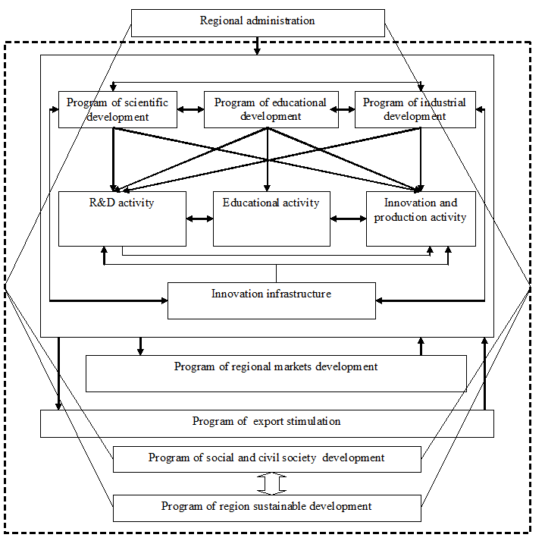
Figure 2. The Programme-based model of regional knowledge economy management
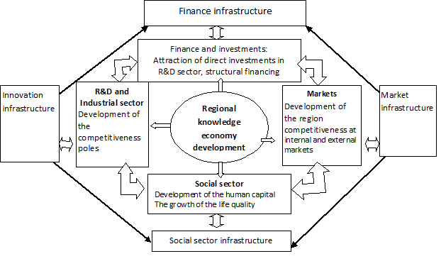
Figure 3. The BSC model of regional knowledge economy management

4) The Ecosystem model is oriented towards the creation of services promoting the growth and development of the knowledge economy (fig.4)
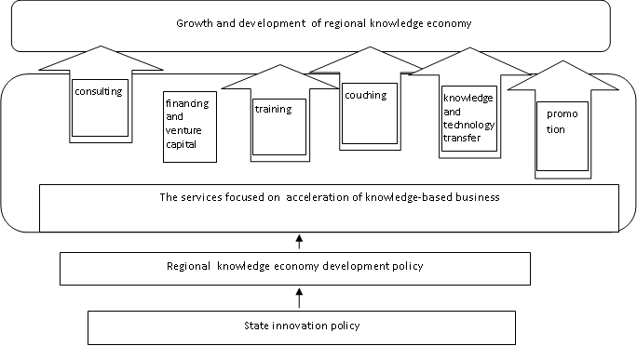
Figure 4. The Ecosystem model of regional knowledge economy management
The Ecosystem model is the most effective model, as illustrated by the example of Singapore. The result of functioning of this model may be presented in the form of a multiplier (fig.5):
Figure 5. Innovative multiplier effect model

A multiplication effect is achieved though the accumulation of knowledge flowing from its generators and the transformation of the generated knowledge into the implementation of social and economic innovations. At the same time, the accumulation starts from less mature phases of innovation process development (in relation to their scaling capacity, which results in the largest GRP or added value growth from the perspective of an economic sector) and comes up to more mature phases.
Let us review the formation of the proposed multiplier using the example of management of the innovation process in industry.
At the first stage, the scale of multiplier effect is determined, expressed in the intensity of flows of the assimilated applied scientific products or those ready for assimilation, for the estimated levels of industrial growth.
The expedient scale of multiplier effect lies in the range between its minimal permissible value providing the existing rate of development and maximum possible value determined by the required rate of industry operation, the required scale of multiplier effect.
The second stage implies the structuring of the multiplier life cycle according to the following phases:
a) generation of new knowledge to replenish the applied scientific reserve;
b) evolution of a multiplier effect to achieve the required scale;
c) maintenance of the ongoing industrial development rate.
The solution of this problem is promoted by the establishment within the stage (a) of a dedicated fund of liquid knowledge-intensive innovations. It is also advisable to develop an adequate system of diversification of innovations. Thus, despite the existing complications in the reorganization of the Russian economy, it is preferable to focus, in line with its geopolitical status, as well as resource, scientific and production potential, on general scientific and technical development, not only on individual development directions prioritized at a given moment.

Conclusion
The logical modelling of the knowledge economy management process in the regions enabled us to reveal basic models of knowledge economy management. The “top-down” model has the lowest ranking among the knowledge economy management models in terms of its effectiveness. The programme-based approach, being the result of the evolution of the “top-down” model, may bear the expected results only under the condition that control and motivation systems are available. The internal mechanism of reproduction of the innovation process, as well as knowledge generation and use, are inherent in this model. Practical application of the BSC model is impeded by its complexity. As practical cases demonstrate, the application of this model is reduced to a number of key performance indicators based on the monitoring of implementation of targeted programmes. The Ecosystem approach is the most effective one, in which the main function of regional governments is the creation and promotion the development of the necessary services, providing the growth of the knowledge economy. During our subsequent studies, we plan to perform a mathematical simulation of the dependency of knowledge economy development in a region on the selected model of management based on the calculation of the multiplier effect.

References
Armstrong, K. (2006). The open method of coordination–governance after Lisbon, Journal of Contemporary European Research, Vol. 2, issue 1, p.1–104.
Barro R. (1977) Unanticipated Money Growth and Unemployment in the United States // American Economic Review. 1977. Vol. 67, No 2. P. 101 - 115.
Barro R. J. (1984) Macroeconomics. N. Y.: Wiley, 1984.
Barro, Robert J. "Economic Growth in a Cross Section of Countries." Quarterly Journal of Economics, May 1991, 106(2), pp. 407- 43.
Boudeville J (1966). Problems of Regional Economic Planning. Edinburg, 1966. рp. 11.
Bucciarelli E., Ciommi M., Giulioni G., and Affortunato F. (2010) Assessing local knowledge dynamics: Regional Knowledge Economy Indicators, International Journal of Social, Behavioral, Educational, Economic, Business and Industrial Engineering Vol:4, No:7, 2010
Buiter W. (1991) The Role of Economic Policy After the New Classical Macroeconomics (Macroeconomic Analysis: essays in macroeconomics and econometrics) / Ed. by D. Currie, R. Nobay, D. Peel. L., 1981.
Lucas R.E., Sargent Т.T. After Keynsian Macroeconomics. In: Rational Expectations and Econometric Practice. L., 1991.
Carlton, Dennis W., and Perloff Jeffrey M. ( 2000.) Modern industrial organization. Reading, MA: Addison-Wesley.
Carrincazeaux, C., Gaschet, F., & Halkier, H. (2010). Knowledge and Regional Diversity: Quantitative Trends. In H. Halkier, M. Dahlström, L. James, J. Manniche, & L. S. Olsen (Eds.), Knowledge Dynamics, Regional Development and Public Policy. (pp. 39-46). Department of History, International and Social Studies, Aalborg University, 2010
Casey J. (2003) Dawkins Regional Development Theory: Conceptual Foundations, Classic Works, and Recent Developments Journal of Planning Literature,Vol.18,No.2(November2003). DOI: 10.1177/0885412203254706
Cruz da N.F., Marques R.C.(2014) Scorecards for sustainable local governments Cities, Volume 39, August 2014, Pages 165-170.
Dang, D., Umemoto, K. (2009). Modeling the development toward the knowledge economy: a national capability approach. Journal of Knowledge Management, Vol. 13, issue 5, p. 359–372.
Del Monte A., Papagni E. (2001), Public expenditure, corruption, and economic growth: the case of Italy, European Journal of Political Economy, Volume 17, Issue 1, March 2001, pp. 1–16.
Doloreux D., Dionne S. (2008), Is regional innovation system development possible in peripheral regions? Some evidence from the case of La Pocatiére, Canada, Entrepreneurship & Regional Development, 20, MAY, 259–283.
Fischer, S.; Gran, S.; Hacker, B.; Jakobi, A. P.; Petzold, S.; Pusch, T.; Steinberg, P. (2010). “Europe 2020” – Proposals for the Post-Lisbon Strategy. Friedrich Ebert Stiftung. Available from Internet: http://www.fes.de/ipa
Friedman M. (1957) A Theory of the Consumption Function. Princeton: Princeton University Press, 1957.
Hansen N. (1990), Innovative regional milieu, small firms, and regional development: evidence from Mediterranean France, The Annals of Regional Science, Springer-Verlag. 13. Heijman W. (2009), Modern Location Theory of the Firm [w;] Space and Economics, Wageningen, the Netherlands.
Higgins B. (1983), From Growth Poles to Systems of Interactions in Space, Growth and Change, 14: pp. 3–13.
House J.W. (1978), France: an applied geography, Londyn
Huggins R. and Izushi H (2007) Bank of Valletta Review, No. 35, Spring 2007
Ioppolo G., Saija G., Salomone R (2012). Developing a Territory Balanced Scorecard approach to manage projects for local development: Two case studies/ Land Use Policy, Volume 29, Issue 3, July 2012, Pages 629-640.
Jaffe Adam B., Lerner J., Stern S. (2005) Innovation Policy and the Economy”, Volume 5, National Bureau of Economic Research. – Cambridge, Massachusetts: The MIT Press, 2005. – 186 с
Kaplan R.S., Norton D.P. (1992)The Balanced Scorecard – Measures then drive Performance // Harvard Business Review. – 1992. – Vol. 70. – N 1. – P. 71-79. Foray D.(1999) CRIS, a cost or an investment? Models of innovation in the information age //CRIS 98 Conference. – Luxembourg, 1999
Krugman P. (2000) How Complicated Does the Model Have to Be? // Oxford Review of Economic Policy. 2000. Vol. 16, No 4. P. 33 - 42.
Kuehn J.A., Bender L.D. (1969), An empirical identification of growth center, Land Economics, 1969.
Kuznets S. (1973) Modern Economic Growth: Findings and Reflections. American Economic Review // American Economic Association. – 1973. – Vol. 63 (3). – Р. 247-258.
Lasuen J. (1971) On growth poles. «Urban Studies», June, 1969. рp. 2. Hoover E. An Introduction to Regional Economics. N. Y., 1971. рp. 26-49.
Leydesdorff, L. (2004). The university–industry knowledge relationship: Analysing patents and the science base of technologies, Journal of the American Society for Information Science and Technology 55(11): 991–1001.
Lucas R.E., Sargent Т.T. (1991) After Keynsian Macroeconomics. In: Rational Expectations and Econometric Practice. L., 1991. P. 301.
Machlup F. (1962) The Production and Distribution of Knowledge in the United States. - Princeton University Press, 1962
Mandel E. (1980). Long Waves of Capitalist Devolopment. Cambridge.
Mankiw N. (2006) Gregory The Macroeconomist as Scientist and Engineer NBER Working Paper No. 12349 June 2006
Marshall, A. [1872] 1925. Mr Jevons’ Theory of Political Economy. In Pigou 1925a. . [1876] 1925. Mr Mill’s Theory of Value. In Pigou 1925a. . [1879] 1975. The Pure Theory of Domestic Values. In vol. 2 of Whitaker
McKee D.L. (1987), On Services and Growth Poles in Advanced Economies, The Service Industries Journal, Vol. 7, No. 2, April 1987, pp. 165–75.
Menger. K. (1871) Grundsatze der Volkswirtschaftslehre. Wien, 1871. Ch. III.
Mensch G. (1979) Das technologische Patt. Innovationen überwinden die Depression. Frankfurta.M.: Umschau-Verl. 1975. Engl. Ausg.: Stalemate in Technology. – Cambridge: Ballinger, 1979
Mori, Tomoya, Koji Nishikimi, and Tony E. Smith (2008). “The Number-Average Size rule: A new empirical relationship between industrial location and city size.” Journal of Regional Science 48(1), 165–211
Pigou, . 1933. The Economics of Stationary States. London: Macmillan
Population Redistribution and Economic Growth: United States, 1870-1950, 1957-1964, Regional Policy; Readings in Theory and Applications / Ed. By Friedman J., and Alonso W. – Cambridge, London, 1975
Richardson Н. (1973) Regional Growth Theory. London, 1973.
Rosenthal, Stuart S., and William C. Strange (2004). “Evidence on the Nature and Sources of Agglomeration Economies”. In: J. Vernon Henderson, and Jacques-François Thisse (Eds.) Handbook of Regional and Urban Economics, vol. 1, Elsevier: North-Holland, pp. 2119–2171
Sala-i-Martin, X.; Barro, R. J. (2003). Economic growth (2nd ed.). Massachusetts .
Samuelson P. A.(1948) Economics: An Introductory Analysis. N. Y.: McGraw-Hill, 1948
Sargent T. J., Wallace N. (1975) Rational Expectations, the Optimal Monetary Instrument, and the Optimal Money Supply Rule // Journal of Political Economy. 1975. Vol. 83, No 2. P. 241 - 254.
Schonberg's Handbuch der pol. Okonomie. Ed. 2. S. 156-173.
Solow R. M. (1980) On Theories of Unemployment // American Economic Review. 1980. Vol. 70, No 1. P. 1 - 11.
Tkachenko E. Bodrunov S. (2014) Development of the Knowledge Economy and Regional Innovation Policy: Russian Practice. The Proceedings of the 15th European Conference on Knowledge Management ECKM 2014, The Santarém School of Management and Technology Polytechnic Institute of Santarém, Santarém, Portugal 4‐5 September 2014. Volume Three. p.964-974
Wieser. F (1884)Ursprung und Hauptgesetze des wirtschaftlichen Wertes. Wien, 1884.
Wrona K. (2014) Towards regional knowledge-based economies: did Structural Funds matter? A comparative case study of the English West Midlands and Polish Silesia. Aston Centre for Europe, Aston University, Birmingham, UK
А Knowledge Economy Index (KEI) 2012 Rankings [ www.worldbank.org/kam.]
Cooke P. (2006) “Public Goods for Economic Development”, UNIDO, Vienna, 2006
Knight R.V. (1992). The Future of European Cities: The Role of Science and Technology. Part IV Cities as Loci of Knowledge-based Development, FAST report FOP 379, Brussels, August, 1992.
Knight, R.V. (1966). Manpower and the Growth of Producer Services, New York: Columbia University Press.
Knight, R.V. (1977). Cleveland Economy in Transition: Implications for the Future, July 1977.
Knight, R.V. (1981). The Region's Economy: Transition to What? Regional Development Program, Cleveland State University.
Knight, R.V. (1982). Cities in the 21st Century, co-editor with Gary Gappert, Vol. 23, Urban Affairs Annual Review: Sage Publications, 1982.
Knight, R.V. (1983). Rethinking Urban Policy: Urban Development in an Advanced Economy Committee on National Urban Policy, National Research Council, Washington, DC.: National Academy Press.
Loet Leydesdorff a & Øivind Strand (2013) The Swedish System of Innovation: Regional Synergies in a Knowledge-Based Economy Journal of the American Society for Information Science and Technology
Yigitcanlar, T. and Velibeyoglu, K.(2008) Knowledge-Based Urban Development: The Local Economic Development Path of Brisbane, Australia. Local Economy 23(3):pp. 195-207.
Russ M. and Jones J.K.(2008) Regional Economic Development Indicators for a Knowledge-Based Economy with Knowledge Deprivation (PDF Download Available). Available from: https://www.researchgate.net/publication/268285927_Regional_Economic_Development_Indicators_for_a_Knowledge-Based_Economy_with_Knowledge_Deprivation [accessed May 28, 2016].

