European Monetary Union Bond Market Dynamics: Pre & Post Crisis

A B S T R A C T Despite the wide range of alternatives that have been proposed by academics and practitioners, the Sharpe ratio remains one of the most popular metrics used to evaluate investment performance. In the proposed research, risks and returns are analysed on the European Monetary Union bonds market, with different bonds ratings and maturities, during the period from 2005 to 2017. The past and current trends and patterns in bond returns are defined using the methods of statistic, correlation and econometric analysis. It was shown that the bond returns are not normally distributed, and that the return distribution depends on bond maturity and the economic situation in the market. The relation between volatility and bond maturity and the Sharpe ratio appeared to be non-linear and not consistent over time. However, the hypothesis about the inverse relation between the Sharpe ratio and bond maturity is not supported by the evidence. Finally, with the help of time-series models it was proven that in the period 2005–2017, the returns on European Monetary Union bonds market tend to decline over time. We used ARIMA models for analysis of the residuals from the bond returns.

Keywords: Sharpe ratio, risks, returns, bond market, European Monetary Union.

JEL Classification: G23 G24

1. Introduction
Currently more and more people take an interest in financial markets, in particular, in investing funds into different securities and financial assets. Therefore, studying the composition and particular features of risks and returns in the bond market – the biggest among all financial markets – is still of high importance although this topic has been widely researched in the last decades. The deep statistic and econometric analysis allows defining and explaining current tendencies in bond returns and identifying past trends and patterns.
Sharpe’s seminal work (Sharpe, 1994) is well known for the development of the idea to analyse the relation between excess return and risk of an asset. Simplicity and ease of the interpretation are the main strengths of the Sharpe ratio. Empirical studies suggest that the use of the Sharpe ratio is appropriate only in case of normally distributed returns. Despite this criticism from the theoretical point of view, the Sharpe ratio is still widely used by practitioners and remains one of the most popular metrics used to rank and compare different types of investments.
The measurement of performance is the cornerstone of the investment evaluation. Since the development of the modern finance theory, this task has been performed within the risk-return approach. The original and the most widely known measure of this kind is the Sharpe ratio presented by Sharpe (1966). The Sharpe coefficient is considered as the first attempt to estimate and predict the asset performance using the capital asset theory and historical financial information from the market. The Sharpe ratio is defined as the mean return in excess of a risk-free rate over the standard deviation from the mean. The calculation and further interpretation of the Sharpe index rest on the hypothesis that returns from financial assets are normally distributed and that an investor’s utility function depends only on expected return and its variance (Lamm, 2003). Simplicity and ease of the interpretation are the main strengths of the Sharpe ratio.
Maller et al. (2010) stress an important distinction between the use of the Sharpe ratio for the ex-ante analysis and the ex-post evaluation of the asset performance. The Sharpe index plays a crucial but quite different role in both situations. On the one hand, the maximum Sharpe ratio characterizes the best and targeted return-risk combination ex-ante because while calculating the maximum Sharpe ratio an investor optimizes the relation between risk and return among the large number of available risky assets. On the other hand, estimating the Sharpe ratio in the moment of the ex-post investment assessment, an investor only adjusts the obtained returns for the risk that has been taken.
Initially, the Sharpe ratio has been proposed as a universal measure for the asset performance evaluation that can be adapted for any investor with specific preferences or any financial asset. However, this proposition has been criticised a lot. The number of studies argues that the use of the Sharpe ratio seems to be restricted and the accurate values can be calculated only in a small number of situations. Cogneau and Hubner (2009) indicate that the Sharpe ratio is an absolute measure used mostly as a ranking criterion that does not refer to a benchmark. Geman and Kharoubi (2003) demonstrate that the choice of a risk-free rate affects considerably the value of the Sharpe coefficient and, therefore, the important assumption about equal risk-free rate for borrowing and lending must be held. Bodie et al. (2005) explain that the Sharpe ratio is only suitable for investors who invest all their funds in just one asset because, according to its definition, the Sharpe ratio captures only total market risk. In case of aggregation of several risky assets, the consolidation of Sharpe ratios is not straightforward because of the covariance effects between volatilities. Taking the previously into account, the Sharpe ratio may not be appropriate for an investor who splits the risky assets.
However, the most contradictory issue concerning the Sharpe ratio that induces the wide discussion among academicians & practitioners lies in the notion of risk. The Sharpe index assumes that the standard deviation of the return distribution provides the full description of risk (Schmidhuber and Moix, 2001). According to Campbell et al. (2001), standard deviation as a measure for risk implies that an investor weights the probability of obtaining positive and negative returns equally, but agents often treat losses and gains asymmetrically. Bacmann and Scholz (2003) agree that risk averse investors seem to strongly dislike losses and prefer to partly sacrifice positive returns in order to avoid negative ones. Generally speaking, that is consistent with the notion of behavioural theory that people attach different values to monetarily equal losses and gains when making decisions under risk (Kahneman and Tversky, 1979). In such case of asymmetric return distribution, the use of standard risk and performance measures may lead to the underestimated risk and the overestimated performance, and, therefore, to the inefficient strategy for optimising return per unit of risk (Lamm, 2003).
In addition, Joro and Na (2006) and Farinelli et al. (2008) summarize that many empirical studies deal with financial return series following non-normal distributions with skewness and kurtosis are pervasive. As expected, hedge funds and other alternative investments are especially prone to generating asymmetric returns, but with a development of financial markets, the returns on other financial assets become the subject of asymmetry, as well.
The majority of empirical studies suggest that the use of the Sharpe ratio is appropriate only in case of normally distributed returns, but financial series having a non-normal return distribution cannot be adequately evaluated using the classical Sharpe ratio (see, for instance, Bacmann and Pache, 2003; Auer, 2015). Bearing in mind this, researchers have come to the point of a need to develop alternative risk measures and incorporate other statistical properties of distribution in the analysis of asset performance.
Ang and Chua (1979) first suggest using the semi-variance which considers only the returns lower than the mean as a substitute for the standard deviation. Sortino and Van der Meer (1991) argue that the semi-variance (and semi-standard deviation) take into account only positive values for returns below the target return and they are, therefore, sensitive to both skewness and kurtosis in the data. Based on their idea, the Sortino ratio, where the standard deviation is replaced with the downside deviation, has been advocated in order to capture the asymmetry of the return distribution (Sortino and Price, 1994). Introduction of a power index permits to account for the investor’s degree of risk aversion.
Vinod and Morey (2001) introduce the double Sharpe ratio, computed as the quotient of the Sharpe ratio estimate to its standard deviation. Lo (2002) suggests to adapt the Sharpe ratio to autocorrelation with a bias corrector. Mahdavi (2004) defines an adjusted Sharpe ratio (ASR) to evaluate assets whose return distributions are not normal. His approach is to transform the real return distribution in order to match it with the distribution of the benchmark returns. Israelsen (2005, 2009) proposes the modified Sharpe ratio in which he exponentiates the denominator with the excess return divided by its absolute value. Watanabe (2006) also considers the third and fourth central moments of a return distribution, but in a simpler form: he develops the Sortino plus skewness/kurtosis ratio as well as the Sharpe plus skewness/kurtosis ratio. Other authors (Zakamouline and Koekebakker, 2008; Campbell et al. 2001; Bacmann and Scholz, 2003; Harvey and Siddique, 2000; Pilotte and Sterbenz, 2006) examine the adjusted for skewness Sharpe ratio and the adjusted for skewness and kurtosis Sharpe ratio.
In contrast, it was proposed to use the value-at-risk (VaR) as a risk indicator. The latest research combines the VaR approach with basic propositions of the portfolio theory and the capital asset model. Kourtis (2016) develops a new portfolio selection model which allocates financial assets by maximizing expected return constrained to the maximum expected loss and VaR limits. He finds the evidence that non-normalities and alternative risk specifications have a great impact on the portfolio selection decision. Bodnar and Zabolotsky (2017) construct an optimal portfolio which minimizes the VaR and, at the same time, coincides with the Sharpe portfolio. They investigate the properties of the optimal portfolio in the sense of maximizing the Sharpe ratio.
Despite the criticism from the theoretical point of view, the Sharpe ratio is still widely used by practitioners. The Sharpe ratio might be considered superior to other performance measures for the following reasons:
- Modigliani, F. and Modigliani, L. (1997) state that the Sharpe ratio is the best-known performance measure in the investment industry.
- The majority of hedge funds, agencies and individual investors use the mean-variance approach in analysing the trade-off between risk and return (see, for instance, Leland, 1999; Amenc et al., 2003; Sharpe, 2007).
- The Sharpe ratio is also reported by financial information providers, such as Morningstar and Yahoo Finance.
- It provides a convenient summary of risk and return of any investment strategy (Sharpe, 1994) and is probably the best understood performance measure because it is simple to calculate compared to other more complex performance metrics and easily communicated even to non-professionals (Lo, 2002).
- A wide range of statistical tests is available for the Sharpe ratio, which is not the case for the other performance measures (Memmel, 2003). Moreover, the Sharpe ratio has been the subject of much research and, thus, its strengths and weaknesses are well known in theory and practice.

We used wide range of measures and ratios used to evaluate the performance of individual financial assets or a portfolio; the majority of them belong to the risk-return approach. This research is aimed to analyse the risks and returns on the EMU (European Monetary Union) bonds market issued by the European Central Bank during the period 2005-2017. The aim is to define and explain current tendencies in bond returns, to make recommendations about investing in EMU bonds, to identify past trends and patterns on bond returns, and to determine the best model describing stochastic processes in returns. One of the new challenges is the monetary policy unification and creation of the EMU that is currently the basis for huge discussion among economists (Grubisic et al., 2011). For these reasons, the empirical analysis of the euro-area financial markets could reveal new tendencies and patterns in European government securities and bring some interesting results.
In line with the main research aim, the following subsidiary objectives are set: (i) to compute the summary statistics of bond returns, (ii) to analyse graphically the dynamics of bond yields and their volatility, (iii) to conduct the correlation analysis, (iv) to calculate the Sharpe ratios for the bonds with different maturities and rank the investment opportunities, (v) to compare the performance of the EMU bonds with different credit ratings, (vi) to estimate the time trend in bond returns.
Within the framework of this research, we implemented the statistic, correlation and econometric analysis to test several hypotheses about normality of the return distributions and the relations between volatility, term-to-maturity and the Sharpe ratio of the EMU bonds. The dataset contains the monthly statistics on bond yields (the bond maturity varies from three months to 30 years). The whole sample contains 3432 observations. The research findings are important to analyze and demonstrate the risks and return opportunities on the money and bond market of European Monetary Union.
This research relies heavily on previous studies that confirm the relevance of the Sharpe ratio use and argue that the simplicity and the exemplariness of the Sharpe ratio are more valuable than the possible measurement errors while estimating the asset performance. Additionally, since EMU bonds are the subject of the analysis, the Sharpe ratio is considered as the appropriate measure for the risk-return trade-off because bonds seem to be the least volatile financial asset and tend to generate returns whose distribution is more closer closer to the normal distribution.

2. Material and methods

In this research, we analysed the risks and returns on the EMU bonds issued by the Central Bank of Europe Union (ECB). We formulated the following hypotheses within the framework of this research:
H1: The returns on EMU bonds are normally distributed.
H2: The volatility of EMU bonds increase with maturity.
H3: The Sharpe ratio for bonds is not consistent over time.
H4: Between the Sharpe ratio and bonds’ maturity exist an inverse relation.
H5: The returns on EMU bonds of all maturity tend to decline over time.
The Jarque-Bera test is applied in order to test the return distribution for normality. The null hypothesis of the Jarque-Bera test is a joint hypothesis of the skewness being zero and the excess kurtosis being zero (Jarque and Bera, 1987). While not rejecting the null, one may conclude the financial series has a normal distribution with skewness and excess kurtosis equal zero.
In the econometric analysis it is necessary first to identify the global trend in bond returns following the common regression equation (1):

${yield}_{t}=α+β×time+ u_{t}$, (1)

Where ${yield}_{t}-$ the observed bond yield, $time-$ the indicator of a time period in years, $u_{t}-$ a stochastic component.
To determine the behaviour of the stochastic component, time-series models of class ARIMA are estimated (Brockwell and Davis, 1996). Differencing, autoregressive and moving average components make up a non-seasonal ARIMA model which can be expressed as a linear equation:

$u_{t}= γ+ φ_{1}u_{d, t-1}+ …+ φ_{p}u_{d, t-p}+ θ_{1}ε_{ t-1}+ …+ θ_{q}ε_{t-q}+ ε_{t}$, (2)

Where $u_{t}-$ estimated values of the stochastic component from the regression (1), p and q – number of lags, $u_{d, t-1},…,u_{d, t-p}-$ lagged values of the stochastic component differentiated d times, $ε_{t}-$ an error component, $ε_{t-q},…,ε_{t-1}-$ lagged values of the error component.
Before the estimation it is required to test the time series for the presence of a unit root or, in other words, for stationarity. Two tests are suggested by the literature: augmented Dickey-Fuller (ADF) test and Kwiatkowski–Phillips–Schmidt–Shin (KPSS) test (Kwiatkowski et al., 1992; Fuller, 1996).
Additionally, it is advisable to calculate and plot the autocorrelation function (ACF) and the partial ACF (PACF) in order to determine the appropriate lags p and q in AR (p) and MA (q) components of an extended ARIMA (p, d, q) model. Autocorrelation characterizes the similarity between observations as a function of the time lag between them. Partial autocorrelation gives the partial correlation of a time series with its own lagged values, controlling for the values of the time series at all shorter lags. The algorithm for estimating the ACF and PACF is introduced by Box, Jenkins and Reinsel (2008) and Brockwell and Davis (2009). General formulas for calculations of the ACF and PACF of order k are presented below in equations (3) – (5):

$ACF\left(1\right)= PACF\left(1\right)= corr(y_{t}, y_{t-1})$ (3)
$ACF\left(k\right)= corr(y_{t}, y_{t-k})$ (4)
$PACF\left(k\right)= corr\left(y_{t}- P_{t, k}(y_{t}\right), y_{t}- P_{t, k}(y_{t-k}))$, (5)

Where $P_{t, k}\left(y\right)-$the projection of the argument $y$ onto the space spanned by $y_{t+1}, …, y_{t+k-1}.$

The final choice about the order of the ARIMA model is made on the basis of the Akaike information criterion (AIC) and the Bayesian information criterion (BIC). The AIC and BIC are the estimators of the relative quality of statistical models for a given set of data. They provide the trade-off between the goodness of fit of the model and the simplicity of the model introducing a penalty term for the number of parameters in the model (Sakamoto et al., 1986; Schwarz, 1978). When comparing models fitted by maximum likelihood to the same data, the smaller the AIC or BIC is, the better the model. AIC and BIC are formally defined as follows:

$AIC=2k-2\ln{L}$ (6)
$BIC=k×\ln{n}-2\ln{L}$, (7)

Where $L-$ the maximum value of the likelihood function for the model, $k-$ number of parameters estimated, $n-$ number of observations.

3. Empirical results and Discussion
In this research the real returns on the EMU bonds are analysed and calculated as nominal EMU bond yields reported by the ECB corrected by the harmonised index of consumer prices (HICP) for the Eurozone. The official statistics consist of two separate datasets: returns on the AAA-rated bonds and returns on bonds of all ratings. For better interpretation, all bonds are divided into three categories in accordance with maturity: short-term bonds (3, 6 and 9 months), mid-term bonds (1, 3, 5 and 10 years) and long-term bonds (15, 20, 25 and 30 years). The return on 3-month European T-bills is considered as a risk-free rate. The main focus of the analysis is the bond performance during the crisis years, from 2008 to 2011 when European financial markets suffered from financial and sovereign crises. To ensure the time validity, the pre-crisis period from 2005 to 2007 and the post-crisis period from 2012 to 2017 should be considered, as well. The whole sample contains 3432 observations in total in the form of panel data with monthly statistics on EMU bond yields for 13 years.
At first, the average annual returns and risks for high-rated bonds and bonds of all ratings for the whole sample period from 2005 to 2017 are compared. The results are presented in Table 1 below.

 | Maturity
AAA-rated Bonds | 3M | 6M | 9M | 1Y | 3Y | 5Y | 10Y | 15Y | 20Y | 25Y | 30Y
Average Return (2005–2017), % | 0.935 | 0.969 | 1.003 | 1.037 | 1.356 | 1.717 | 2.441 | 2.808 | 2.957 | 3.001 | 2.998
SD, % | 1.506 | 1.543 | 1.562 | 1.571 | 1.564 | 1.520 | 1.413 | 1.349 | 1.306 | 1.275 | 1.252
Bonds of All Ratings | 3M | 6M | 9M | 1Y | 3Y | 5Y | 10Y | 15Y | 20Y | 25Y | 30Y
Average Return  (2005–2017), % | 1.097 | 1.206 | 1.296 | 1.370 | 1.787 | 2.206 | 2.996 | 3.387 | 3.576 | 3.668 | 3.712
SD, % | 1.424 | 1.435 | 1.445 | 1.452 | 1.437 | 1.382 | 1.261 | 1.190 | 1.139 | 1.097 | 1.063
Difference between groups in average return, % | 17.401 | 24.520 | 29.294 | 32.112 | 31.775 | 28.458 | 22.742 | 20.651 | 20.955 | 22.247 | 23.807
Difference between groups  in SD, % | 5.728 | 7.550 | 8.079 | 8.231 | 8.812 | 10.004 | 12.101 | 13.394 | 14.648 | 16.182 | 17.847
Table 1. Average annual returns and volatility of EMU bonds with different credit ratings depending on the term-to-maturity, 2005–2017. Source: calculated by the authors, based on ECB data.

As expected, the annual bond yields increase with maturity. According to the capital market theory, the bond volatility should increase with maturity, as well, because term-to-maturity is the main component of bond credit risk. Longer maturity causes higher levels of uncertainty of future returns and, therefore, higher risks. However, the statistics suggest that the annual volatility of bond returns decreases slightly from 1.5% to 1% with maturity.
Furthermore, by definition, high-rated bonds are more reliable, more investment-grade and less risky than low-rated bonds. Despite this fact, the statistics show that the average risk of the bonds of all ratings is smaller than the risk of AAA-rated bonds while those average returns are definitely higher than the average returns of AAA-rated bonds. That is illustrated clearly by Figure 1. From the graph, one may also deduce that the difference in absolute values between risks and returns of high-rated bonds and bonds of all ratings enlarges with maturity. In other words, the investments in middle- or even low-quality bonds may become advantageous in the long-term perspective. For this reason, the subsequent analysis is devoted primarily to the description of common tendencies for all different kinds of bonds in the EMU bond market rather than to the dissection of the investment-grade bonds only.

Figure 1. Yield and volatility curves for bonds of different credit ratings, 2005–2017. Source: calculated by the authors, based on ECB data.

Figure 2 illustrates the dynamics of average annual yields on the short-term, mid-term and long-term bonds during the analysed time period. In 2005-2008 the economic situation in Europe was improving and the positive trend in average yields during these years is observed. In summer 2008 the returns on short-, mid- and long-term bonds were approximately the same; the returns on short- and mid-term bonds even reached the local maximum of more than 4% when the financial crisis occurred. Obviously, short-term securities were the most negatively affected by the crisis, and their yields dropped sharply while long-terms bonds were relatively stable. After the financial crisis, Europe experienced regional sovereign crises in 2011-2012 that are marked with frequent and considerable fluctuations in bond yields. Europe and the European financial markets seemed to recover from shocks, but the interest rates and bond returns have not reached the pre-crisis level. In light of crisis events, the European Monetary Union had to reconsider and to reset its monetary policy, and these actions resulted in declining bond returns. Interestingly, there were two events in the beginning of 2015 and in mid-2016 that caused rather significant falls in the long-term bond yields, but did not influence short-term rates at all. These events, made financial markets and investors feel uncertain about the future, were probably the decision about prolongation of sanctions against Russia and the referendum in the United Kingdom about exiting from the European Union. During 2017 bond yields remained more or less stable characterizing the current economic situation positively.

Figure 2. The dynamics of the average annual bond yields, 2005–2017. Source: calculated by the authors, based on ECB data.

Then, the descriptive statistics are calculated to analyse the distribution of bond yields and its statistical properties. From Table 2, it is true that the average return rises with maturity. In 2005–2007 the returns increase evenly with a 0.5 percentage point difference between short- and mid-term bond returns and mid- and long-term bond returns. In 2008–2011 the average returns on mid-term and long-term bonds seem to be almost equal and exceed short-term returns by 1.5 percentage points. On the contrary, in 2012–2017 the difference between mid- and long-term yields is almost 2 percentage points.
The volatility from 2005 to 2011 it declines with maturity. Such situation is consistent with the results of Ilmanen (1995) who claims that long-term government bonds are the least risky among all government securities because they are exposed only to the interest rate risk. In 2012–2017 this trend unfolds in accordance with the capital market theory, and longer maturities associate with higher risks. Conversely, Eling (2008) demonstrates that the functional positive relationship between risk and return is generally true for different kinds of financial assets independent of other statistical characteristics.

 | Min. | 1st Qu. | Mean | Median | 3rd Qu. | Max. | Var. | SD. | Skew. | Kurt. | JB Test
Sample period 2005-2017
ST | -0.575 | 0.099 | 1.200 | 0.703 | 2.091 | 4.145 | 2.048 | 1.431 | 0.703 | -0.766 | p-value = 0.004
MT | -0.153 | 0.657 | 2.090 | 2.350 | 3.038 | 4.513 | 1.807 | 1.344 | -0.181 | -1.167 | p-value = 0.011
LT | 1.088 | 2.538 | 3.586 | 3.977 | 4.492 | 5.242 | 1.254 | 1.120 | -0.803 | -0.774 | p-value = 0.002
Subsample 2005-2007
ST | 1.954 | 2.168 | 2.974 | 2.984 | 3.747 | 4.023 | 0.560 | 0.748 | -0.071 | -1.621 | p-value = 0.064
MT | 2.434 | 2.881 | 3.408 | 3.514 | 3.892 | 4.335 | 0.341 | 0.584 | -0.182 | -1.306 | p-value = 0.115
LT | 3.575 | 3.823 | 4.095 | 4.067 | 4.310 | 4.660 | 0.107 | 0.326 | 0.190 | -1.076 | p-value = 0.167
Subsample 2008-2011
ST | 0.435 | 0.695 | 1.579 | 1.135 | 1.887 | 4.145 | 1.444 | 1.202 | 1.147 | -0.139 | p-value = 0.015
MT | 1.962 | 2.376 | 2.899 | 2.766 | 3.146 | 4.513 | 0.432 | 0.657 | 0.769 | -0.230 | p-value = 0.056
LT | 2.073 | 2.458 | 2.997 | 2.846 | 3.208 | 4.520 | 0.081 | 0.284 | -0.666 | 1.721 | p-value = 0.038
Subsample 2012-2017
ST | -0.575 | -0.399 | 0.060 | 0.050 | 0.421 | 1.329 | 0.230 | 0.480 | 0.537 | -0.341 | p-value = 0.095
MT | -0.153 | 0.168 | 0.891 | 0.539 | 1.688 | 2.671 | 0.709 | 0.842 | 0.601 | -1.050 | p-value = 0.029
LT | 1.088 | 1.871 | 2.698 | 2.281 | 3.750 | 4.643 | 1.090 | 1.044 | 0.281 | -1.386 | p-value = 0.042
Table 2. Summary statistics for the short-, mid- and long-term bond yields, 2005–2017.
The full table is in Appendix A. Source: calculated by the authors.

In addition, higher central moments of distribution, particularly, skewness and kurtosis, are also taken into consideration. They might play an important role during the analysis of non-normal return distributions and investment making decisions. Skewness mainly describes how is asymmetric the distribution. A positive skewness indicates that more observations are found in the right tail of the distribution. Kurtosis measures the degree to which a distribution is more or less peaked than a normal distribution. A return distribution exhibiting high kurtosis tends to overestimate the probability of achieving the average return. Assuming rationality and risk aversion, investors would prefer assets and portfolios with positive skewness and negative kurtosis (Bacmann and Scholz, 2003; Harvey and Siddique, 2000).
The results are, in general, consistent with the theory. In the pre-crisis years the distributions of short- and mid-term bond returns are characterised with negative skewness while the returns on long-term bonds are positively skewed. During the crises the situation is vice versa: short- and mid-term returns have positive skewness, but the long-term returns – negative. In 2012–2017, the distributions of all bond returns appear to be positively skewed. During the whole analysed time period, the returns on bonds of all maturities have negative kurtosis. However, these findings contradict Campbell et al. (2001) who observe negative skewness and positive kurtosis analysing US Treasury bond returns. Table 2(a) outlooks the quick visualisation of discussed significance of summary statistics.

 | Mean | SD. | Skew. | Kurt. | JB Test | Key Notes
Sample period 2005-2017 |  |  |  |  |  | --Average return rises with maturity for all periods  --Volatility from 2005 to 2011 declines with maturity whereas it reverses for 2012-17 in accordance with the capital market theory.  --Pre-crisis years the distributions of short- and mid-term bond returns are characterised with negative skewness while the returns on long-term bonds are positively skewed. During the crises the situation is vice versa and after crisis the distributions of all bond returns appear to be positively skewed.  -- Assuming rationality and risk aversion, investors would prefer assets and portfolios with positive skewness and negative kurtosis
ST | 1.200 | 1.431 | + tive | - tive | p-value = 0.004
MT | 2.090(↑) | 1.344(↓) | - tive (↓) | - tive (↓) | p-value = 0.011
LT | 3.586(↑) | 1.120(↓) | - tive (↓) | - tive (↑) | p-value = 0.002
Subsample 2005-2007
ST | 2.974 | 0.748 | - tive | - tive | p-value = 0.064
MT | 3.408(↑) | 0.584(↓) | - tive (↓) | - tive (↑) | p-value = 0.115
LT | 4.095(↑) | 0.326(↓) | + tive (↑) | - tive (↑) | p-value = 0.167
Subsample 2008-2011
ST | 1.579 | 1.202 | + tive | - tive | p-value = 0.015
MT | 2.899(↑) | 0.657(↓) | + tive (↓) | - tive (↓) | p-value = 0.056
LT | 2.997(~) | 0.284(↓) | - tive (↓) | + tive (↑) | p-value = 0.038
Subsample 2012-2017
ST | 0.060 | 0.480 | + tive | - tive | p-value = 0.095
MT | 0.891(↑) | 0.842(↑) | + tive (↑) | - tive (↓) | p-value = 0.029
LT | 2.698(↑) | 1.044(↑) | + tive (↓) | - tive (↓) | p-value = 0.042
Table 2 (a). Moment of summary statistics Source: calculated by the authors.
Note:
(↑) Represents there is a increases in the value between short- and mid-term bond or mid- and long-term bond
(↓) Represents there is a increases in the value between short- and mid-term bond or mid- and long-term bond
(~) Represents the value between short- and mid-term bond or mid- and long-term bond are almost similar or equal
+ tive Represents the positive coefficient of Skewness and Kurtosis coefficients
- tive Represents the negative coefficient of Skewness and Kurtosis coefficients

For visualisation purposes, the values of standard deviation and skewness of analysed bond returns are plotted against term-to-maturity for different time periods. First, Figures 3 and 4 show the evidence that the volatility and skewness of returns are not consistent over time. Second, the relationships risk – maturity and skewness – maturity are non-linear. Third, both standard deviation and skewness vary significantly during the crises 2008–2011 compared to pre-crisis and post-crisis years. Before 2012 the correlation between risks and term-to-maturity appears to be negative, so risk averse investors may use such a discrepancy as an investment opportunity and invest in long-term bonds to obtain higher returns for lower risk.

Figure 3. Volatility curves for EMU bonds, 2005–2017. Source: calculated by the authors, based on ECB data.

From the other point of view, analysing the behaviour of the skewness curve, one may conclude that in periods of economic and financial stability it is preferable to invest in long-term assets, but during crises and slight recessions the investments with short maturities are more beneficial and have rational basis. In any case, it is necessary to take into account more than one measure characterising the return distribution to make the correct and balanced investment decision.

Figure 4. Skewness curves for EMU bonds, 2005–2017. Source: calculated by the authors, based on ECB data.

In order to test whether bond returns are normally distributed, the Jarque-Bera test of normality is implemented. The calculations suggest that during the whole sample time period from 2005 to 2017 the return distributions are non-normal because the returns are affected by the large number of events within 12 years and, therefore, exhibit considerable fluctuations. In 2005–2007, yields on all bonds follow the normal distribution at a 5% significance level. During the crises in 2008–2011, only mid-term bond returns are consistent with the normal distribution. In 2012–2017, only the return distribution of short-term bonds can be considered as normal. To sum up, the normality test shows the evidence of non-normality in data and on a par with skewness and kurtosis coefficients confirms a clear asymmetry in distributions. This actually corresponds to the studies of Joro and Na (2006) and Farinelli et al. (2008), who reveal that most of returns on different financial assets are not normally distributed. To illustrate the non-normality in analysed bond returns, the histograms of bond return distributions are provided in Figure 5.

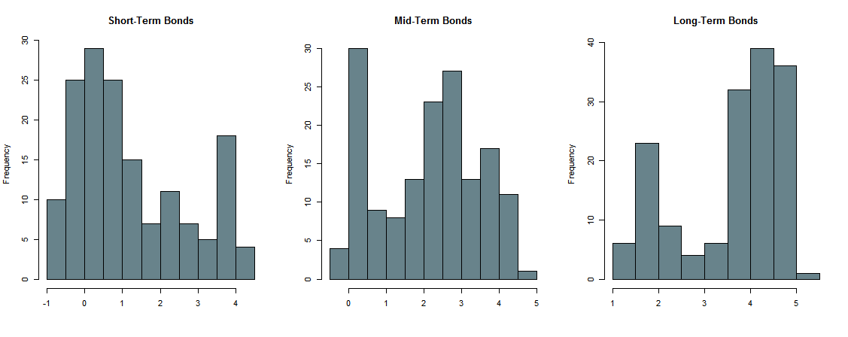
Figure 5. Distribution histograms of the short-, mid- and long-term bond returns, 2005–2007. Source: calculated by the authors.

The next step in the empirical analysis is the calculation and the interpretation of the Sharpe ratios for the EMU bonds. The relevant ratios are presented in Table 3. In 2005-2007 the Sharpe ratios for the short- and long-term bonds are four times higher than for the mid-term bonds. During the crisis period, from 2008 to 2011, the Sharpe ratio for the long-term bonds is 10 and 5 times higher than ratios for short- and mid-term bonds respectively. In 2012–2017 the long-term bonds demonstrate the best reward-to-volatility ratio as well. Risk-free values is negative in 2012-2017, average return is twice lower in comparison to previous periods as well as risk premium. This situation can be explained by more stable money and bonds market in EU.

Date |  | ST | MT | LT | Risk-free
2005-2007 | Average Return, % | 2.974 | 3.408 | 4.095 | 2.882
 | SD, % | 0.748 | 0.584 | 0.326
 | Risk Premium, % | 2.974 | 0.526 | 1.212
 | Sharpe Ratio | 3.973 | 0.900 | 3.714
2008-2011 | Average Return, % | 1.579 | 2.899 | 4.537 | 1.449
 | SD, % | 1.202 | 0.657 | 0.284
 | Risk Premium, % | 1.579 | 1.450 | 3.088
 | Sharpe Ratio | 1.308 | 2.205 | 10.881
2012-2017 | Average Return, % | 0.060 | 0.891 | 2.698 | -0.030
 | SD, % | 0.480 | 0.842 | 1.044
 | Risk Premium, % | 0.060 | 0.921 | 2.728
 | Sharpe Ratio | 0.126 | 1.058 | 2.584
Table 3. The Sharpe ratios for EMU bonds, 2005–2017.
The full table is in Appendix B. Source: calculated by the authors, based on ECB data.

In Figure 6 is shown the relation between Sharpe ratios and term-to-maturity depending on the time. It is quite evident that Sharpe ratios change over time and with the investment horizon. Even exists a non-linear relationship between Sharpe ratios and term-to-maturity in the 2005–2007 and 2008–2011 subsamples, the positive correlation between them is observed: the Sharpe ratio, in general, increases with maturity. According to the analysis, long-term bonds perform much better than short-term bills and mid-term notes. Despite the fact that short-term EMU Treasury bills provide high returns, the long-term bonds benefit on account of actually low volatility.

Figure 6. The Sharpe ratios for EMU bonds depending on maturity, 2005–2017. Source: calculated by the authors, based on ECB data.

On the one hand, these results are consistent with the findings of Lo (2002) and Hodges et al. (1997) who indicate that the Sharpe ratio is not time-consistent, and it varies substantially with the holding period.
The correlation matrices are compiled to illustrate to what extent the dynamics of bond returns and the return distributions of bonds with different maturities are similar to each other during the analysed time period. The computed correlations are presented in Table 4. The returns on short-term EMU bills and mid-term EMU notes are almost perfectly correlated independent of economic situation: the correlation coefficients between these bond yields exceed 0.94 in pre-crisis and post-crisis years, and even during the crisis period. The returns on mid- and long-term bonds are highly correlated only before 2008 and after 2012, but in 2008–2011 the correlation coefficient equals 0.66. The short- and long-term bond returns are the least correlated in all time periods. Pilotte and Sterbenz (2006) comment that short- and long-term bonds differ in fundamental ways since they are exposed to different types of risk. They conclude also that combining bonds with short and long maturities, an investor can create a well-diversified portfolio with very low level of risk. A general pattern is that since the EMU has reconsidered and changed its monetary policy after the sovereign crises, bonds of different maturities have more common features and their yields show the similar dynamics over time.

Sample Period 2005-2017 |  |  |  | Subsample 2005-2007
 | ST | MT | LT |  | ST | MT | LT
ST | 1.000 | 0.921 | 0.677 | ST | 1.000 | 0.977 | 0.764
MT |  | 1.000 | 0.901 | MT |  | 1.000 | 0.841
LT |  |  | 1.000 | LT |  |  | 1.000
Subsample 2008-2011 |  |  |  | Subsample 2012-2017
 | ST | MT | LT |  | ST | MT | LT
ST | 1.000 | 0.941 | 0.417 | ST | 1.000 | 0.959 | 0.909
MT |  | 1.000 | 0.662 | MT |  | 1.000 | 0.978
LT |  |  | 1.000 | LT |  |  | 1.000
Table 4. Correlations between the returns on bonds with different maturities, 2005–2017. Source: calculated by the authors.

The second part of the empirical analysis is devoted to the time-series analysis of the EMU bond returns. First, as proposed in equation (1), the trend model is estimated to analyse how the bond returns change over time. Table 5 provides the estimated slope coefficients for three types of bond maturity and for each defined subsample period.
The results suggest that in 2005–2007, the bond yields grow steadily and besides, the growth rate of bonds with maturity of less than one year is three times higher than the growth rate of long-term bonds. The returns on short-, mid and long-term bonds increase monthly on average by 0.07%, 0.05% and 0.023% respectively. In 2008–2011, the bond yields obviously decline. While the mid- and long-term bonds are slightly affected by the recession, the short-term bonds are hit the most by the crises events: their yields decrease on average by 0.05% every month. After the crises in 2012–2017 the descending tendency in bond returns continues. Surprisingly, the long-term bond yields decrease the most with the average tempo of 0.045% per month. For the whole sample period from 2005 to 2017, the dynamics of returns on bonds with different maturities are characterised with a negative time trend as well. In addition, short-term bonds are more sensitive to business cycle patterns and, therefore, are subject to more significant fluctuations than bonds with longer maturities.

 | Subsample 2005-2007 | Subsample 2008-2011 | Subsample 2012-2017 | Sample Period 2005-2017
ST | 0.069***  (0.003) | -0.048***  (0.011) | -0.022***  (0.0008) | -0.027***  (0.001)
MT | 0.052***  (0.003) | -0.019**  (0.006) | -0.038***  (0.002) | -0.026***  (0.001)
LT | 0.023***  (0.004) | -0.022***  (0.006) | -0.045***  (0.003) | -0.019***  (0.001)
Table 5. Results of the trend model estimation. Standard errors are given in parentheses. Significance levels: ** 0.01 *** 0.001. Source: calculated by the authors.

Figures 7, 8 and 9 provide the graphical representation of the estimated fitted values and residuals from the trend models. Fitted values are those estimated average yields that lay on the trend line. Residuals that are computed as the difference between real and fitted values characterise the stochastic component of bond returns. Residuals are an important basis for the subsequent time-series analysis since they are detrended and free from any external influence of the market or economic conditions. From these graphs one can easily notice the disparities between fitted values and residuals estimated separately for each subperiod and estimated over the whole time period.

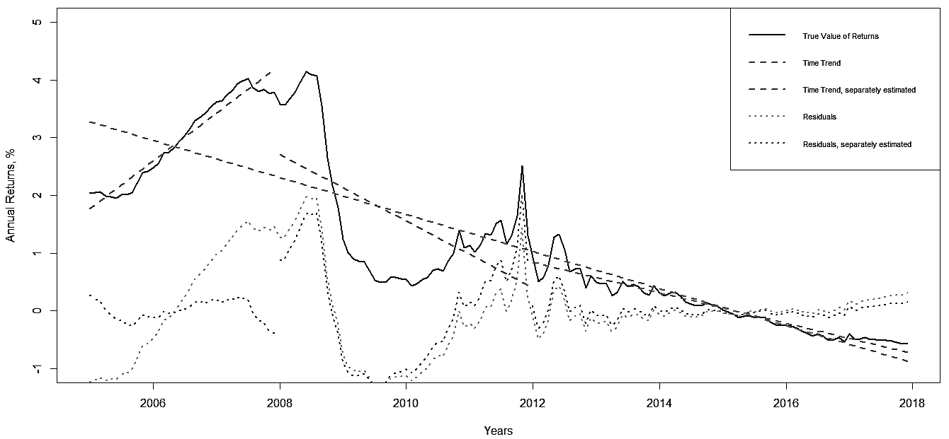
Figure 7. True values, fitted values and residuals from the trend model estimation for the short-term bond yields. Source: calculated by the authors.

The next step within this econometric part is the residuals analysis. First, the residuals are tested for stationarity using the ADF and KPSS tests. The null hypothesis of the ADF test is that the time series is non-stationary, so the null should be rejected to have stationary series. KPSS test is vice versa. Both tests detect the presence of a unit-root and suggest that residuals are non-stationary either for the whole sample period or for the separated subperiods. As an attempt to get rid of the unit-root, the first difference of the residuals is calculated. The residuals for the subsamples 2005–2007 and 2008–2011 are non-stationary even after taking the first difference. Thus, in order to model the behaviour of the stochastic component of the time series, it is better to use the first difference of the residuals for the whole time period despite it being measured less accurately than the residuals estimated separately for each subperiod. The explicit results of the tests appear in Appendix C.

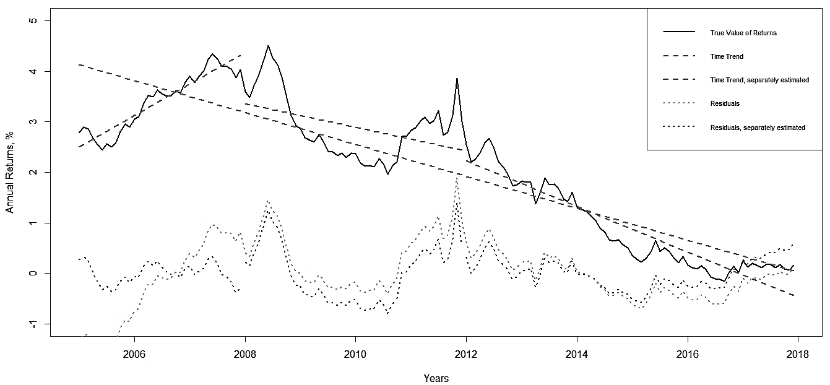
Figure 8. True values, fitted values and residuals from the trend model estimation for the mid-term bond yields. Source: calculated by the authors.

The ACF and PACF functions of the first difference of the residuals are plotted to have an idea about the order of AR and MA components of proposed the ARIMA model (see equation (2) in the previous chapter). The graphs of ACF and PACF functions can be found in Appendix D. The functions’ values suggest using AR of order 1 or 2 to model the stochastic component of the short-term bond yields, but do not state the appropriate order of MA. On the contrary, the graphs propose to use MA of order 1 or 2 and show the evidence of probable absence of the AR component while assessing the mid- and long-term bond yields.

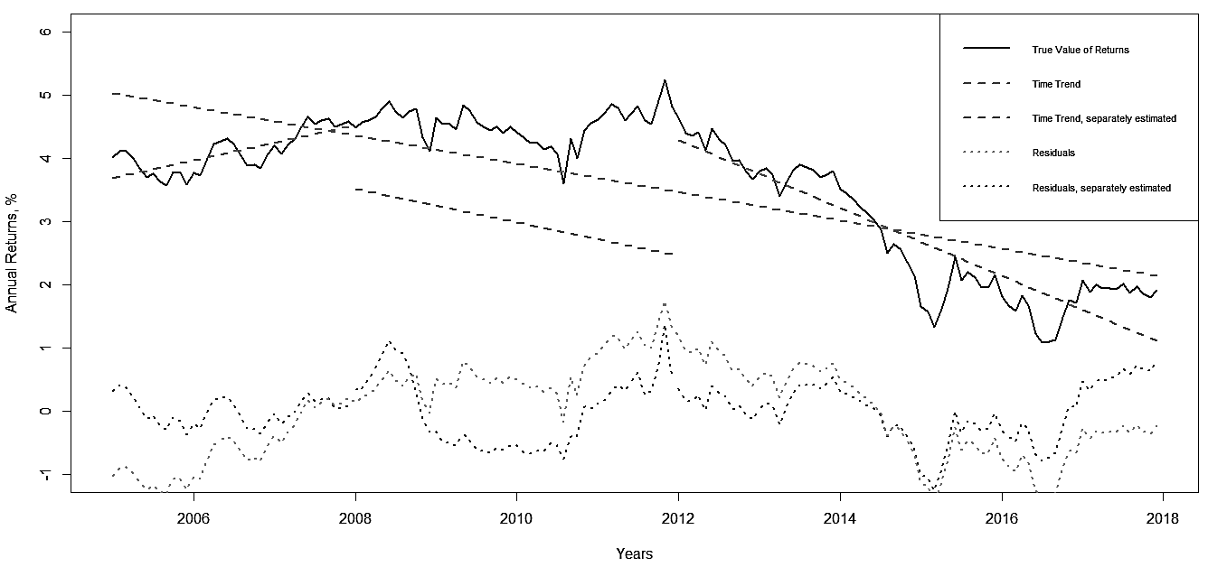
Figure 9. True values, fitted values and residuals from the trend model estimation for the long-term bond yields. Source: calculated by the authors.

Although it is a common practice to rely on the ACF and PACF functions while determining the appropriate order of the time-series models, these functions may underestimate or overestimate the significance and the importance of any particular AR or MA component. In order to avoid such confusing situations, the set of ARIMA models is examined with AR and MA orders varying from 0 to 2. The final choice of the best model explaining the dynamics of the stochastic component of the bond yields is made on the basis of the Akaike and Bayesian information criteria. The values of AIC and BIC are presented in Appendix E.
According to these criteria, the most appropriate models to determine the stochastic component of bond returns are: ARIMA (1, 1, 1) for the short-term bills, ARIMA (0, 1, 1) or ARIMA (0, 1, 2) for the mid-term notes, and ARIMA (0, 1, 1) for the long-term bonds. As it is known, the presence of AR components makes the model more predictable and more logical because the future value of a variable depends to a certain extent on the past values of this variable. If the model contains only MA components, then the future value of a variable is represented by a linear combination of past error terms. From this point of view, the results are in line with the capital market theory because long-term financial assets subject more to the future uncertainty than short-term assets.
To draw the line under this chapter, the empirical analysis was aimed to question a number of hypotheses concerning the performance of EMU bonds. It was shown that, in general, the bond returns are not normally distributed. Indeed, the normality of the return distribution depends on the bond maturity, economic situation in the market, etc. Then, the relation between volatility and maturity of a bond appeared to be non-linear; it could be either positive or negative. The positive relation between them is observed for the subsample time period from 2012 to 2017 only. Furthermore, it was proven that the Sharpe ratio is an appropriate measure to estimate and compare bond performance, but it is not consistent over time. The hypothesis about the inverse relation between the Sharpe ratio and bond maturity is not supported by the evidence. Finally, it was discovered that during the analysed time period from 2005 to 2017 the returns on EMU bonds of all maturity tend to decline over time.

4. Conclusion
To sum up, the government bond market has been widely and deeply researched in the recent literature. Economists pay attention to the specific features of the bond market compared to other financial markets and analyse in great detail the determinants of bond yield and risk components. Nevertheless, the research in this direction is still of high importance taking into consideration the last economic crises and other challenges that financial markets experience today. New and interesting results can be obtained by analysing the last tendencies on the European government bond market.
This research tested five hypotheses. First, it was demonstrated that the EMU bond returns are not normally distributed over the completely analysed period from 2005 to 2017. Such results generate situation that returns are affected by the large number of events within such a long time and, therefore, exhibit considerable fluctuations. However, yields on all bonds follow the normal distribution at 5% significance level for the subsample 2005–2007. Thus, it is possible to conclude that the form of the return distribution depends on the business cycles and the economic situation in the market.
Second, it was shown that the Sharpe ratio is an appropriate measure to estimate bond performance, and compare and rank the financial assets according to the risk-return trade-off. Furthermore, the Sharpe ratios are normally not consistent over time. The hypothesis about the inverse relation between the Sharpe ratio and bond maturity is not supported by the evidence that contradicts the recent empirical studies (Bodie et al., 2013)
Third, positive relation between bond volatility and bond maturity is observed for the subsample from 2012 to 2017 only. In 2005–2011 the relation between volatility and maturity of a bond appeared to be negative. That is to a certain extent counterintuitive and disagrees with the capital market theory. A risk averse investor may use such an opportunity to obtain higher returns for a lower level of risk.
Finally, with the help of time-series analysis it was shown that the returns on the EMU bonds tend to decline over time. For the whole sample period from 2005 to 2017, the returns on short-, mid- and long-term bonds decrease monthly on average by 0.027%, 0.026% and 0.019% respectively. In addition, short-term bonds are more sensitive to business cycles and subject to more significant fluctuations than bonds with longer maturities. From the estimation of ARIMA models, it can be concluded that the best models describing stochastic processes in bond returns are ARIMA (1, 1, 1), ARIMA (0, 1, 1) or ARIMA (0, 1, 2) and ARIMA (0, 1, 1) for the short-, mid- and long-term bonds respectively. The absence of AR components in a model makes it less predictable, so the results are in line with the capital market theory because long-term financial assets are subject more to future uncertainty than short-term assets.
In the future this research can be improved and extended into different directions. The estimated ARIMA models can be used to forecast the dynamics of the bond yields. The bond risks and returns can be also compared and analysed on the basis of other performance measures, value-at-risk approach, and the coefficient of risk aversion. All maturity bonds show relatively stable volatility, between 1,2 and 1,5% during last decade (Figure 1). Low bonds volatility is related to stability of ECB and almost excluded default risk on these bonds. In general, the global trend on EMU bond market will be almost unchanged. Short volatility changes are found only in the money market that is more susceptible to trading or these assets are more attractive to portfolio in situations of crisis. However, one cannot identify the trend of higher EMU bonds volatility in the future. The situation with returns is more interesting. Each crisis (financial and sovereign crises) has affected the growth of yields. Given that Italy in the beginning of 2019 has big budget problems and that Greece has not yet emerged from the fiscal crisis, there is a high probability that there will be one more (maybe smaller) sovereign crisis in EMU. Such a situation announces a rise in yields on debt instruments.
Certainly it is important to look at some theoretical situations associated with this research. Although in most cases the volatility declines with maturity and that we can find positive relationship between risks and return (Ilmanen, 1995; Eling, 2008). However, on some new instruments these rules do not apply. New financial instruments with the shorter term to maturity can offer bigger yields on the market in comparison with long-term bonds. This is not a matter of their higher risk, it’s a matter of their market attractiveness. We need to point out another interesting trend. We can see on figure 3 that only in the post-crisis period we have a growing trend of risk in relation to the growth of maturity, while the situation was reversed in the years before the crisis. The explanation is very rational if we compare this trend with the volatility of the instruments (Figure 1). In the same period, volatility on the money market was much higher than the volatility on the bond market, so we can conclude that this volatility has influenced the growth of their standard deviations. On the other hand, this is confirmed by the calculated Sharpe ratios. Short returns (higher volatility) and long term bonds offer the best semi-variance results - the asset performance. Such situation (non time-consistent Sharpe ratio) has already been explained earlier in the previous research of Lo (2002) and Hodges et al. (1997) with non-normal distributions Joro and Na (2006) and Farinelli et al. (2008). Lastly, these portfolios are close to the statement of Bodie et al. (2005) explanation that the Sharpe ratio is only suitable for investors who invest all their funds in just one asset because, the Sharpe ratio captures only total market risk. Since we can exclude the default risk on EMU market and term to maturity in researched portfolios, we conclude that yields and volatility were largely dependent on the attractiveness of debt instruments on EMU markets.

References
Amenc, N., El Bied, S., Martellini, L., 2003. Predictability in hedge fund returns. Financial Analysts Journal, 59(5), 32-46.
Ang, J., Chua, J., 1979. Composite measures for the evaluation of investment performance. Journal of Financial and Quantitative Analysis, 14(2), 361-384.
Auer, B., 2015. On the role of skewness, kurtosis, and the location and scale condition in a Sharpe ratio performance evaluation setting. International Journal of Theoretical and Applied Finance, 18(6), 1550037:1-13.
Bacmann, J., Pache, S., 2003. Optimal hedge fund style allocation under higher moments. Intelligent Hedge Fund Investing.
Bacmann, J., Scholz, S., 2003. Alternative performance measures for hedge funds. AIMA Journal, 1(1), 1-9.
Bodie, Z., 2013. Managing bond portfolios. In: Bodie, Z., Kane, A. and Marcus, A.J. (eds.) Essentials of Investments (9th ed.). NY: McGraw-Hill/Irwin.
Bodnar, T., Zabolotskyy, T., 2017. How risky is the optimal portfolio which maximizes the Sharpe ratio? AStA Advances in Statistical Analysis, 101(1), 1-28.
Box, G., Jenkins, G., Reinsel, G., 2008. Time Series Analysis, Forecasting and Control (4th ed.). Hoboken, NJ: Wiley.
Brockwell, P., Davis, R., 1996. Introduction to Time Series and Forecasting. NY: Springer.
Brockwell, P., Davis, R., 2009. Time Series: Theory and Methods (2nd ed.). NY: Springer.
Campbell, R., Huisman, R., Koedijk, K., 2001. Optimal portfolio selection in a value-at-risk framework. Journal of Banking and Finance, 25(9), 1789-1804.
Cogneau, P., Hübner, G., 2009. 101 ways to measure portfolio performance. Journal of Performance Measurement, 14, 56-69.
Eling, M., 2008. Performance measurement in the investment industry: Does the measure matter. Working Papers on Risk Management №49.
Farinelli, S., Ferreira, M., Rossello, D., Thoeny, M., Tibiletti, L., 2008. Beyond Sharpe ratio: Optimal asset allocation using different performance ratios. Journal of Banking and Finance, 32(10), 2057-2063.
Fuller, W., 1996. Introduction to statistical time series (2nd ed.). NY: John Wiley and Sons.
Geman, H., Kharoubi, C., 2003. Hedge funds revisited: Distributional characteristics, dependence structure and diversification. Journal of Risk, 5(4), 13-32.
Grubisic, Z., Zaric, S., Vukovic, D., 2011. FDI Inflow in see Countries and its Consequences in the Context of the Financial Crisis. Finance and the Performance of Firms in Science, Education, and Practice. Tomas Bata University in Zlin, Faculty of management and economics, Czech Republic. (edt.) DrahomiraPavelkova, (Proceedings paper), 116-129. ISBN 978-80-7454-020-2.
Harvey, C., Siddique, A., 2000. Time-varying conditional skewness and the market risk premium. Research in Banking and Finance, 1(1), 27-60.
Hodges, C., Taylor, W., Yoder, J., 1997. Stocks, bonds, the Sharpe ratio, and the investment horizon. Financial Analysts Journal, 53(6), 74-80.
Ilmanen, A., 1995. Time‐varying expected returns in international bond markets. The Journal of Finance, 50(2), 481-506.
Israelsen, C., 2005. A refinement to the Sharpe ratio and information ratio. Journal of Asset Management, 5(6), 423-427.
Israelsen, C., 2009. Refining the Sharpe ratio. Journal of Performance Measurement, 13(3), 23-27.
Jarque, C., Bera, A., 1987. A test for normality of observations and regression residuals. International Statistical Review, 55, 163–172.
Joro, T., Na, P., 2006. Portfolio performance evaluation in a mean–variance–skewness framework. European Journal of Operational Research, 175(1), 446-461.
Kahneman, D., Tversky, A., 1979. Prospect theory: An analysis of decision under risk. Econometrica, 47(2), 263-291.
Koekebakker, S., Zakamouline, V., 2008. Analysis of financial decision making with loss aversion. European Financial Management Association Annual Meeting, Athens.
Kourtis, A., 2016. The Sharpe ratio of estimated efficient portfolios. Finance Research Letters, 17, 72-78.
Kwiatkowski, D., Phillips, P., Schmidt, P., Shin, Y., 1992. Testing the null hypothesis of stationarity against the alternative of a unit root. Journal of Econometrics, 54, 159-178.
Lamm, R., 2003. Asymmetric returns and optimal hedge fund portfolios. Journal of Alternative Investments, 6, 9-21.
Leland, H., 1999. Beyond mean-variance: Performance measurement in a non-symmetrical world. Financial Analysts Journal, 55(1), 27-36.
Lo, A., 2002. The statistics of Sharpe ratios. Financial Analysts Journal, 58(4), 36-52.
Mahdavi, M., 2004. Risk-adjusted return when returns are not normally distributed: Adjusted Sharpe ratio. Journal of Alternative Investments, 6(4), 47-57.
Maller, R., Durand, R., Jafarpour, H., 2010. Optimal portfolio choice using the maximum Sharpe ratio. The Journal of Risk, 12(4), 49-73.
Memmel, C., 2003. Performance hypothesis testing with Sharpe ratio. Finance Letters, 1(1), 21-23.
Modigliani, F., Modigliani, L., 1997. Risk-adjusted performance. The Journal of Portfolio Management, 23(2), 45-54.
Schmidhuber, C., Moix, P., 2001. Fat tail risk: The case for hedge funds. AIMA Newsletter, 48(1), 29-31.
Pilotte, E., Sterbenz, F., 2006. Sharpe and Treynor ratios on treasury bonds. The Journal of Business, 79(1), 149-180.
Sakamoto, Y., Ishiguro, M., Kitagawa G., 1986. Akaike Information Criterion Statistics. D.: Reidel Publishing Company.
Scholz, H., Wilkens, M., 2005. Investor-specific performance measurement: A justification of Sharpe ratio and Treynor ratio. International Journal of Finance, 17(4), 3671-3691.
Schwarz, G., 1978. Estimating the dimension of a model. Annals of Statistics, 6, 461-464.
Sharpe, W., 1966. Mutual fund performance. The Journal of Business, 39(1), 119-138.
Sharpe, W., 1994. The Sharpe ratio. Journal of Portfolio Management, 21(1), 49-58.
Sharpe, W., 2007. Expected utility asset allocation. Financial Analysts Journal, 63(5), 18-30.
Sortino, F., Price, L., 1994. Performance measurement in a downside risk framework. The Journal of Investing, 3(3), 59-64..
Sortino, F., Van der Meer, R., 1991. Downside risk. The Journal of Portfolio Management, 17(4), 27-31.
Vinod, H., Morey, M., 2001. A double Sharpe ratio. Advances in Investment Analysis and Portfolio Management, 8, 57-65.
Watanabe, Y., 2006. Is Sharpe ratio still effective? Journal of Performance Measurement, 11(1), 55–66.
Appendices
Appendix A

 | Min. | 1st Qu. | Mean | Median | 3rd Qu. | Max. | Var. | SD. | Skew. | Kurt.
Sample period 2005-2017
3M | -0.589 | 0.067 | 1.097 | 0.515 | 2.003 | 4.062 | 2.029 | 1.424 | 0.806 | -0.670
6M | -0.575 | 0.103 | 1.206 | 0.702 | 2.076 | 4.157 | 2.058 | 1.435 | 0.699 | -0.776
9M | -0.562 | 0.126 | 1.296 | 0.826 | 2.132 | 4.262 | 2.088 | 1.445 | 0.600 | -0.869
1Y | -0.546 | 0.143 | 1.370 | 0.954 | 2.263 | 4.340 | 2.107 | 1.452 | 0.514 | -0.936
3Y | -0.393 | 0.257 | 1.787 | 1.943 | 2.779 | 4.513 | 2.065 | 1.437 | -0.005 | -1.192
5Y | -0.213 | 0.634 | 2.206 | 2.595 | 3.306 | 4.524 | 1.910 | 1.382 | -0.366 | -1.216
10Y | 0.438 | 1.669 | 2.996 | 3.483 | 3.983 | 4.711 | 1.589 | 1.261 | -0.714 | -1.009
15Y | 0.848 | 2.227 | 3.387 | 3.818 | 4.375 | 5.048 | 1.416 | 1.190 | -0.771 | -0.883
20Y | 1.056 | 2.493 | 3.576 | 3.951 | 4.514 | 5.217 | 1.298 | 1.139 | -0.794 | -0.801
25Y | 1.182 | 2.678 | 3.668 | 4.047 | 4.557 | 5.318 | 1.204 | 1.097 | -0.810 | -0.733
30Y | 1.266 | 2.803 | 3.712 | 4.036 | 4.546 | 5.386 | 1.129 | 1.063 | -0.802 | -0.681
Subsample 2005-2007
3M | 1.960 | 2.110 | 2.882 | 2.811 | 3.670 | 3.914 | 0.536 | 0.732 | 0.039 | -1.668
6M | 1.949 | 2.169 | 2.983 | 2.999 | 3.758 | 4.038 | 0.568 | 0.753 | -0.084 | -1.620
9M | 1.927 | 2.226 | 3.055 | 3.141 | 3.773 | 4.117 | 0.582 | 0.763 | -0.163 | -1.555
1Y | 1.920 | 2.282 | 3.109 | 3.247 | 3.792 | 4.183 | 0.583 | 0.763 | -0.216 | -1.492
3Y | 2.139 | 2.670 | 3.309 | 3.465 | 3.866 | 4.337 | 0.435 | 0.659 | -0.291 | -1.231
5Y | 2.500 | 2.983 | 3.448 | 3.544 | 3.871 | 4.351 | 0.299 | 0.547 | -0.198 | -1.169
10Y | 3.111 | 3.437 | 3.767 | 3.733 | 4.043 | 4.469 | 0.159 | 0.399 | 0.016 | -1.088
15Y | 3.386 | 3.661 | 3.967 | 3.945 | 4.197 | 4.577 | 0.120 | 0.346 | 0.124 | -1.044
20Y | 3.551 | 3.814 | 4.080 | 4.056 | 4.294 | 4.647 | 0.106 | 0.326 | 0.180 | -1.062
25Y | 3.636 | 3.875 | 4.145 | 4.097 | 4.351 | 4.692 | 0.102 | 0.319 | 0.211 | -1.089
30Y | 3.688 | 3.920 | 4.186 | 4.135 | 4.390 | 4.723 | 0.101 | 0.318 | 0.224 | -1.106
Subsample 2008-2011
3M | 0.298 | 0.603 | 1.449 | 0.926 | 1.779 | 4.062 | 1.552 | 1.246 | 1.256 | -0.013
6M | 0.407 | 0.678 | 1.575 | 1.150 | 1.852 | 4.157 | 1.470 | 1.212 | 1.113 | -0.193
9M | 0.563 | 0.784 | 1.712 | 1.320 | 2.130 | 4.262 | 1.371 | 1.171 | 1.007 | -0.346
1Y | 0.686 | 0.919 | 1.842 | 1.518 | 2.274 | 4.340 | 1.257 | 1.121 | 0.951 | -0.404
3Y | 1.523 | 2.010 | 2.583 | 2.429 | 2.894 | 4.513 | 0.576 | 0.759 | 0.806 | -0.026
5Y | 2.194 | 2.742 | 3.140 | 3.137 | 3.408 | 4.524 | 0.303 | 0.550 | 0.479 | -0.174
10Y | 3.300 | 3.866 | 4.030 | 4.045 | 4.228 | 4.711 | 0.091 | 0.302 | -0.116 | 0.147
15Y | 3.683 | 4.302 | 4.425 | 4.432 | 4.578 | 5.048 | 0.058 | 0.241 | -0.432 | 1.627
20Y | 3.700 | 4.475 | 4.572 | 4.588 | 4.719 | 5.217 | 0.064 | 0.252 | -0.745 | 2.500
25Y | 3.586 | 4.465 | 4.594 | 4.634 | 4.792 | 5.318 | 0.090 | 0.300 | -0.780 | 1.889
30Y | 3.444 | 4.336 | 4.557 | 4.640 | 4.824 | 5.386 | 0.144 | 0.379 | -0.599 | 0.500
Subsample 2012-2017
3M | -0.589 | -0.421 | -0.030 | 0.034 | 0.265 | 0.888 | 0.149 | 0.385 | 0.148 | -0.847
6M | -0.575 | -0.395 | 0.072 | 0.051 | 0.438 | 1.404 | 0.243 | 0.493 | 0.586 | -0.235
9M | -0.562 | -0.380 | 0.139 | 0.062 | 0.550 | 1.695 | 0.320 | 0.565 | 0.757 | -0.014
1Y | -0.546 | -0.374 | 0.187 | 0.065 | 0.633 | 1.850 | 0.376 | 0.613 | 0.823 | 0.003
3Y | -0.393 | -0.187 | 0.496 | 0.207 | 1.212 | 2.211 | 0.618 | 0.786 | 0.728 | -0.805
5Y | -0.213 | 0.183 | 0.961 | 0.523 | 1.851 | 2.805 | 0.878 | 0.937 | 0.598 | -1.131
10Y | 0.438 | 1.031 | 1.920 | 1.417 | 2.993 | 3.915 | 1.132 | 1.064 | 0.413 | -1.360
15Y | 0.848 | 1.546 | 2.406 | 1.974 | 3.492 | 4.376 | 1.117 | 1.057 | 0.325 | -1.386
20Y | 1.056 | 1.827 | 2.661 | 2.260 | 3.717 | 4.608 | 1.093 | 1.045 | 0.282 | -1.384
25Y | 1.182 | 1.998 | 2.813 | 2.406 | 3.877 | 4.747 | 1.080 | 1.039 | 0.261 | -1.383
30Y | 1.266 | 2.107 | 2.912 | 2.476 | 3.985 | 4.840 | 1.075 | 1.037 | 0.249 | -1.386
Summary statistics for the returns on EMU bonds with different maturities, 2005–2017. Source: calculated by the authors, based on ECB data.

Appendix B

Date |  | 3M | 6M | 9M | 1Y | 3Y | 5Y | 10Y | 15Y | 20Y | 25Y | 30Y
2005-2007 | Average Return, % | 2.882 | 2.983 | 3.055 | 3.109 | 3.309 | 3.448 | 3.767 | 3.967 | 4.08 | 4.145 | 4.186
 | SD, % | 0.732 | 0.753 | 0.763 | 0.763 | 0.659 | 0.547 | 0.399 | 0.346 | 0.326 | 0.319 | 0.318
 | Risk Premium, % | 2.882 | 2.983 | 3.055 | 0.227 | 0.427 | 0.565 | 0.885 | 1.085 | 1.197 | 1.263 | 1.304
 | Sharpe Ratio | 3.936 | 3.959 | 4.006 | 0.297 | 0.647 | 1.033 | 2.221 | 3.138 | 3.669 | 3.956 | 4.105
2008-2011 | Average Return, % | 1.449 | 1.575 | 1.712 | 1.842 | 2.583 | 3.14 | 4.03 | 4.425 | 4.572 | 4.594 | 4.557
 | SD, % | 1.246 | 1.212 | 1.171 | 1.121 | 0.759 | 0.55 | 0.302 | 0.241 | 0.252 | 0.3 | 0.379
 | Risk Premium, % | 1.449 | 1.575 | 1.712 | 0.393 | 1.134 | 1.691 | 2.581 | 2.976 | 3.123 | 3.145 | 3.108
 | Sharpe Ratio | 1.163 | 1.299 | 1.462 | 0.35 | 1.494 | 3.073 | 8.536 | 12.333 | 12.39 | 10.483 | 8.196
2012-2017 | Average Return, % | -0.03 | 0.072 | 0.139 | 0.187 | 0.496 | 0.961 | 1.92 | 2.406 | 2.661 | 2.813 | 2.912
 | SD, % | 0.385 | 0.493 | 0.565 | 0.613 | 0.786 | 0.937 | 1.064 | 1.057 | 1.045 | 1.039 | 1.037
 | Risk Premium, % | -0.03 | 0.072 | 0.139 | 0.217 | 0.526 | 0.991 | 1.95 | 2.436 | 2.691 | 2.843 | 2.942
 | Sharpe Ratio | -0.08 | 0.146 | 0.247 | 0.305 | 0.63 | 1.026 | 1.805 | 2.277 | 2.546 | 2.706 | 2.809
Risk premiums and the Sharpe ratios for EMU bonds with different maturities, 2005–2017.
Source: calculated by the authors.

Appendix C

 |  | 2005-2007 | 2008-2011 | 2012-2017 | 2005-2017
ST | Residuals | ADF: p-value = 0.794  KPSS: p-value = 0.1 | ADF: p-value = 0.724  KPSS: p-value = 0.034 | ADF: p-value = 0.231  KPSS: p-value = 0.1 | ADF: p-value = 0.283  KPSS: p-value = 0.1
 | First Difference | ADF: p-value = 0.598  KPSS: p-value = 0.1 | ADF: p-value = 0.298  KPSS: p-value = 0.1 | ADF: p-value = 0.01  KPSS: p-value = 0.1 | ADF: p-value = 0.01  KPSS: p-value = 0.1
MT | Residuals | ADF: p-value = 0.261  KPSS: p-value = 0.1 | ADF: p-value = 0.858  KPSS: p-value = 0.039 | ADF: p-value = 0.945  KPSS: p-value = 0.016 | ADF: p-value = 0.125  KPSS: p-value = 0.032
 | First Difference | ADF: p-value = 0.19  KPSS: p-value = 0.1 | ADF: p-value = 0.152  KPSS: p-value = 0.1 | ADF: p-value = 0.01  KPSS: p-value = 0.1 | ADF: p-value = 0.01  KPSS: p-value = 0.1
LT | Residuals | ADF: p-value = 0.021  KPSS: p-value = 0.1 | ADF: p-value = 0.869  KPSS: p-value = 0.035 | ADF: p-value = 0.845  KPSS: p-value = 0.04 | ADF: p-value = 0.551  KPSS: p-value = 0.01
 | First Difference | NA | ADF: p-value = 0.152  KPSS: p-value = 0.1 | ADF: p-value = 0.01  KPSS: p-value = 0.1 | ADF: p-value = 0.01  KPSS: p-value = 0.1
The results of ADF and KPSS tests for stationarity in the residuals and the first difference
of residuals, EMU bonds with different maturities, 2005–2017.
Source: calculated by the authors.

Appendix D

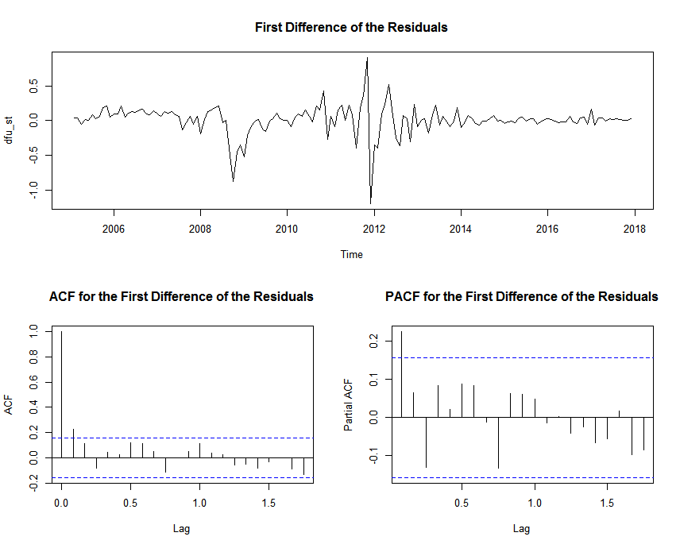
Graphical representation of the first difference of the residuals, the ACF and PACF functions
for the short-term EMU bond returns, 2005–2017. Source: calculated by the authors.
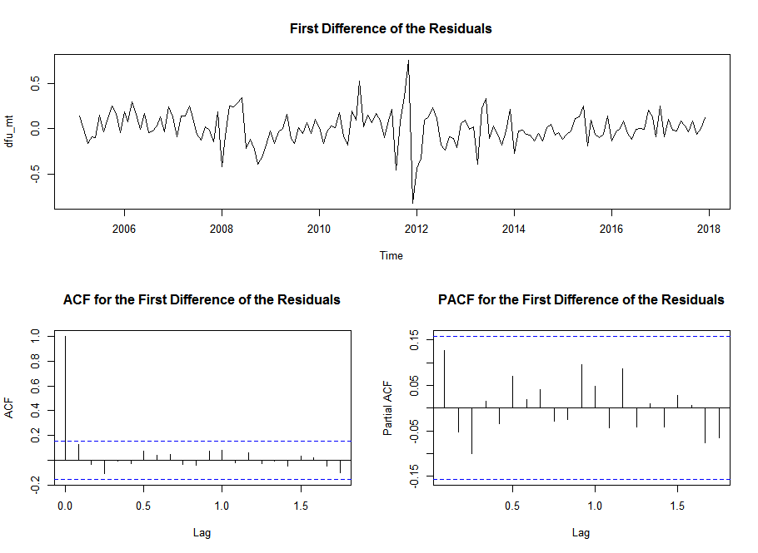
Graphical representation of the first difference of the residuals, the ACF and PACF functions
for the mid-term EMU bond returns, 2005–2017. Source: calculated by the authors.

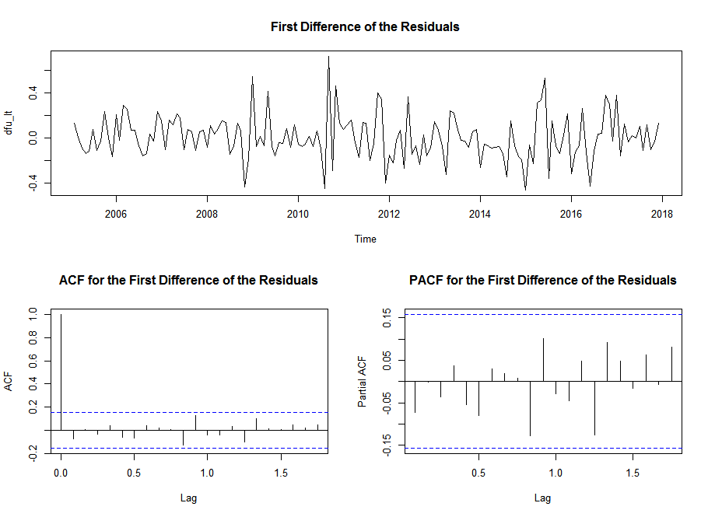
Graphical representation of the first difference of the residuals, the ACF and PACF functions
for the long-term EMU bond returns, 2005–2017. Source: calculated by the authors.

Appendix E

MA  AR | 0 | 1 | 2
0 | NA | AIC = -42.785  BIC = -36.711 | AIC = -46.478  BIC = -37.367
1 | AIC = -10.085  BIC = -4.011 | AIC = -48.104  BIC = -38.992 | AIC = -46.505  BIC = -34.357
2 | AIC = -11.866  BIC = -2.755 | AIC = -46.884  BIC = -34.736 | AIC = -47.765  BIC = -32.580
The values of AIC and BIC for the set of ARIMA models estimated for the first difference
of the residuals of the short-term bond returns, 2005–2017. Source: calculated by the authors.

MA  AR | 0 | 1 | 2
0 | NA | AIC = -70.628  BIC = -64.554 | AIC = -71.525  BIC = -62.414
1 | AIC = -17.870  BIC = -11.796 | AIC = -71.396  BIC = -62.285 | AIC = -69.525  BIC = -57.377
2 | AIC = -26.210  BIC = -17.099 | AIC = -69.715  BIC = -57.568 | AIC = -68.086  BIC = -52.902
The values of AIC and BIC for the set of ARIMA models estimated for the first difference
of the residuals of the mid-term bond returns, 2005–2017. Source: calculated by the authors.

MA  AR | 0 | 1 | 2
0 | NA | AIC = -50.562  BIC = -44.488 | AIC = -49.236  BIC = -40.125
1 | AIC = 10.004  BIC = 16.078 | AIC = -49.241  BIC = -40.130 | AIC = -47.245  BIC = -35.098
2 | AIC = -5.074  BIC = 4.037 | AIC = -47.243  BIC = -35.095 | AIC = -46.175  BIC = -30.990
The values of AIC and BIC for the set of ARIMA models estimated for the first difference
of the residuals of the long-term bond returns, 2005–2017. Source: calculated by the authors.

