Supplementary Information – ERP measurement epochs

Peak latency  measurement epoch (ms) | Puretone  (Experiment 1) | Auditory  (Experiment 1) | Audiovisual  (Experiment 2)
P50 | 20-75 | 20-65 | 8-79
N1 | 76-115 | 60-150 | 54-132
P2 | 116-170 | 115-235 | 123-291
N2 | 171-260 | 180-350 | 179-434
P3a | na | 238-550 | na
aMMN | na | 86-165 | na
Table 1: Measurement epochs (ms) for peak latency of ERPs following inspection of grand average waveforms.

Peak amplitude  measurement epoch (ms) |  | Puretone  (Experiment 1) |  | Auditory  (Experiment 1) |  | Audiovisual  (Experiment 2)
 |  | Young | Old | Young | Old | Young | Old
P50 | Standard | 47-63 | 36-56 | 33-57 | 27-53 | 584-610 | 590-616
 | Deviant | na | na | 33-55 | 35-61 | 589-625 | 602-628
N1 | Standard | 87-104 | 85-103 | 78-104 | 78-100 | 642-662 | 646-664
 | Deviant | na | na | 101-123 | 87-115 | 649-673 | 650-674
P2 | Standard | 138-156 | 140-164 | 153-177 | 150-208 | 723-745 | 731-768
 | Deviant | na | na | 174-218 | 173-217 | 730-762 | 747-793
N2 | Standard | 198-228 | 201-257 | 265-305 | 276-356 | 825-869 | 855-917
P3a | Deviant | na | na | 292-366 | 312-410 | na | na
Table 2: Measurement epochs (ms) for peak mean amplitude of ERPs. Range based on one standard deviation around the mean peak latency.

Supplementary information – ERP Hearing threshold correlational analyses
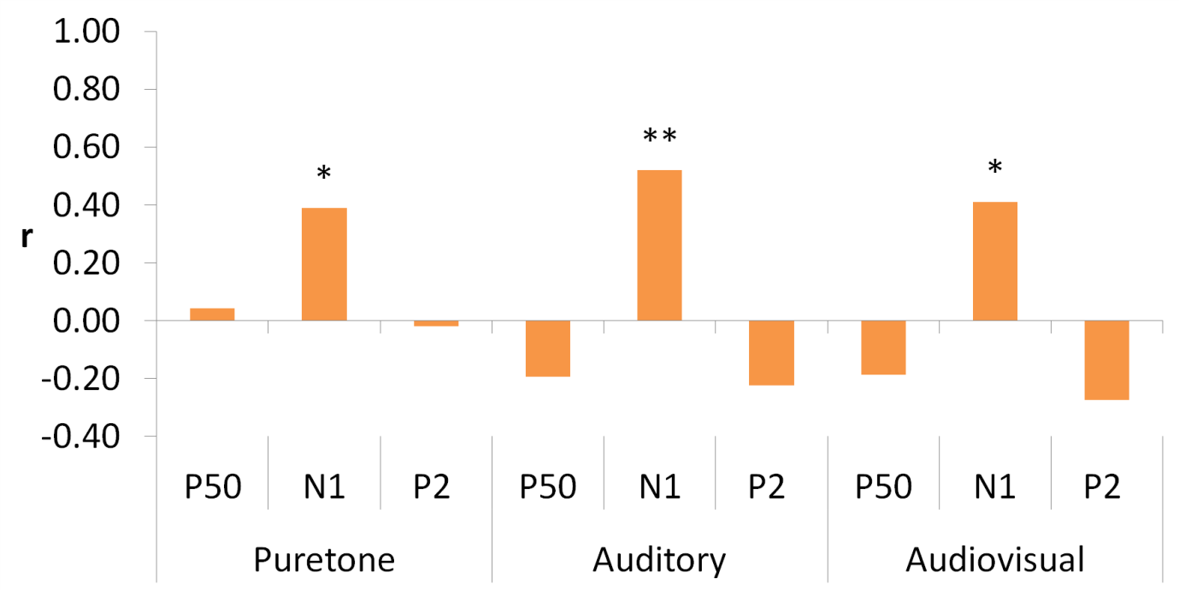

Figure 1. Pearson’s r correlations between mean decibel increase in stimulus intensity for the auditory and audiovisual stimuli and peak amplitude measures for responses to standard stimuli in older adults. Note that values for negative peaks have been reversed so that a positive correlation equates to an enhanced peak amplitude irrespective of polarity across all components. * p < 0.05 ** p < 0.01

