Evgeny Steiner

National Research University ‘Higher School of Economics’ (Moscow)

**Hokusai Manga: Its Title and Its Genre**

This publication investigates the meaning of the title and supra-heading of *Hokusai Manga* (subsequently in this text – *HM*) and provides a detailed analysis of the term *manga* which is difficult to understand and translate. In doing so, it puts HM into the context of the early modern Japanese picture-books and offers an attempt to classify its genre.[1]

It is widely known that during the course of his long life Hokusai (1760-1849) drew and published albums (or picture books – *ehon*) which he called *Manga*: “random, whimsical, or funny pictures.” *HM* has a sacral status for connoisseurs and lovers of Japanese art, but does it truly merit all this high esteem? It is a great masterpiece, indeed, but its admirers sometimes ascribe to it what is not there – such as the epithets “first” or “foremost.” Under close scrutiny it appears that this seemingly well-known oeuvre posits more questions than it offers ready answers. In other words, *HM*  is a cult name, but what stands behind it?

Let us take the authorship: it is quite feasible that the First volume had included not only Hokusai’s drawings but also those of several of his disciples. Such doubts extend beyond the individual drawings: if we look closely at the design of the pages and double-spreads, we might question whether it was Hokusai himself who composed them. In many cases, they were designed by his editors. We should also consider the composition of the whole volumes, in other words the thematic order and progression of the pages. The majority of specialists believe that there is no order in the sequence of pages at all, whereas in many cases it is possible, in my opinion, to suggest a rather strict compositional schema organized in a detailed fashion and based on subtle associations. Or, let us look at the pragmatic purpose of *HM*: there are some indications that it was created as a manual for fledgling artists or as collections of humorous pictures and cartoons for sheer amusement, or as a pictorial thesaurus of things Japanese. How do we reconcile this? Or, take the editions: what should we call the canonical edition of *HM*?

This publication investigates the meaning of the title and supra-heading of *HM* and provides a detailed analysis of the term *manga* which is difficult to understand and translate. In doing so, it puts *HM* into the context of the early modern Japanese picture-books and offers an attempt to classify its genre.

**Journey to the West and the Birth of *Hokusai Manga***

A testimony to the origin of the First volume of *HM* (and there was not even the slightest hint of further installments) can be found in the Introduction by Hanshū Sanjin 半洲散人 (1772-1824). It says:

This autumn the Reverend set off for the journey to the Western [provinces] and made a stop in our land. We all met together at Gekkōtei Bokusen, and it was an immensely joyous pastime. During that time more than three hundred of all sorts of sketches were made – from [Daoist] immortals and Buddhist saints to warriors and women, and down to birds and beasts and all kinds of plants and trees.

Detailed commentaries will be put aside for now (they can be found in the full translation of this Introduction in the appropriate chapter). Let us note that it talks about Hokusai’s journey in 1812 (the date is given at the end of this Introduction) to the provinces west of Edo, when he made a stop at Nagoya and participated in a drawing event (or a few events) with a group of local artists at the house of a certain Bokusen. From the language of the text it is not clear whether it was a single party or whether they gathered several times. The verb form (*urete*) can designate one occasion: “gathered once.” Because of this, many previous authors wrote that, on the occasion of the visit of the celebrity from the capital (Hokusai was slightly over fifty, and it was the time of the beginning of his fame), the local artists and other people of the brush (calligraphers and poets) gathered for a party in his honor. During the party, with Hokusai and the whole company in high spirits because of spirits and lofty conversation, an impromptu drawing marathon ensued. This kind of gathering with brushes to hand (not to mention wine cups) was popular among artists and lovers of painting. The genre might be described as something midway between a speed drawing contest and a demonstration of virtuosity and wit in the treatment of a certain theme. Such gatherings were sometimes called “battles in ink” and were known by their representation in prints or prose. As a genre, they perfectly correspond with the communal and agonal character of the traditional Japanese forms of creative acts. They can be called a visual parallel to poetic contests *uta-awase* 歌合せ, or meetings for the collective composition of linked poetry (*rengakai* 連歌会). As was the case with poems and individual strophes composed during such gatherings, they were gathered, arranged and published as a single volume. Thus, the supporters of this point of view claim that the First volume of *HM* is the output of this one super-productive night and is thus a chaotic agglomerate of inspired sketches with no unifying plan or organizing idea.

While I am sympathetic to the idea of the inspired (and even untrammeled) drawing during a convivial meeting of colleagues and admirers, I do not support the legend that it all occurred on a single night. More than three hundred sketches are mentioned by Sanjin; it would be impossible to draw so many at one sitting. Let us say it was exactly three hundred for the sake of an easy count. If the merrymaking lasted eight hours (which is quite a long time), the time available for the uninterrupted process of drawing works out at 1.6 minutes for one sketch – without any breaks for talking, drinking and toilet visits. And there is no time at all for thinking and planning what else to draw. If we imagine that the party lasted for ten hours (which is rather difficult to imagine), this gives precisely two minutes for each drawing; this is equally hard to accomplish. Certainly, some small sketches are simple enough to be jotted down in a few seconds, but there are many others, large and detailed, that would not have been easy to draw even in five minutes. And, of course, although Hokusai was “mad about drawing,” he was not a robot who required no breaks. In order to salvage the ‘one night’ theory, one might suggest that a good half of the drawings had been executed not by the master himself but by other participants. If we talk about two or three, or perhaps, fifteen, it may possibly have taken place. The volume was composed within the timespan of two years by two of Hokusai’s disciples: the same Bokusen and Hokuun. Both were pretty good artists, and both issued their own picture books with drawings typologically similar to Hokusai’s. Nevertheless, the signed albums of both Bokusen and Hokuun differ in an obvious way from the drawings in *HM*. At the same time, the majority of drawings there – whether scrupulously finished or sketchy and abbreviated – betray Hokusai’s own hand.

Thus, the idea of one great night should be left aside. Hokusai stayed in Nagoya for several days, and there may have been more than one drawing party. Also, as Hokusai’s journey lasted a few months, he had to accumulate a huge quantity of all kinds of sketches – from street scenes and landscapes to depictions of animals and birds. In the world’s museums can be found hundreds of his drawings made on scraps of paper of various sizes and forms and pasted on album pages. It is more than feasible that, in Bokusen’s studio, Hokusai not only drew but also demonstrated his road sketches. Before his departure he left them to his local admirers. After two years they were organized into a compact picture book volume.

**The Term *Manga***

**These days, when they speak of *manga*, people usually mean thick volumes of comics or perhaps graphic novels for adult (often young) audiences. This kind of picture book appeared at the end of the Meiji epoch in Japan and gained enormous popularity in the following decades when it worked out its own themes (sentimental juvenile love affairs or brutal adventures), style (black-and-white precisely drafted figures with the minimum of background and with dialogue texts in bubbles), and poetics (dynamic action; combination of general views with large fragments in their own frames on one page, etc.) This modern *manga* can be only partially linked with the *manga* of Hokusai’s times. To a substantial degree it is also a fruit of the familiarity with Western magazines’ cartoons.**

**When Hokusai titled the first issue of his *manga* “*Hokusai Manga*,” this word was rare enough, and the colossal success of this picture book and the following volumes precipitated imitations in the genre and in the usage of the word “*manga*” itself. Since those times and up to the present day, Hokusai is often called the progenitor of *manga* – by “*manga,”* people mean both contemporary comics and certain picture books of his epoch.[2] Neither assertion is entirely correct. Hokusai was not the first to create such books and was not even the first to use the word in a book title. We must now discuss the history of the term “*manga*” in more detail.**

**Hanshū Sanjin, the author of the Introduction to the First volume, wrote that Hokusai himself, when asked what he would like to call the book, answered: *Manga*. Usually, it is translated as “random pictures.” (There is also a popular rendering as *Hokusai Sketchbooks,* but *Hokusai Manga* is far more than just sketches.) The dictionary entry for the character *man* 漫 gives the meaning “random, not organized,” but in this case it is incorrect, for it makes little sense. The pictures in *HM* are not random and disjointed; they are organized in a certain way into a coherent compositional entity; we will discuss how this is done later. For now, it is important to say that, thematically, the content of the First volume was “three hundred odd of all kinds of sketches – from [Daoist] immortals, Buddhist saints, men and women to birds, beasts and various plants,” as Sanjin has written. Thus, judging by the multifarious and comprehensive content of the *HM* volumes, it would be better to translate this binominal combination of characters as “pictures of all sorts.”**

**However, the semantic area of the character *man* includes meanings such as “any, various, irregular, not in order, random, curious, caricaturistic, humorous, or motley.” Thus, it presumes a certain core of free sketchiness, the grotesque, and humor. There are chapters in *HM* bearing titles such as “comic (or crazy) pictures” (*kyōga*** 狂画) or “sketchy (abbreviated) pictures” (*ryakuga* 略画). These terms as well as similar ones – “sketchy (abbreviated) brush” (ryakuhitsu略筆), “running brush” (*sōhitsu* 走筆), “crude pictures” (*soga* 粗画), “mischievous pictures” (*giga* 戯画) and a dozen of others – were known years before Hokusai. They were often used in the titles of books. The word *manga* factually combines all these terms in one all-embracing one, similar to how the encyclopedic omnitude of *Hokusai Manga* formed a synthesis of numerous picture books of his forerunners and contemporaries. Nevertheless, he was not the first to use this word.

Due to some surprising historical fortuity, in the same year of 1814 when the First volume of *HM* was published, another picture book with the word “*manga*” in its title appeared. It belonged to a virtually unknown artist, Aikawa Minwa, and was called *Manga Hyakujo (One Hundred Women in the Manga Style)*.[3] The day and month of its release are unknown. It cannot be precluded that this Aikawa saw *HM* or perhaps heard from his friends that such a book was in preparation (the preparations took close to two years, by the way) and quickly picked up this very apt title. But I would like to think that he did not steal the felicitous discovery of Hokusai – he may simply have been thinking along the same lines and caught the idea that was floating in the air, as sometimes occurs even with artists of modest talent.

As for the word *manga*, it already existed around that time. The master of comic verse Karai Senryū 柄井川柳 wrote a haiku:

*Manga to wa* Dubbed «sketchy comics»

*iedo midari wo* They are still inadvertently

*nai tehon* Decent portrayals.

**Here, there is a wordplay based on the polysemantic meaning of the word *manga*. In one sense we can say, “although these pictures are called grotesque, they are pretty truthful,” and in another we can say “although they are called rude pictures, they are not so improper.”[4] Judging by this, pictures known as “*manga*” had been known at least since the 1780s (Senryū died in 1790).**

**In 1798 the word *manga* was used by the renowned writer Santō Kyōden** 山東京伝 in the Introduction to the picture book of the artist Kitao Shigemasa 北尾 重政 under the title *Passerby for Every Season* (*Shiki no yukikai* 四時交加). This book engaged the public’s interest and, moreover, Hokusai was well acquainted with Kyōden (who himself began as an artist, a disciple of Shigemasa, under the name Kitao Masanobu) and collaborated with him in the 1790s.

But this was not the first usage. Thirty years before Santō Kyōden, in 1769, a book in three small volumes of drawings in free humorous style from the brush of the famous painter Hanabusa Itchō 英 一蝶 (1652—1724) was published. Itchō had been long dead by then, and the drawings were compiled and prepared for this edition by the artist Suzuki Rinshō 鈴木鄰松, 1732-1803). The book has the word *manga* in its title, but it is not easy to translate it in a succinct way. In my understanding, it can be rendered as *The Sketches of [the master named] The Nest of Butterflies Who Is Excelled in Drawing*.[5] The drawings in this book, of funny street scenes and depictions of merchants and artisans, in some respects foretell the drawings of Hokusai.

The reading *mankaku* instead of *manga*, as Isao Simizu suggested, has a serious justification important to our investigation of the sources of this term and of its semantics. Shimizu found that these characters with the reading *mankaku* are explained in the Introduction to the book by the writer Suzuki Kankyō 鈴木煥卿 (alias Rōkai Ittoku撈海一得) under the title *Mankaku Zuihitsu* 漫画随筆, which may mean, according to the dictionary meaning of its characters, *Variously Sketched Essays*, or simply *Zuihitsu in the Manga Manner*. Simizu wrote that he had originally accepted the first version,[6] but later found the book (initially he dealt only with its title) and realized that it was a collection of literary essays in the *zuihitsu* genre without pictures and without discussion of *manga* pictures. In the *kambun* Introduction to this book[7] in the very first line it is said that *mankaku* (or *manga* – no readings are provided) is a bird. Indeed, in Chinese lexicons the characters *manhua* (Jap. *mankaku* or *manga*) are explained as the name of a certain bird.[8] In Japan, where it could be seen until the end of the 19th century, it was called *berasagi* 箆鷺 (Lat. Platalea leucorodia), a spoonbill, because of its long beak with a round widening at the end. Hokusai, by the way, depicted it in III-25l.

This is what is said in the Introduction to *Mankaku Zuihitsu*:

In the Great Ocean there lives a bird. All days long it flies over waters, catches little fish and eats it, but cannot be sated. <…> Often people, not so [refined] spiritually, play music or chess, or write and draw – hundreds of arts they amuse themselves with, but as for the mastery in any single one, - they have none. And as for me, I like only to read and to write. All days long I am engrossed in it, but still crave it more and more – as that *mankaku* 漫画 bird.[9]

Thus, the title *Manga Zuihitsu* can be translated as *The Essays of Insatiable* or *Sketches that are Always not Enough*.

As with this *mankaku* bird, insatiability became the distinctive feature of the *manga* genre, concludes Shimizu. It is appropriate to stress here that investigation of the remote and unexpected sources of this term is useful not only for purely scholastic interest – where and when it emerged - but also because it adds significantly to the clarification of its semantics. Thus, the title *Hokusai Manga* we can now render as *Hokusai’s Endlessly Variegated Pictures*. This insatiability perfectly corresponds with Hokusai’s obsession (or craziness) with pictures (*ga*) or the art of drawing (*kaku*), for this is exactly what he called himself: Gakyō Rōjin画狂老人 (The Old Man Crazy About Painting).[10]

I have already mentioned that, in the year of publication of the First volume of *Hokusai Manga* (1814), another picture book with the word *manga* in its title was printed. After Hokusai’s runaway success, other books with the word *manga* in their titlesbegan to appear – other artists or publishers wanted to catch the moment and capitalize on the success of *manga*. In 1817, an album called *Kōrin Manga*, a collection of drawings by the great painter Ogata Kōrin (1658-1716), was issued. The publishers Eirakuya and Kadomaruya (who had published *HM*) used drawings by Tatebayashi Kagei立林何帛 (1st half of the 18th c.), an artist of the Rimpa School who collected and edited many of Kōrin’s drawings of flowers, plants and butterflies. It is a black-and-white and not particularly attractive edition.

The following year, 1818, saw the publication of Hokumei Manga北明漫画. The publisher is not known, and as for Hokumei, he was a little-known disciple of Hokusai and worked from 1804-1830 (years Bunka-Bunsei). He was born to the Inoue family, and because of his affiliation with Hokusai’s school he was called Katsushika Hokumei; for an artist’s name (*go*) he chose the one closely resembling his teacher’s: Gakyōjin 画狂人 (Crazy About Painting). In 1823, there appeared an anonymous book *Kokkei Manga*滑稽漫画 (*A Humorous Book*).[11]

The editors of *HM,* who were quite good artists in their own right, Hokuun and Hokkei, also created their own books of *manga* during the next few decades: Hokuun in 1818-1830 and Hokkei in 1830-1844. In total, during the lifetime of Hokusai about fifteen books with the word *manga* in their title, prepared by various artists, were published.[12] (See Ill. 1). 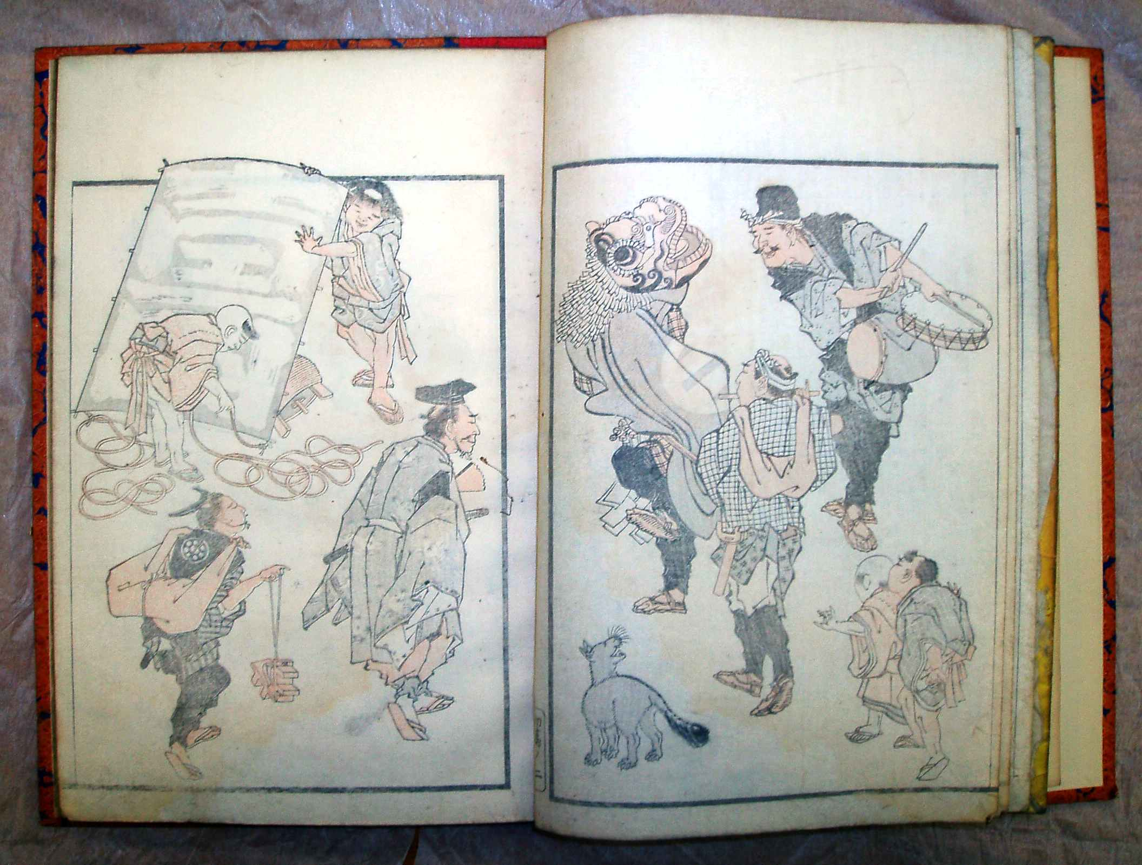

Ill. 1. A double-page from *Hokuun Manga*. The British Museum.

**The Titles of *Hokusai Manga* Volumes**

The majority of editions of *HM* have vertical strips of paper with the title glued on the left side of the cover. These strips are called *daisen* 題簽. In the upper part of a *daisen,* the text is written in two columns (*tsunogaki* 角書き) with two little characters in each column. (The translation and interpretation of these characters I will discuss later.) Below are the large characters *Hokusai Manga* and the number of the volume from the Initial issue (*shohen* 初編) to the Second and on to the Fifteenth.

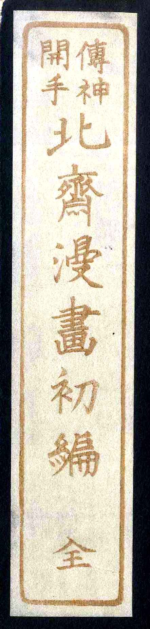

Ill. 2. The title of the First Volume of *Hokusai Manga*.

Four little characters *denshin kaishū* 傳神開手 in the upper part of the strip serve as a supra-heading, as they often did in old Japanese books. Usually, *denshin kaishū* is understood as “a drawing manual” in a few variations:

1. “The education of beginners by the spirit of things.”[13]
2. “Das Wesen Vermitteln und das malen lernen.”[14]
3. “L'initiation a la transmission de l'essence des choses.”[15]
4. “Transmitting the Spirit, Revealing the Form of Things.”[16]

There are rather convoluted explanations: “Denshin Kaishu means “imparting the essential nature of a subject to the viewer so that they can also learn the art of painting,”[17] and there is the commendably simple: “Meaning unknown.”[18]

Because the meaning of this locution is very important, in my opinion, for an understanding of the essence of *HM*, it deserves thorough investigation. Where did it come from to become the title of *HM*?

It first appeared as a seal’s impression on the publisher’s wrapping band (*fukuro*袋) of the first volume of *HM*, printed in the first month of 1814. Besides this, it is written as the heading of the Introduction to this volume: “The Introduction (*jo*) to *densin kaishū*”. The author of this text was Hanshū Sanjin半洲散人, about whom not much is known apart from the fact that he was amongst the group of artists who hosted Hokusai in Nagoya in 1812. Hanshū Sanjin used the two parts of this expression (*denshin* and *kaishū*) separately in his eulogy. *Denshin* goes back to one of the primeval concepts of Chinese aesthetic theory, *chuanshen* (“transmission of the soul or essence”), in a work of art. The origin of this concept can be traced back to the teaching of *wenqi* (Jap. *bunki*文氣) proposed by the poet and theorist Cao Pi (曹丕, 187-226). *Wenqi* is often translated as “the pneuma of literature;” in a broader context it can be understood as the emanation of culture. The idea of *chuanshen* was treated in a detailed way by the great Song poet Su Shi (蘇軾, 1037-1101), whose depiction appears several times in the pages of *HM*. He taught that, in poems, as well as in paintings, it is necessary to capture the true spirit or essence of the object. For some artists, such as the famous painter of the Jing dynasty Gu Hutou顧虎頭 (better known as Gu Kaizhi顧愷之, 344—ca. 405), this spirit is located in the pupils of the eyes, while other artists place their indomitable spirit points in other locations.[19]

In other words, “the transmission of the essence” was understood as capturing a certain spiritual wave emanating from the object and its fixation by the artist in his material representation (thus being perceptible to a spectator as an emanation from the artist’s work.) Hence, in his wording, Hanshū Sanjin connected Hokusai to the thousand-year-old venerated traditions of the spirited Chinese artists and poets.

At the end of his Introduction, Hanshū Sanjin used the combination of *kaishū* (lit. “opened hand”) in the sentence where he said that those who wish to master truthful drawing should use this *kaishū*. This binôme is found only in a very specific usage in the art of karate (“the mode of the open hand”); its usage in the meaning “a manual” is not known in dictionaries. Because of this, the editors who issued a modern edition of *HM* explained this expression as *nyūmonhen* 入門編 (“introductory handbook”). But the genre of *HM* does not look like a manual for novice artists (the genre specificity will be discussed later). It is clear that it can be used as a certain instruction, but how exactly? I think that, with the combination of the classical Chinese aesthetic term *denshin* and the nonce word *kaishū* in the heading of his Introduction, Hanshū Sanjin had in mind something along these lines: *[The Manual] Opening how by Hand the Spirit can be Transmitted*, or *The Guide Opening how to Transmit the Essence*, or, in accordance with the two-tact principle of translation of four-character Chinese formulae, *The Transmission of Spirit and Opening of Skills*. (In the semantic field of the character *shū*, “hand,” there are meanings such as “skills, dexterity, or manual.”)

As a result of all these meanings, the felicitous find of Hanshū Sanjin was transferred to the wrapping of the book in the form of an aphorism engraved on a seal. Perhaps it was done at the last moment, as the style of the engraving is rather crude. In the following editions, the cover wrappings bear impressions of different (better) seals with the same text. Thus, the expression *Denshin kaishū* became a part of the title of *HM* and found its way onto the paper strips of the *daisen* – and later to bibliographic descriptions – as a supra-title.

**Genres of Picture Books before Hokusai**

**It is important to know the history of the term *manga* but no less important to place *HM* in the context of picture books by Hokusai’s predecessors even if their books did not have the word *manga* in their titles. To this end we can mark out four main groups:**

1. **Books with drawings of comic subjects or grotesque characters.**
2. **Collections of classical subjects and iconographic samples, which often served as reference books for young artists.**
3. **Manuals of drawing of various contents.**
4. **Illustrated dictionaries and thematic compilations.**

**The first group is significant not only for *HM* but for all *manga* of the 20th century. Its history, according to Shimizu Isao, “is still not known well enough for the broad audience in Japan.”[20] Shimizu brings the beginning of the comic *manga* to the early 18th century – the books of caricatures *toba-e*** 鳥羽絵 **that have a remote ancestor in *Chōjū giga*** 鳥獣戯画, **the famous hand scroll of the 12th century about animals’ frolics, attributed to Toba Sojō** 鳥羽 僧正. Prominent representatives of this style were Takehara Shunchōsai竹原春潮斎 (first half of the 18th c.) and Hasegawa Mitsunobu長谷川光信 (mid-18th c.). The *toba-e* style was recognizable by the grotesque caricaturistic drawings with skinny figures, which resembled sticks (for example, *Toba-e ogi no mato*鳥羽絵扇の的, [*A Target Shaped as a Fan in the Toba Style*], the artist Ooka Shunboku 大岡春卜, the publisher Terada Yoemon, 1720) and the more lively compositions of Shunchōsai in a book *Toba-e akubi dome*鳥羽絵欠び留 (*Humorous Pictures Toba-e for Stop Yawning*, 1720, the second edition of 1793, which Hokusai would probably have known). Hokusai himself resorted to this manner, such as in his book *Fūryū odoke hyakku*風流戯百句 (*One Hundred Poems with Risque Jokes*, ca. 1811). Some subjects from this book closely resemble humorous pages in the 12th volume of *HM* (see, for instance, XII-7l-8r). Even more correlations with *toba-e* can be seen in Hokusai’s motifs and the grotesque shapes of his figures – cf. the composition with Sato no Tadanobu forcing his way with the help of a *go* board through a group of attackers (IV-4l) and the similar composition in Hasegawa Mitsunobu’s book *Toba-e fudebyōshi*鳥羽絵筆拍子 (*Brush Rhythms in the Toba Style*), 1724. (See ill. 3 and 4).

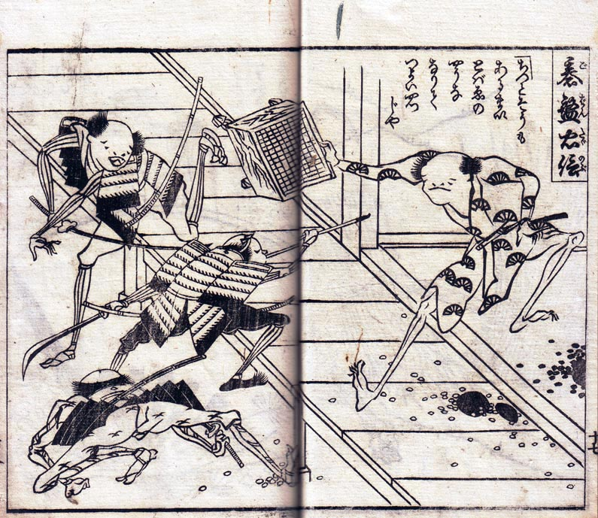

Ill. 3. Hasegawa Mitsunobu. *Toba-e fudebyōshi,* 1724.



Ill. 4. *Hokusai Manga*, IV-4l.

Besides *toba-e*, to this group belong numerous picture books in the genres *kyōga*, *giga* and *ryakuga*. Hokusai produced “comic (or crazy) pictures” (*kyōga)* himself, and his disciples were involved with this genre too. For example, shortly before the release of the First volume of *HM,* Bokusen published *Kyōgaen* 狂画苑 (*The Garden of Comic Pictures*) in three volumes. Many subjects and the manner of representation foreshadowed Hokusai (such as human figures with enormously long arms and legs, or people playing the *janken* game, or heroes of the past shown in a risible manner). As for the “sketchy (or abbreviated, or simplified) drawing” *ryakuga*, Hokusai was preceded by Kitao Masayoshi北尾正美 (alias Kuwagata Keisai 鍬形蕙斎, 1764-1824), who published two albums in 1795: *Ryakuga shiki* 略画式 (*The Method of Simplified Drawing*) and *Shoshoku ekagami* 諸職畫鑑 (*The Mirror of Images of All Craftsmen*). The first book is divided into two parts: “Playing animals” and “People.” Keisai represented many specific postures and attitudes of various animals – for instance, 54 postures of cats or 24 of tigers. In the second part he depicted many artisans working at their crafts. Soon, this interesting artist was practically forgotten, obscured by a deep shadow cast over him by Hokusai.[21] The genre of such pictures actually has a long tradition going back to mediaeval scrolls of contests between artisans (*Shokunin uta-awase*職人歌合わせ). Hokusai must have known this. Moreover, it is evident that he had thoroughly absorbed Keisai’s method and developed it further. This fact was already noticed by one of the first enthusiasts and connoisseurs of Japanese art in Europe, Theodore Duret: “In publishing his Mangua, Hokusai was simply taking the same path that the other artist had already gone down [ryakuhitsu], and enlarging it.”[22]

There are numerous games depicted in the Eleventh volume of *HM,* and Hokusai would not only have seen them in the real world but could also have borrowed them from the picture book *Ehon otona asobi*絵本大人遊 (*A Book of Pictures of Adults’ Games and Amusements*, 1792-93). There, he would have seen many comically treated grimaces, which he included in his Tenth volume in large quantities.[23]

**The second group** consists of old Chinese and Japanese compendia of samples of paintings. There are such well-known books as *The Instruction of Painting from The Studio of Ten Bamboos* (Ch. *Shizhuizhai huapu*, Jap. *Jitchikusai shogafu* 十竹齎書画譜), 1627-33, compiled by Hu Zhengyang, and *The Transmission of Painting from The Mustard Seed Garden* (Ch. *Jieziyuan* *Huazhuan*, Jap. *Kaishien gaden*芥子園画伝), 1679-1701, compiled by Li Yu. The latter was especially popular in Japan, and his influence on Hokusai will be discussed later. We should also mention *A Collection of Eight Kinds of Painting* (Ch. *Bazhong huapu*, Jap. *Hasshu gafu*八種画譜, 1620-28) compiled by the Hangzhou scholar Huang Fengchi黃鳳池 (1558-1626). In Japan it was first published in Kyoto in 1672 and reprinted in 1710. It included 421 full-page illustrations, 213 of which dealt with the realm of nature. Besides this, there were illustrations to the subjects of Chinese classical poetry and reproductions of famous Chinese paintings. For Japanese artists, *Hassu gafu* was the first extensive source of information on Chinese painting – both in compositions and in technique. It was especially popular amongst the artists of the Nanga School. Subsequently it yielded its popularity to *The Mustard Seed Garden*.

On top of the above-mentioned, another Chinese book gained popularity in Japan: *Liexian quanzhuan* (Jap. *Ressen zenden*列仙全伝, *The Complete Biographies of the Host of Immortals*), compiled by Wang Shizhen 王世貞 (1526-90). It included numerous legends about Daoist immortals and was published in ten volumes in 1650, reissued in three volumes in 1775. In Japan it was printed in Kyoto in 1791 in eight illustrated volumes (*Uzō ressen zenden*有象列仙全傳). Hokusai would certainly have known it, as well as a collection of comic verses about various personages from this book that was published slightly later (*Kyōka ressen zenden*狂歌列仙画像集).

As for the Japanese sources, one should mention texts of masters of the Kanō School and other classical artists who made annotated lists of subjects and motives for their disciples. First of all were the books of Tachibana Morikuni 橘守国 (1679-1748). He drew and wrote several manuals which were very popular up to the publication of *HM*. Amongst Tachibana’s books were the following: *Ehon shahōbukuro* 絵本冩宝袋 (*A Book of Pictures: A Sack of Precious Images*, 1710, reprinted in 1770) in ten volumes; *Ehon shoshin hashira date* 絵本初心柱立 (*A Book of Pictures: The Pillar for Beginners*, 1715); *Shasei kimono zuga* 写生獣図画 (*The Drawings of Animals in the Truthful Style*, 1719); the monumental *Ehon tsuhōshi* 絵本通宝志 (*A Book of Pictures: The Collection of the Treasures of the World*, 1729) and *Ehon nezashi takara* 絵本直指宝 (*A Book of Pictures: The Treasure of Direct Learning*. 1745) – more than thirty volumes in total.

Another important source for studying the laws of painting, as well as themes and subjects, was the book by Hayashi Moriatsu 林守篤 (beginning of the 18th c.) *Gasen* 画筌 (*The* *Dragnet of Pictures*, 1721). This compendium contains six volumes. According to the Introduction, it was written in 1712. Moriatsu was a disciple of the famous Kanō Tan’yū 狩野探幽 (1602-1674). The first volume includes theoretical discourses; the next four demonstrate samples of landscapes, plants, animals, birds, and Chinese and Japanese figures, as well as recommendations on how to depict them correctly. The last volume gives advice on how to mount paintings and how to care for scrolls. As a student of the Kanō School in his younger years, Hokusai would surely have studied this book. 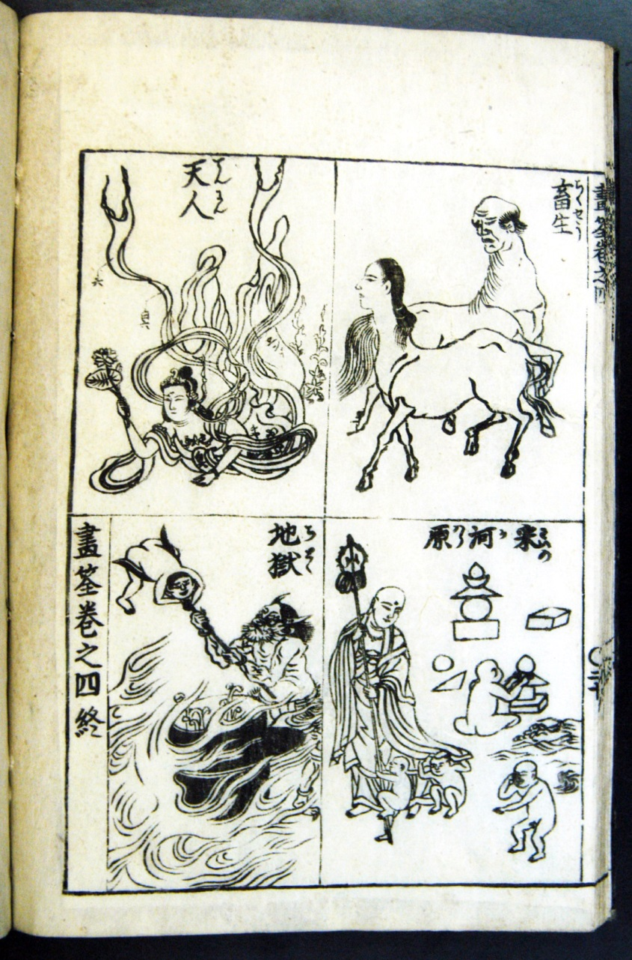

Ill. 5. Hayashi Moriatsu. *Gasen*. Scenes of Hell.

As for technical drawings, such as armour and weapons, or Western motifs, Hokusai could have sought guidance in the book *Kōmō zatsuwa* 紅毛雑話 (*Various Observations on the Red Hair [Peoples]*, 1787). It was a treatise by Morishima Chūryō 森嶋中良 (1754-1810?), which was the free adaptation of the Dutch version of the French *Dictionnaire Oeconomique* by Abbé Noel Chomel (1633-1712) brought to Nagasaki by Isaac Titsingh in the early 1780s. It was published in 1787 with illustrations by Shiba Kōkan and Kitao Masayoshi. Hokusai made a close copy of a bear trap with a gun in front of a den (see XIII-15l-16r).

**The third group includes numerous books with the words *edehon* (“manual of drawing”) or *gafu* (“tutorial of Painting”). Hokusai himself produced quite a lot of them. Amongst his immediate predecessors, one may mention Kawamura Bunpō** 河村文鳳 (1779-1821), who in 1811-12 published three volumes of *Bunpō gafu* 文鳳画譜 (*Bunpō’s Tutorial of Painting*) with numerous small figures of men and beasts populating the pages.

The **fourth** group comprises books of an encyclopedic nature, such as the Chinese *Sancai* *tuhui* 三才圖會 (*The Compilation of Three Natures* *in Pictures*, 1607) compiled by the scholar Wang Qi. This fundamental edition was popular in Japan both in its original form and in a Japanese adaptation by Osaka’s scholar Terajima Ryōan 寺島良安. His work under the title *Wakan sansei zue* 倭漢三才圖會 (*Japanese-Chinese Compilation of Three Natures in Pictures*) was published in 1712-15 in 81 volumes. It contains 105 chapters about pretty much everything – from celestial constellations to plants to descriptions of crafts. One more important source was the compendium of Buddhist iconography *Butsuzō zui* 仏像図彙 (*The Collection of Buddhist* *Imagery*) compiled in 1690 by Kanō Hidenobu 狩野秀信 on Chinese materials. It contains more than eight hundred sample images of buddhas, bodhisattvas, and other Buddhist figures alongside Buddhist ritual objects and implements. Its new edition was issued in 1783; Hokusai made extensive use of the images from this book 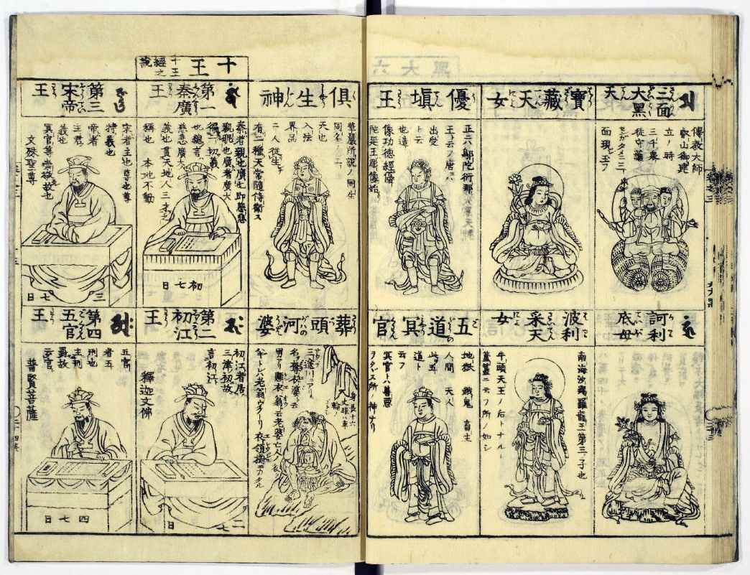

Ill. 6. Kanō Hidenobu. *Butsuzō zui*. Scenes of Hell and other characters.

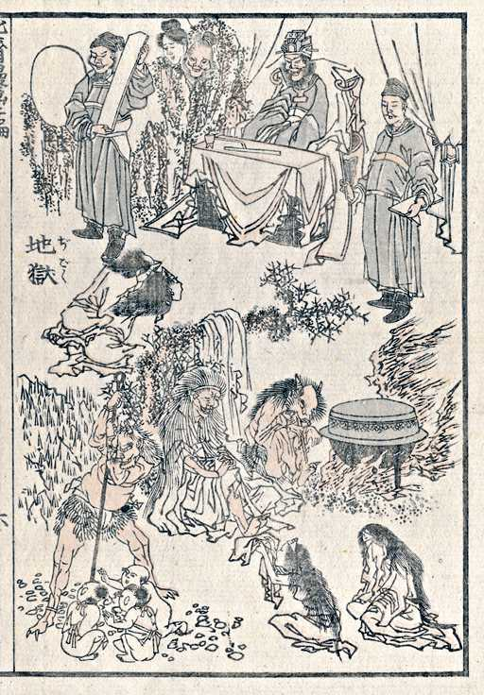

Ill. 7. *Hokusai Manga*, II-6r. Scenes of Hell.

Even more important as a source of information was the bestiary of another Kanō artist, Toriyama Sekien 鳥山 石燕 (1712-1788). His book *Gazu hyakki yakō*画図百鬼夜行(*The Night Parade of Hundreds of Demons*) was published around 1776 and continued in 1779, 1780 and 1784. It depicted all kinds of ghosts, demons, devils, animated musical instruments and home utensils etc. Sekien relied on the scrolls of artists of the Tosa School, who drew “one hundred demons” back in the Muromachi epoch. For example, there is a hand scroll traditionally attributed to Tosa Mitsunobu (1434-1525), *Hyakki yakō emaki*百鬼夜行絵巻 (*The Hand scroll of the Night Parade of Hundreds of Demons)*, which belongs to Shinjuan sub-temple of Daitokuji monastery and is ranked a National Treasure. The earliest extant scroll is that of Tosa Yukihide (alias Fujiwara Yukihide伝土佐行秀, who worked from 1410 to 1430). In 1770, pictures from his *Hyakki yakō* were engraved and published in the collection *Kyōgaen* (The Garden of Comic Pictures) in Kyoto by an artist named Sōkensai (or Suzuki Rinshō鈴木鄰松). These images were most certainly used by Sekien and, most probably, by Hokusai. In *HM* there are more than thirty images of ghosts and fantastic creatures that look very similar to Sekien’s.

At the end of this section let us outline the broader context of *HM* – comparing it with typologically similar European works. Hokusai’s *Manga* can be compared with the genre of mediaeval encyclopedias and compendia *summa universalis*, which were compiled throughout the Middle Ages, beginning with *De Universo* by Hrabanus Maurus (ca. 789-856). The closest visual similarity to Hokusai in old Europe is perhaps the album of drawings by Villard de Honnecourt (13 c.), although the quantity (ca. 250) and the level of compositional organization are not as significant as in Hokusai’s work. Nevertheless, Villard, as well as Hokusai, represented religious subjects and motifs, architectural drawings, various technical implements and machines, people, and animals.[24] Perhaps, to many savant readers, *HM* resembles the albums and notebooks of Leonardo da Vinci, but let us mention in passing that Leonardo was inspired by a totally different artistic strategy: *varietà*.[25]

**The Genre of *Hokusai Manga***

With this lengthy list of forerunners and sources (the above-mentioned are not exhaustive but serve as typological samples), the problem of defining *HM*’s genre is not easy to solve. In the Introductions to several volumes of *HM*, their authors described the circumstances of *HM*’s creation. Thus, Hanshū Sanjin wrote in the First volume, “Verily, those who really desire to learn how to draw should open [this book] as a manual.” But he made this conclusion after praising the incompatible art of Hokusai in depicting everything in the world. In other words, this does not mean that *HM* was originally envisioned as a manual for disciples.

Two other Introductions tell us more directly that Hokusai had intended to provide his disciples with a teaching aid. Kōzan Gyoō 絳山漁翁 in his Introduction to the Fourth volume says, “Indeed, the master created the guidebook for his disciples! His care and kindness make him a real teacher.” The same Gyoō elaborated on this subject in the Introduction to the Eighth volume:

Many [aspiring artists] flocked to [Hokusai’s] gate to study his art. However, the Reverend said, “There are no teachers in drawing. One ought to realistically recreate [life], and then you get everything by yourselves.” But those who entered the gate were saddened by these [words.] One of them uttered persuasively, “The Reverend is the founder of the art family Katsushika. The juniors who gathered here crave for [learning] this style. Naturally, there is no one besides the Teacher who can be asked [to instruct] in this. <…> If disciples who came to the gate of the Reverend do not get the book of his samples, they will not grasp the spirit of Katsushika [School.] Is it not evident?” <…> The Reverend absorbed these words and began to depict mountains and waters, human figures, beasts and birds, plants and trees, pots and utensils. By letting [all this] be engraved, he endowed his disciples with it.

**The “book of samples” (*rimpon*** 臨本) can also be translated as a “book for copying.” It was a generic name for teaching aids for art students – for example, *The Manual of the Mustard Seed Garden* was defined by this word – but, as we will see later, *HM* can by no means be reduced to drawing samples and how-to aids. (That said, some images could be used, of course, in this capacity.)

Besides the private opinion of Kōzan Gyoō, there were other reasons for the creation of *HM*. Thus, Ryūtei Tanehiko 柳亭種彦 (1783-1842) in his Introduction to the Eleventh volume wrote about just “amateurs” who should be understood as admirers of Hokusai’s art in general and his *Manga* in particular. “Since that year of Bunka, he freely released his mind and feelings and, following his brush, this way or another he created ten volumes of engraved drawings already. Nevertheless, urged by his insatiable admirers, the Reverend took upon his brush again and, collecting those [subjects] that somehow poured out, promptly prepared this issue.” This point of view looks, in my opinion, more feasible. As for the allegations of specially envisioned and designed manuals for disciples, they had been expressed by only one author out of all the Introductions.

Concerning teaching aids, one should mention that Hokusai himself prepared quite a lot of them – and they bore the words *edehon* (“the drawing manual”) or *gafu* (kind of “tutorials” or “formulae of pictures”). His *edehon* minutely demonstrate the types of brushstrokes exemplified by the strokes of Chinese characters and enumerate the order of these strokes in the drawing of this or that picture. In his book *Santai gafu* 三體画譜 (*The Formulae of Pictures in Three Styles*), Hokusai draws landscapes in various styles and manners and marks these styles with special notation. *HM* is radically different from these types of technical (yet aesthetically appealing) books.

Perhaps the best definition of *HM* would be “a pictorial encyclopedia of Japanese life”. It includes images from the ancient mythology and religions of China and Japan, historical tales and narratives, literary stories, geography, crafts and occupations, mores, humor and games, and the worlds of plants and beasts to boot. In its breadth *HM* is simply unique.

With this abundance of predecessors to *HM* – iconographic compendia, manuals for artists, and illustrated encyclopedias – a question emerges: was Hokusai original in his *Manga*, and if so, to what extent? Why is his *Manga* so famous whilst many other books are known only to a narrow circle of specialists? In what respects does *HM* differ from other similar picture books? Well, as for its fame, to a certain degree it is a matter of chance: the issues of *HM* were printed in huge runs and were brought to Europe early, and it was in Europe that the notion of his grandiose uniqueness was formed, whereas other artists who worked in similar genres were known only to a few well-informed connoisseurs. This fact, incidentally, explains the bewilderment of educated Japanese at the end of the 19th century who believed that Western admirers were elevating the fame of Hokusai to too high a level. Here, we witness a typical a typical overvaluation of a figure beyond his context. On the other hand, Hokusai is by no means a typical artist, and although not as unique as the first European aficionados thought, is undoubtedly great. In *HM* his grandeur was revealed in his use of many different sources to create something principally new and of higher quality. First, it has thematic broadness. Second, it has genre broadness: to the body of traditional art manuals and compendia he added a humorous element – the drawings in comic styles, such as *kyōga*, *ryakuga* and so on. On top of the simple comic effect he often added a satirical dimension based, inter alia, on wordplay (see, for example, the Twelfth volume). This was quite a new implementation. Finally, one should not forget that, while borrowing from iconography, Hokusai drew in his own style – which means in a more aesthetically interesting and skillful way than the majority of his forerunners. Many of them, being painters, considered their picture books of samples as technical aids, and because of this they often drew quite schematically. Hokusai, to the contrary, being a born draughtsman, viewed this work as self-sufficient. In other words, the unique character of *HM* lies in its universality and aesthetic qualities.

------------------

**Evgeny Steiner**

Professor, School of Asian Studies, National Research University Higher School of Economics, Moscow;

Professorial research Associate, Japan research Centre, SOAS, University of London.

1. This study was carried out within “The National Research University Higher School of Economics’ Academic Fund Program in 2013-2014, research grant No. № 12-01-0197”.
2. See, for instance, Bouquillard, Jocelyn and Marquet, Christophe, *Hokusai, First Manga Master*. N. Y.: Abrams, 2007.
3. Aikawa Minwa 合川珉和. *Manga Hyakujo* 漫画百女. Publisher Maekawa Rokuzaemon前川六左衛門 et al., 1814.
4. This poem and its translation is borrowed from the book: Kern, Adam. *Manga from the Floating World: Comicbook Culture and the Kibyōshi of Edo Japan*. Cambridge: Harvard University Press, 2005, p. 142.
5. It is not easy even to give a definite reading of the characters漫画図考群蝶画英: It may be *Mankaku zukō gunchō kakuei* (this is the opinion of the researcher of the early *manga* Isao Simizu – see Simizu Isao清水勳*,*  *Edo no Manga: taihei no yo no esupuri*江戶のまんが : 泰平の世のエスプリ [Manga of the Edo Time: The Spirit of the Great Epoch], Tokyo: Kodansha, 2003, p. 178) or *Manga zukō gunchō gaei* (several library catalogues).
6. Shimizu Isao, *Manga no Rekishi*漫画の歴史 [History of Manga], p. 19.
7. See the photograph of it in Shimizu 2003, p. 176, ill. 84.
8. It was noted at the same time by another Japanese researcher, Miyamoto Hirohito, but he did comment on any possible connection between the bird and the genre of pictures. See: Miyamoto Hirohito宮本大人. “Manga: Gainen no jūsōka katei” // Bijutsu 「漫画」概念の重層化過程－近世から近代における。美術史), #154, vol. LII, No. 2(2003), p. 319.
9. Translation is mine by the photograph in Shimizu 2003, p. 178.
10. At the end of this story one should point out two things: did Hokusai really read the Introduction to the *Mankaku Zuihitsu* book? Because there is no documented evidence of this, one can admit that he may not have done so. But might he not even have heard about such a bird with its strange name and such a memorable description of its habits? This is rather unlikely as he was very familiar with numerous Japanese editions of Chinese compendia and encyclopedias.
11. Mentioned in Shimizu 2003, p. 180.
12. See the general list in the aforementioned article by Miyamoto *Manga: gainen no jūsōka katei*.
13. <http://www.japanesegallery.co.uk/default.php?Sel=mmanga&Submenu=4>
14. Nagata Seiji (Ed.). *Hokusai*. Berlin: Nikolai, 2011, S. 205.
15. Christophe Marquet. “La réception au Japon des albums de peintures chinois du XVIIe siecle”. *Histoire et civilisation du livre – Revue internationale*. Vol. 3. Paris: Droz, 2007, p. 110.
16. <http://metmuseum.org/collections/search-the-collections/57682?img=3>
17. [www.berlinerfestspiele.de/.../mgb11_presse](http://www.berlinerfestspiele.de/.../mgb11_presse)
18. <http://www.artsconnected.org/resource/49557/random-sketches-by-hokusai-lx>
19. See more in: *Chinese Theories of Theater and Performance from Confucius to the Present*, ed. and translated by Faye Chungfang Fei. Ann Arbor: U. of Michigan, 1999. (First paperback 2002 p. 30), and Lee Won-gyu. “Sushi’s Theory of Chuanshen” // *The Journal of Chinese Language and Literature, vol. X (1998, August).*
20. Shimizu 2003, p. 62.
21. See the reproduction of these albums in a book with a telling title: *The Edo Draftsman Kuwagata Keisai: The Man Shaded by Hokusai* (Atsumi Kuniyasu, *Edo no kufusha Kuwagata Keisai: Hokusai no kesareta otoko*. Tokyo: Shohan, 1996. 渥美國泰著, 江戶の工夫者鍬形蕙斎 : 北斎に消された男.
22. Quoted via Marquet 2007, p. 22.
23. See, for instance, reproductions from Ehon orona asobi in an article by Suzuki Shigemi “The Examination of the Subjects in Hokusai’s Picture Books” in the book *Picture Books and Ukiyo-e* (*Hokusai ehon daizai kentō* 鈴木重三「北斎絵本の題材検討」、絵本と浮世絵), Tokyo: Bijutsu Shūppansha, 1978, pp. 214-215.
24. Now in Biblioteque Nationale, Paris, MS Fr 19093.
25. The category of *varietà* is dealt at length in the book: Баткин Л.М. *Леонардо да Винчи и особенности ренессансного творческого мышления*. Москва: Искусство, 1990, or, in a shorter form in: Batkin, Leonid. *Leonardo da Vinci*. Bari: Latezza, 1988.