

Nataliya S. Karpova

INTERNATIONAL GAS PROJECTS OF RUSSIA IN THE CONTEXT OF A CHANGING ECONOMIC ENVIRONMENT AND PARADIGM

WORKING PAPERS

SERIES: INTERNATIONAL RELATIONS

WP BRP 22/IR/2015

This working paper is an output of a research project implemented as part of the Individual Research Program of the School of World Economy and International Affairs at the Higher School of Economics (HSE). Any opinions or claims contained in this Working Paper do not necessarily reflect the views of HSE.

Nataliya S. Karpova[1]

**INTERNATIONAL GAS PROJECTS OF RUSSIA IN THE CONTEXT OF A CHANGING ECONOMIC ENVIRONMENT AND PARADIGM[2]**

**Abstract**

This paper explores the current changes in the world gas market where Russia has a wide spectrum of economic interests, international projects, as well as problems to be solved in the context with decline in demand and prices for natural gas and other energy commodities, growing contradictions and rivalry among the leading market players, political pressure and the introduction of market restrictions (sanctions). The country needs a new paradigm of development, pre-empting the future and reacting in the moment.

Keywords: world gas markets, key players, demand for energy, price volatility, the Russian gas strategy and projects, challenges of sanctions, strategies for the future.

JEL Classification: Z

**INTERNATIONAL GAS PROJECTS OF RUSSIA IN THE CONTEXT OF A CHANGING ECONOMIC ENVIRONMENT AND PARADIGM**

**Introduction:**

**Rethinking Talents**. Countries like people are endowed with a variety of talents that determine their destiny and paths of life. In lucky cases talents may be historically relevant and recognized by contemporaries, but may also be devaluated and lost in changing times. Talents not only present opportunities, but always require "fees": clear must for constant and hard work to cultivate and adopt the talent, as well as fight against external and even internal temptation of barbaric and predatory use or misuse. However, most gifted personalities do not want to give up and adhere to their destination due to or in spite of the difficulties and circumstances.

This phenomenon is observed in the life of countries whose "talents" are based on a unique combination of natural and historical factors that shape their material, intellectual and spiritual culture. Very often quite noticeable imperfections and shortcomings also come as logical continuation and accompaniment of talents and merits. Refined “chemistry” of all “ingredients” generates unique social and economic profiles of countries.

In times of profound changes in the global environment, especially during the so-called interphase transitions (say, from the current industrial to post-industrial society[3]) many latent and hardly predictable processes in the world economy, politics and society come to the surface. Changes and turbulences often raise constriction of traditional fields of activities and redistribution of spheres of influence of major world players that provoke their tough controversy and opposition (often in aggressive forms). All these could be summarized as eternal and infinite struggle of the Past and the Future (Old and New). In those periods traditional "talents" of countries and regions (as well as of other market players) are subjects to a very severe test, rethinking and even revision.

**Commodity markets and key players in the context of global changes and tensions**

One can guess the struggle in a very unstable behavior of commodities’ markets (natural and “in paper”) accompanied by multi-level and tangled “gearing” of resource-rich and interested countries to maintain or gain positions on transforming markets. It is not as mentioned a new phenomenon. Many times in modern history prices for products such as raw commodities have demonstrated high sensitivity to external changes and shocks. For instance, prices of oil had a very predictable reaction to political and economic changes, and to natural disasters such as hurricanes (Figure 1).

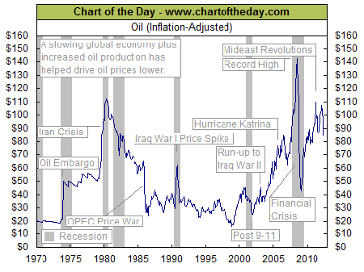

Figure 1. External shocks influencing world oil prices, 1970-2015

Source: http://www.chartoftheday.com/20110304.htm

The struggle for “strategic minerals” (as it was named in the USA more than 100 ago) accompanied by sharp decline in world prices has a long history. It usually went in counter phase with the global economic cycle and demonstrated its destructive (partly, innovative) character many times during the last century. The Middle East, rich in oil and gas region traditionally acts as a trigger for many oil shocks. Today we just observe some new or renovated scenarios.

Gas - natural gas (NG), liquefied natural gas (LNG) and gas from non-conventional resources or nonconventional (NCG) constitutes its own group of major energy resources and connectedly follows the crude oil price’ trends (although sometimes with a slight lags and minimal deviations). If we look at the diagram presenting weights of regions on gas markets in terms of proved gas reserves we see convincing predominance of the Middle East region with almost 45% of world gas reserves and of Europe & Eurasia region with more than 1/3 of them (Figure 2).

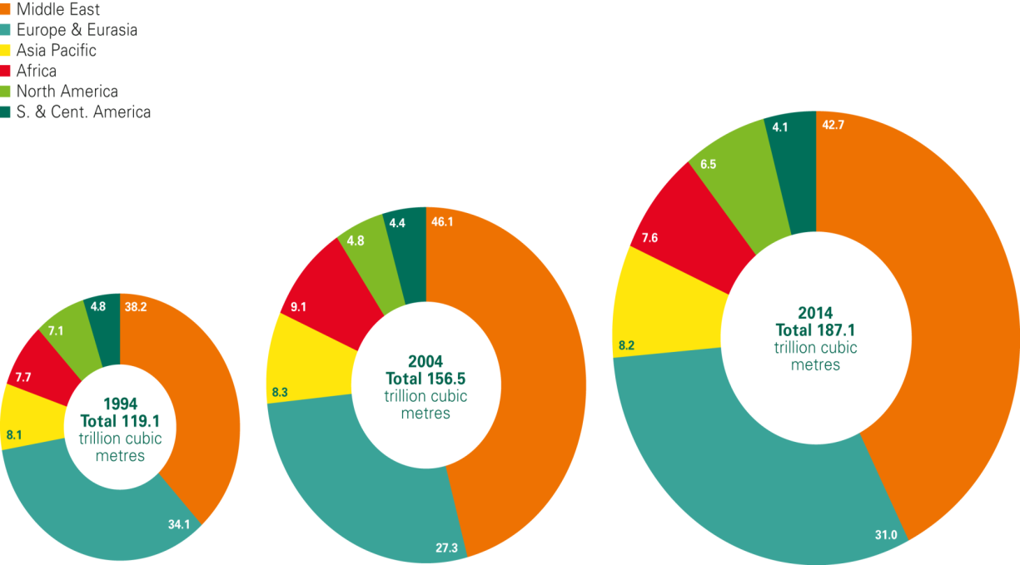

Figure2. Distribution of proved gas reserves: 1994, 2004 and 2014, %

Source: BP Statistical Review of World Energy, June 2015, bp.com/statisticalreview#BPstats, P.3

Even clearer is the ratio of reserves to local production in the region, where the Middle East has the greatest potential for growth (see Figure 3).

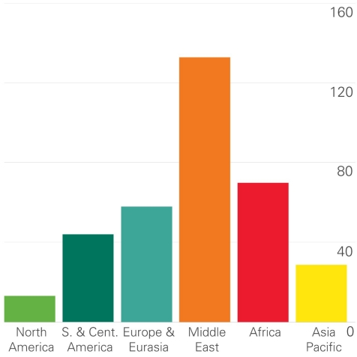

Figure 3. Reserves-to-production (R/P) ratios 2014 by region

Source: BP Statistical Review of World Energy, June 2015, bp.com/statisticalreview#BPstats, P.4

Military conflicts in the Middle East region are related to the gas, oil and other strategic resources (“local talents with global impact”) and can be seen as a new stage of continuous economic struggle for control over regional wealth.

Figures 2 and 3 give a clear idea of European commitment to gas markets and interests, too. This does not mean that other regions will remain uninvolved in the long term.

In the last 2 years energy prices have fallen faster than predicted by many experts: Ural oil approached $35 per barrel at the end of 2015 with some gloomy forecasts suggesting $16–20) instead of an expected price level of reversal to $50.

According to international oil and gas companies, after the price reduction to the level of leverage (roughly $50) demand starts to grow and production, reduced due to the low profitability, increases. This can take several years. However, nowadays experts started to doubt that leverage will take place at this level, suggesting an even lower figure.

The prices of gas on the main selling points and hubs went accordingly down with more visible connection to oil, back to its historic spread of $8 (Figure 4).

# Oil/Gas Relationship Returning To Normal

# Figure 4. Historical Oil/Gas Relationship Returning to Normal, November 1993-November 2015

# Source: http://oilprice.com/Energy/Oil-Prices/Chart-Of-The-Day-Natural-Gas-Suggests-33-Oil.html

It seems that the "leverage" at $50 does not work yet tending to act on the lower rates or takes more time for actualization (at least 2-3 years).

appearance of illegal and cheap oil[4] on the market in combination with other factors led to a devaluation of energy markets. Shifts and a slowdown in the global economy (“sneezing China” and etc.), changes in the energy production balance towards new sources, the influence of speculative markets, political rivalry, and climate changes made their own adjustments leaving niches for black swans.

Russia cannot be on the sidelines of gas interests as an undisputed leader in reserves and the second after the US natural gas’ producer[5] (Figure 5.).

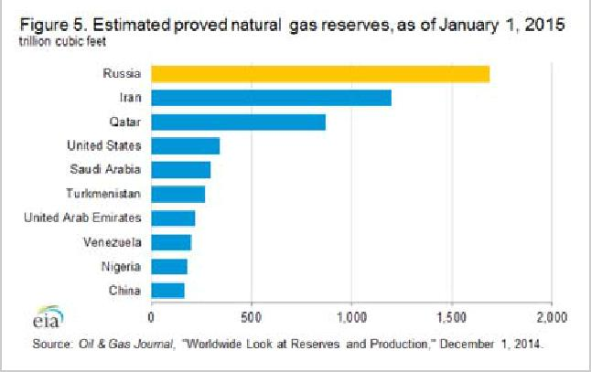

Figure 5. Estimated proven natural gas reserves, as of January 1, 2015, trillion cubic feet

Source: Oil & Gas Journal, "Worldwide Look at Reserves and Production," (December 1, 2014), P. 32.

The country is followed by Iran and Catar, and also at a certain visible distance by the USA, Saudi Arabia, Turkmenistan, United Arab Emirates, Venezuela, Nigeria and China. All of them look as interested and involved players in the current raw materials markets and their resegmentation.

In a very general description of the roles of the three main leaders, it turns out that for several decades Russia acts as a major supplier of natural gas (NG) to Europe, Qatar as the main exporter of liquefied natural gas (LNG) to Southern-East Asia and to the United States (with at least 3 big signed LNG-contracts for the periods up to 2036, mainly with international corporation), and Iran remains for political reasons an "offside" player for a number of years as a powerful hidden "card" in the game for the global gas market. Time for this “Joker”, apparently, will come in the near future (around 2017) and bring new market movements or even shocks.

Today all interested players on the gas and oil markets focus on the following options: to maintain market share by increasing production, to minimize costs or to bring falling prices back (to certain economically reasonable levels).

Oil-exporting countries (mainly OPEC) prefer to increase production volumes balancing total revenues against losses of falling prices, to save market share and to optimize costs associated with down-sizing established production facilities. Some aggressive new players in the Middle East impudently and even brutally focus on plundering oil and gas reservoirs and on building illegal production-marketing infrastructures. Before the Russian operation in Syria, spoliation was a very profitable campaign. In the future, from the perspectives of the international coalition in the fight against terrorism and its economic projects, profitability of resource capture is questionable. However, direct losses and a significantly narrowing base of revenues is unlikely to rein in terrorist leaders, but will give rise to a desperate resistance, probably, in the form of new projects. Whether they will continue to exploit regional benefits in energy sector or leave the depreciating energy markets, will become clear in the near future.

Commodity-rich countries look for an increase in energy prices and reduce production, observe and concern losses in their export revenues, deficits in their budgets and squeezing market capacities, as well as experience fluctuations of national currencies to US dollar. In 2015 Norwegian krone depreciated by 16%, Canadian dollar by 19%, Brazilian real by 50% (experts predict the difficulties for Saudi Arabian Riyal, Indian rupee and some other currencies).

The USA. Falling energy prices keep US dollar up. (As known, the movement of these indicators traditionally occurs in antiphase.) An increase of the discount rate by the Federal Reserve (from 0–0.25% to 0.25–0.5%) in December 2015 opened prospects for further strengthening of the dollar (at least theoretically). It gives new opportunities for expanding the economic influence of the United States US as a leader of new large-scale economic integration agreements—the Transatlantic Trade and Investment Partnership and the Trans-Pacific Partnership. The rise of the US currency will probably not affect national exports, and will support external investment. In addition to further expected expansion of traditional exports, the US returns as an exporter to the world energy markets – primarily, to the oil market after forty years’ break[6]. Changes in the gas sector look even more impressive. The volume of shale gas in the last 5–6 years has increased dramatically; its share exceeded 35% of total the US gas production (from 5% in 2007) and could reach 50% by 2025. The US will move from a major gas importer to an emerging exporter by 2017. The US has begun reconstruction and renovation of regasification terminals, built for imports, into LNG plants. By 2016, according to American data, technical requirements will be completed [Karpova, 2014a].

This transformation has happened for many reasons, including the well-known, although still disputable phenomenon of "shale revolution" which, in our opinion, is the brainchild of financial markets with 40+ years of preliminary technological evolution [Karpova, 2014a, pp.140–141]. Interpreted in any ways shale progress gives a chance to use economically attractive low prices for American gas, firstly, in the US Herry Hub (Figure 6) for gas export (launching in 2016 from reconstructed LNG terminals) and for a new wave of re-industrialization. Re-industrialization was widely advertised 3–4 years ago but in connection with the still unsolved problem of the US national debt, seemed at the time just a good intention.

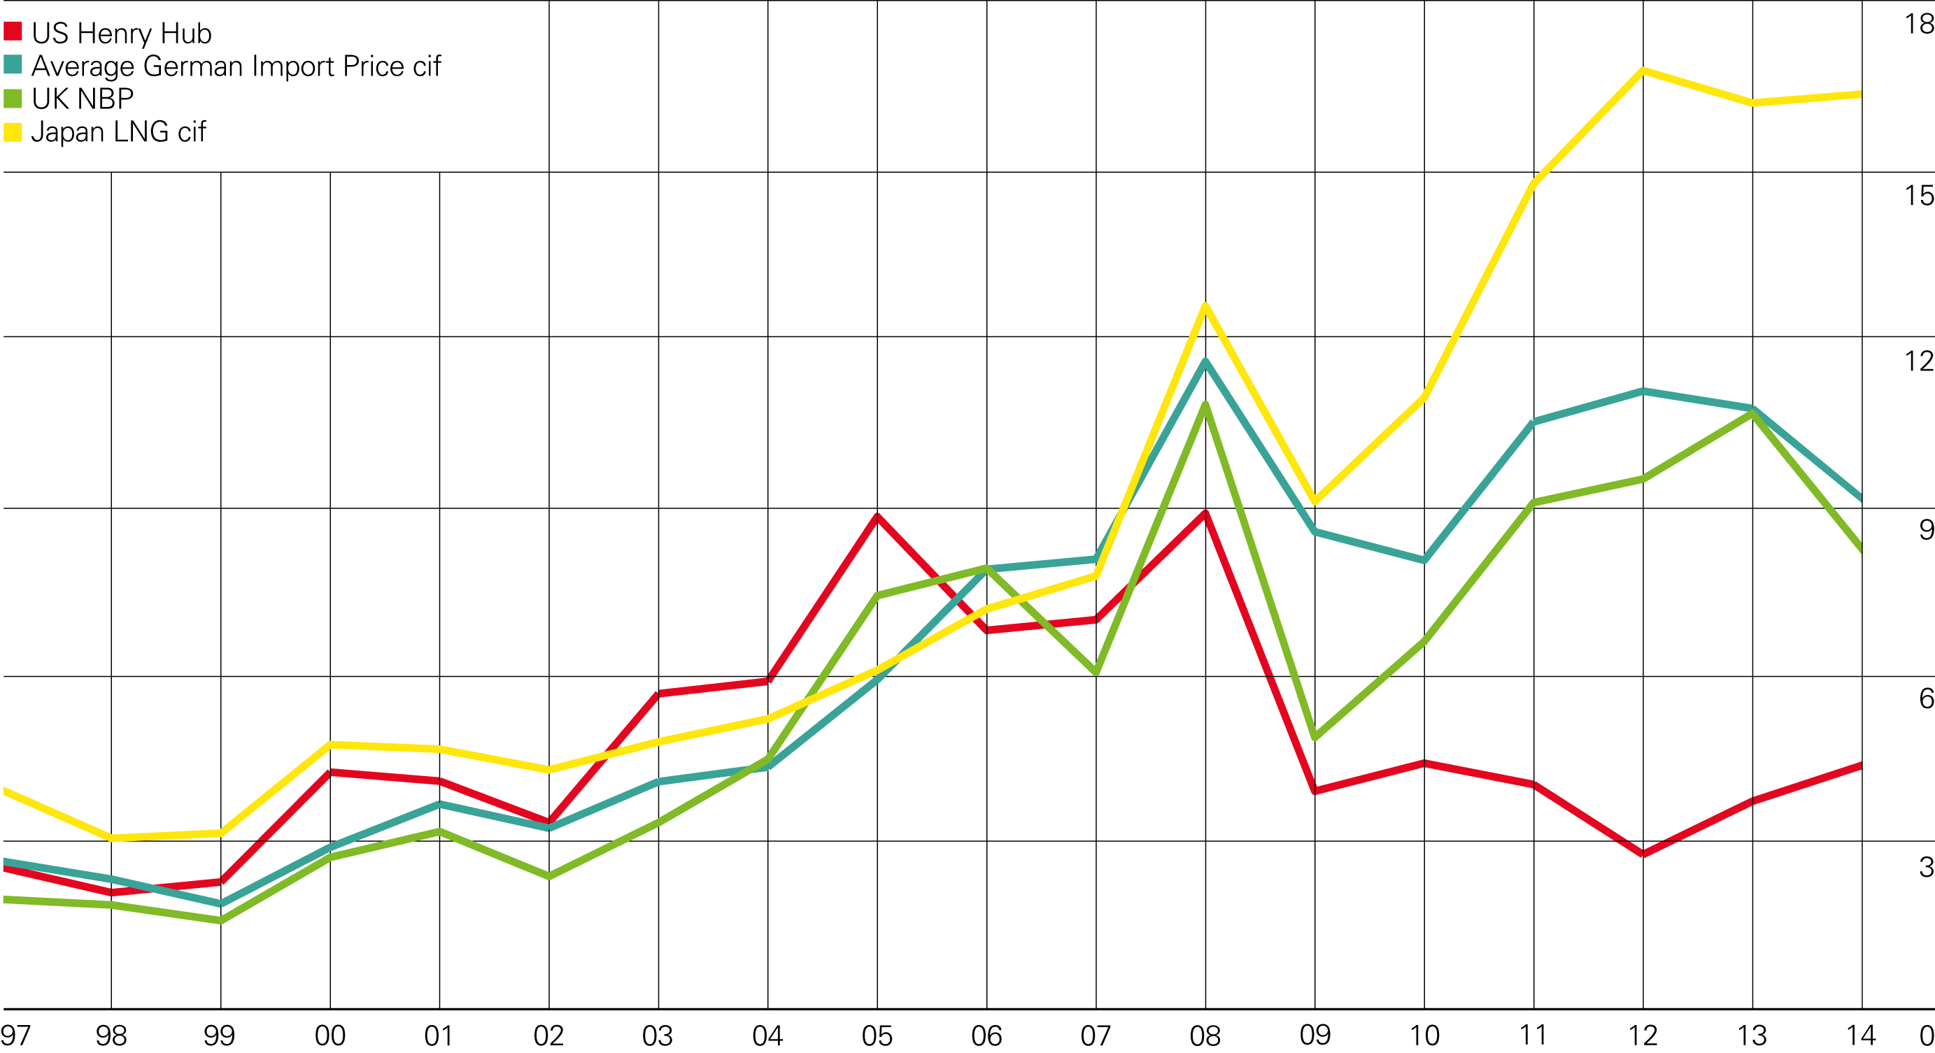

Figure 6. Gas prices in major selling points/hubs, $/Mmbtu, 1997-2014

Source: BP Statistical Review of World Energy, June 2015 bp.com/statisticalreview#BPstats, P.7.

New forceful factors give the United States a trump card in the game for world leadership, especially since this very purpose has been promoted and perceived as a great national idea. American experts talk about serious gains and bright perspectives of the national energy breakthrough. “The North American energy revolution is here, it is big, and it will only increase in importance as the United States comes close to becoming a net energy exporter, which is set to happen around 2020. The resulting shift in global energy supplies will benefit consuming countries and erode the power of traditional producers. These developments could also undercut OPEC’s traditional role as the manager of global energy prices, perhaps to the extent that energy prices plummet. Such a disturbance could, in turn, cascade through all countries that depend on hydrocarbons for their public finances. Even without such a dramatic drop in prices, the global flow of energy will continue to be transformed - and, with it, economic and geopolitical relationships. The United States, meanwhile, will be uniquely positioned to profit from the shift and seize new opportunities. The energy boom will add fuel to the country’s economic revitalization, and the reduction of its dependence on energy imports will give it some measure of greater diplomatic freedom and influence” [[Blackwill](https://www.foreignaffairs.com/authors/robert-d-blackwill" \o "More articles by Robert D. Blackwill)&[O'Sullivan](https://www.foreignaffairs.com/authors/meghan-l-osullivan), 2014].

No doubt that the United States are interested to use political advantages from market leadership and now demonstrate a play against competitors:

“…The United States should also begin using its new energy resources to prevent allies from being bullied by less friendly suppliers. …” [[Blackwill](https://www.foreignaffairs.com/authors/robert-d-blackwill" \o "More articles by Robert D. Blackwill)&[O'Sullivan](https://www.foreignaffairs.com/authors/meghan-l-osullivan), 2014].

Energy is considered as an important conductor of national interest and powerful factor in relations with allies and partners:

“…Applications for LNG terminals designed to send gas elsewhere, by contrast, must go through a review process that determines whether such trade is in the U.S. national interest. For the many countries in Asia and Europe that want to add U.S. natural gas imports to their energy mix, achieving this special trade status holds extra value. In fact, this incentive proved crucial in convincing Japan - hungry for gas in the wake of the Fukushima disaster, which took its entire nuclear power infrastructure offline - to join the talks for the Trans-Pacific Partnership…” [[Blackwill](https://www.foreignaffairs.com/authors/robert-d-blackwill" \o "More articles by Robert D. Blackwill)&[O'Sullivan](https://www.foreignaffairs.com/authors/meghan-l-osullivan), 2014].

Nevertheless, the first LNG deliveries from the United States scheduled for February 2016 to Europe – to Lithuania, long wished to “get rid” of “less friendly suppliers”. Negotiations on the first shipments focused understandably on price - the Lithuanian Lietuvos Energija asked US to sell gas at a price lower than in Russia. The list of other countries demonstrating readiness to “get rid” is quite predictable.

The country sends a clear message to the countries with potentially attractive markets for US’ energy export and cooperation:

“The shift in global energy … gives Washington a new way of reinforcing its alliances. Many countries now hope to follow the United States’ lead and start tapping their own unconventional gas and oil resources, and the U.S. government has started to integrate the country’s energy experience into its diplomacy. Two State Department projects - the Unconventional Gas Technical Engagement Program and the Energy Governance and Capacity Initiative - are bringing technical expertise from across the government to help other countries (so far, small developing ones) build up their own oil and gas industries ….” [[Blackwill](https://www.foreignaffairs.com/authors/robert-d-blackwill" \o "More articles by Robert D. Blackwill)&[O'Sullivan](https://www.foreignaffairs.com/authors/meghan-l-osullivan), 2014].

In January 2014 Chevron and Royal Dutch Shell at the end of several years of preparatory work signed a long-term (50-year sharing agreement in shale production with the Ukrainian government worth more than US$10 billion. Donbass was considered as one of the most attractive sources. President Viktor Yanukovych said at the time that these agreements would allow Ukraine by 2020 to fully provide itself with gas and even to start exports. Poland and Romania cancelled the preliminary agreement in this sphere for ecological reasons [Karpova, 2014b].

share the US’s optimism and are concerned about energy price fluctuations and a protracted economic recession. Debates in the European Union (especially in the Commission of Energy) with hard statements and claims for restrictive actions towards the recent partners just often camouflage contradictions between the members and manoeuvres to meet their vital economic interests at expense of others.

**The positions and reactions of Russia: gas projects**

Russia is strongly committed to the global gas market. The more than 50 international gas projects of Russia are a symbol of the country's role as a commodity giantof industrial era with its dominating mass production and consumption. One third of the gas produced is exported. More than 20 projects are transported via 175 000 km of pipelines, mainly from remote areas of Western Siberia, such as Yamburg, Urengoy, and Medvezhye fields). International gas projects are carried out by two dozen Russian companies, more than 90% of which are private, dominated by the "Gazprom" group which produces more than 77% of Russian gas. The state owns a controlling stake in Gazprom (50.002%) and acts as a guarantor of its activities in Russia and abroad.

Most projects are implemented in the field of dry natural gas, less in LNG. In a sense, Russia being closely linked with European commitments and gas infrastructure had missed an opportunity to take relevant position in the LNG market, which developed mainly in Southeast Asia.

Russia is also modestly represented on the market of NCG, although the first practical results in this sphere were achieved in the early 1950s (namely, in Donbass, Ukraine, USSR). Leading national companies carry out projects in this area, but they are seen as excessively costly, environmentally hazardous and far from commercial scale.

Russia initiates intense gas trade flows devoting serious efforts to economic, legal and technical infrastructures.(Figure 7).

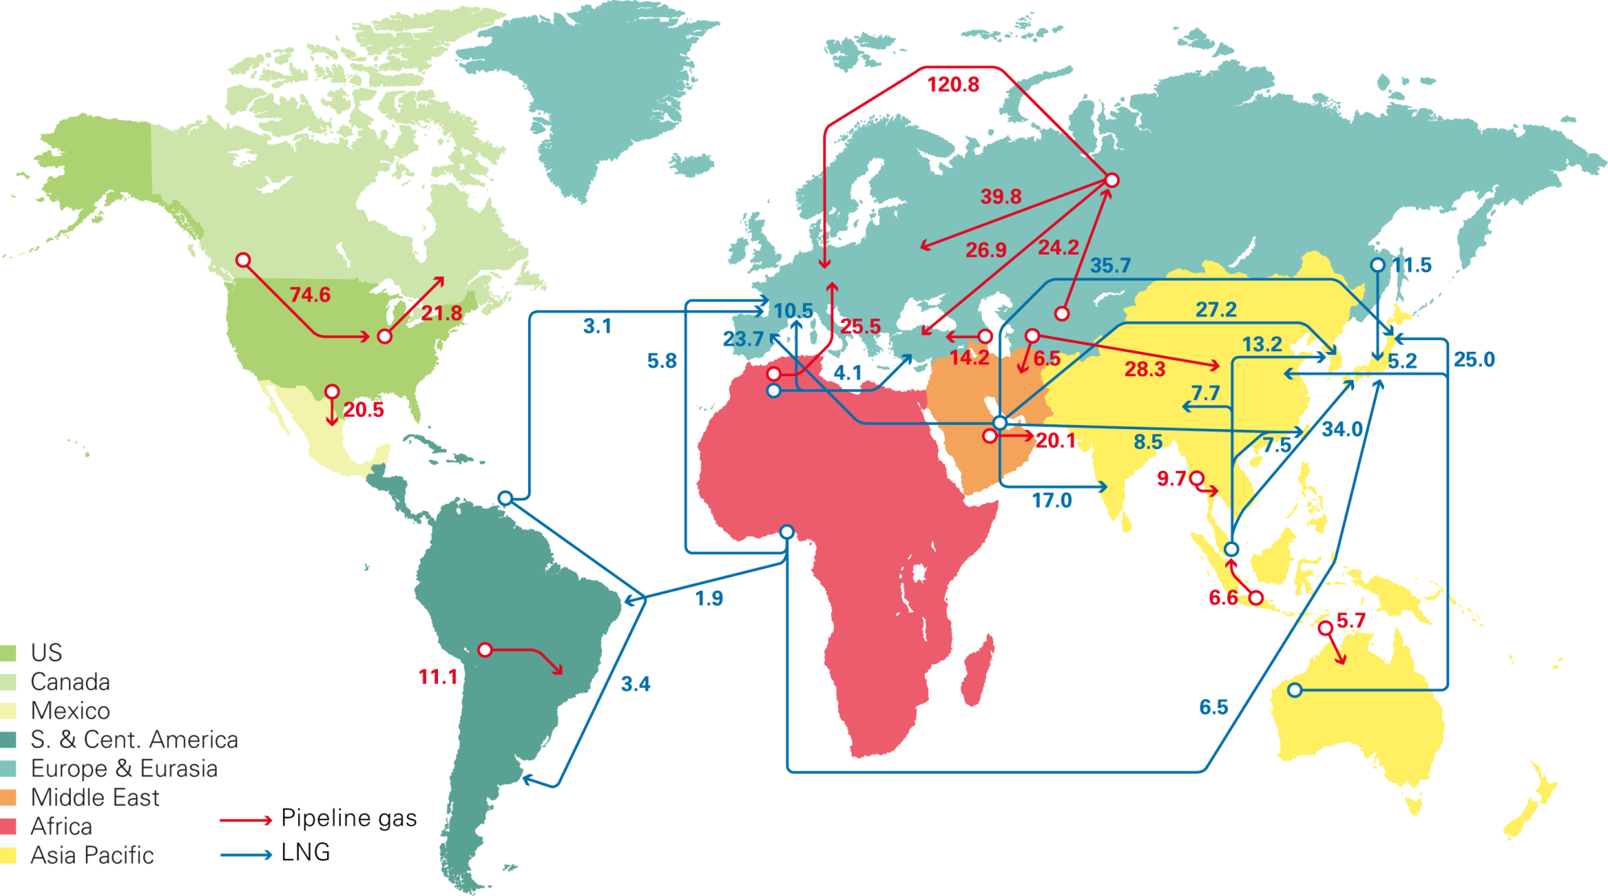

Figure 7. Major gas trade flows, 2014

Source: BP Statistical Review of World Energy, June 2015 bp.com/statisticalreview#BPstats, P.6.

Traditionally, Russian gas projects have been focused on neighbour close and economically prosperous (at least until the turbulences of 2010-s) countries of Europe. During the last decades the Russian gas sector was strongly integrated with the companies of interested countries and in fact played as a congruent part European economy, while staying outside the EU legal field. Russia and Europe are interdependent in terms of energy. Europe is dependent on Russia as a source of supply for both oil and natural gas, with more than 30% of European crude and natural gas supplies coming from Russia in 2014. (In 2013 about half of that volume was delivered via Ukraine.) Some countries within Europe, especially Finland, the Baltics’ states, southern-eastern Europe receive almost all of their natural gas from Russia. It arise their dissatisfaction of dependency and is often used as a basis for real and fictitious claims to Russia.

At the same time Russia is also dependent on Europe as a market for its oil and natural gas and the relevant export revenues. In 2014 almost 90% of Russia's natural gas exports went to Europe. All these considerations logically grounded the idea of a future “all-European economic space” which was shared by many experts and general public in Russia and partly abroad.

The European gas directory was constantly supplemented with other projects around the vast Russian border, first of all in Asia—in the former Soviet republics, Japan, China and Turkey. The role of Asian has grown in recent years mainly due to the Chinese market and its interest in the diversification and security of raw material supply. Existing enthusiasm has cooled due to the fact that Chinese economy is slowing and turning towards implementation of inward-focused strategy of a “new normal”. China also has the world's largest reserves of NCG. So far they were slightly evolved for technological and economic reasons; however, their activation could limit or modify the Russian gas projects in the future [Karpova, 2015].

Historically Russia was committed to dozens of smaller projects worldwide within a mutually beneficial scientific, technological and industrial cooperation in Vietnam, Algeria, Iraq, United Arab Emirates, Libya, Bolivia, and Venezuela. Serious preconditions for cooperation were built with interested partners in Argentina, Brazil, Bangladesh, Egypt, Pakistan, Iran, Sri Lanka, Uruguay, the Dominican Republic, Tanzania, Mozambique, Myanmar and other countries. In recent times it appeared that efforts to establish partnerships in different regions seem politically justified, but appeared to be quite costly in the context of low gas (oil) prices and economic sanctions.

The geographical variety of Russian gas projects has not reduced the importance of traditional relations. The “Nord Stream-2” agreement in September 2015 clearly demonstrated that the role of Europe for Russia remained crucial, despite reducing and structurally transforming demand for energy in Europe (and worldwide), controversies with Energy Union, difficulties of negotiating with some partners and the lack of a unified position within EU.

Long-standing debate concerning “state-controlled” Gazprom in the context of market liberalization and security is still quite painful dispute in EU. (At the same time one can clearly see widespread of state capitalism in Europe and other countries, noted in authoritative studies like World Investment Report, etc. and seen in life.) The European Commission has pursued energy market liberalization for a number of decades and the completion of the internal energy market is a stated aim of the Energy Union. A collective gas purchasing mechanism could fall foul of the EU’s own anti-trust laws regarding buyer cartels, affecting the idea of the Energy Union and leaving it on uncertain ground. The Southern Corridor, importing gas from the Caspian and Mediterranean, avoiding Russian transit, was touted as a way towards increasing supply security, but the progress of pipeline projects in this region has been slow.

An agreement on “Nord Stream-2” was signed by international companies but the EU Commission did not approve the project. It supported Poland and Ukraine’s intentions to remain key transit states despite—or indeed because of—geopolitical tensions in this region. The problem became the “elephant in the room” when EU leaders met in Brussels in December 2015, critics, mainly from Eastern Europe, complained that it would increase dependence on Russia; harm Ukraine, by ripping €2 billion a year from its budget; was against rules laid down by the third energy package; and violated the spirit of EU sanctions on Russia, which were designed to inflict pain in the energy and banking sectors. They also noted that with Nord Stream currently operating at just 50%, there was no market logic for expansion. Even Italy, considered a Russian ally, joined the Eastern European opposition criticizing “Nord Stream-2” in context with unfair previous blockage of the Russian pipeline to Italy as well as Southern Stream project. “Pipelines for us are a nightmare. Nabucco failed. South Stream failed. Turkish Stream failed and we have no alternative route in the south, while we are to double the capacity in the north,” one EU diplomat commented, listing three defunct EU and Russian pipeline projects [Zalan, 2015].

Another EU diplomat characterized “Nord Stream-2” as Germany and Russia’s €11 billion plan to double the capacity of their Baltic Sea gas pipeline. Representatives of Germany countered that the project would help EU energy security, by allowing Russia to keep supplying EU customers if it had any other dispute with Ukraine as a transit state [Radio Liberty, 2015].

The US voiced criticism, too. Amos Hochstein, the U.S. special envoy for international energy affairs, told the media on December 16 that Washington views the pipeline as part of Russia's “overarching political agenda to get rid of Ukraine as a transit country”. He called that an attempt to “undermine the economic stability of the county by non-military means” [Steinhauser, 2015]. “Elephant” really had done a noise and warmed up an atmosphere around prolongation of sanctions.

Sanctions initiated by the US Administration and its European allies and the fall of oil and gas prices and have reduced foreign investment in Russia, made it more difficult for Russian energy firms to finance new projects, especially higher-cost projects such as deepwater, Arctic offshore, and shale projects, and put pressure on the Russian economy in general. The sanctions against Russia put an end or temporarily interrupted exploration in most of places (for example, in China-oriented Yuzhno-Kirinskoye field) [US Energy Information Agency, 2015]. Among other measures, the sanctions limited Russian firms' access to the US capital market, specifically targeting four Russian energy companies: Novatek, Rosneft, Gazpromneft, and Transneft. Total agreed to explore shale resources in partnership with LUKoil, but then, because of sanctions, stopped its involvement in September 2015. ExxonMobil, Shell, BP, and Statoil also signed agreements with Russian companies to explore shale resources. But the cut-off of large-scale investments that Western firms had planned to make in these resources can complicate a way to the future gains of Russia in Arctic and other perspective fields. All these with limited by sanctions access to Western modern technologies and equipment can strike the Russian leading positions in the world’s gas and oil sectors in the future.

**The existence and ambiguity of external demand**

The phenomenon of the Russian economy’s reliance on the resource sectors is based on combination of two main internal and external factors: a resource-driven economic paradigm (fuelled by strong and often greedy and corrupt economic interests) and quite unbalanced by countries and regions but still a significant external demand for energy.

Despite the evident connotation of “blessing or curse” the Russian energy sector is attracting powerful economic and political actors in the country and abroad. The 21st century was supposed to be a “golden age of gas”, an environmentally friendly energy source with stable and growing projected demand at least until 2030s [International Energy Outlook, 2011]. Each percentage point of GDP growth in the world so far suggests 0.8–1.0% increase in energy consumption and in the fast-growing economies such as China and India it is much higher than 1.0%. Moreover today, 2.6 billion people in developing countries still use traditional biomass for heating and cooking, and 1.3 billion people have no access to electricity. For most developing countries expensive unconventional energy resources are not accessible for economic reasons in the foreseeable future. The situation is ambiguous and twofold—as long as the rich countries reduce the use of energy, poorer countries are looking for an opportunity to get access to it on acceptable terms.

The role of natural gas is difficult to overvalue in context with smooth but still very actual transfer of the UN’s Millennium Development Goals into Sustainable Development Goals. The UN General Assembly also adopted a resolution entitled "Promotion of new and renewable energy sources", where 2014–2024 was declared the Decade of Sustainable Energy for All. The resolution stressed the importance of public access to energy as the most important tool for poverty eradication and social and economic development in general. The current refugee crisis in Europe exposed new tensions between the “rich North” and the “poor South”. It bore out many visible and still invisible problems and contradictions, and clearly manifested what it meant to procrastinate in achieving the UN Goals.

**Blessing or curse?**

For many decades natural resources have acted as the most important factor of economic survival and development of Russia and an instrument of its interaction with the rest of the world. External demand, although quite volatile, has opened opportunities for Russia: (1) a relatively stable long-term income from exports; (2) the use of external demand and export as “a tool” to break economic and political blockades and the iron curtains in 1920, 1930–1970s etc.; (3) the availability of important goods and services on international markets in exchange for raw materials; (4) political and economic weight in international affairs.

The negative side is the character of a resource-driven economy. Revenues from the natural gas sector (export duties and taxes, including a tax on mineral extraction) form more than 5% of the Russian budget. (The contribution of oil revenues is 7-8 times higher and in the aggregate, these industries provide about 45-50% of the budget revenues).

At the same time revenues from natural gas exports in 2014 accounted for about 14% of Russia's total export revenues. As a result Russia's economic growth is highly dependent on and driven by energy exports. With world economic growth declining, a corresponding fall in demand for natural commodities and their price volatility increases the risks and economic instability of the Russian economy. In some assessments the correlation between world oil price and GDP is around 0.90. The estimated change in world oil and gas prices by ± 10% leads to a ± 1.5­–2% change in Russian GDP [Ollus, 2007]. The effect works through changes in government spending, investment and consumption it can be observed with some fluctuations but generally the correlation looks evident. In lucky periods of high world prices for energy resources the country’s generous export revenues attract envy glances from abroad and acute critics of corruption and questionable resource money “cutting” from inside.

This is not an exclusively Russian problem. Much empirical evidence suggest that countries with a large share of primary exports in GDP do not not fully reinvest their wealth and have bad growth records, high income differentiations and gaps in living standards, especially if quality of institutions, rule of law and corruption are bad [McKinsey Global Institute, 2013]. A fall in world primary resource prices and inbound decrease of the Russian GDP (and other economic and social indicators) demonstrated it with dramatic clearness.

The position of the market leader imposes on Russia a long list of duties. It is a great challenge to match market’s urgent needs and high long-term expectations in a very costly and risky energy sector. It envisages advanced potentials of the resource-rich countries and their companies in terms of economy, technology and labour. It fact Russia with 2.3% of world population produces 11.5% of global primary energy. It gives the Russian oil and gas sector a strategic importance for the world economy. It is also a matter of responsibility in business-customer relations and the image of Russia as reliable supplier. According to the Minister of Energy only in 2013 did the amount of investment pass $30 billion (nearly 5% of GDP). After a decline in 2014–15s, the amount has to be restored.

World practice shows that the gas sector is a complicated and risky business with large initial investments and tax burdens from one side, and slow outcome from the other. On average one gas project takes 15–25 years, namely: exploration, appraisal, development (5 years), production (10­–20 years), and decommissioning (1–2 years). Normally, only 1 out of 6 explorations is profitable. Expenditures grow year by year for distant and less accessible gas fields. They need unique and expensive drilling support structures and equipment, and demand vast additional investments. As a rule it takes 5–8 years before the first pay-out. Understandably, this business is a matter of big multinational companies which combine their efforts and share the risks in international projects.

It is important to underline that, as a rule, each Russian gas project has from one to five major foreign partners from the leading oil and gas MNCs, and a considerable number of stakeholders and closely integrated companies. In recent years, the Russian government has offered special tax rates or tax holidays to encourage investment in difficult-to-develop resources, such as Arctic offshore and low-permeability reservoirs, including shale reservoirs. Attracted by the tax incentives and the potentially vast resources many international companies (ExxonMobil, Royal Dutch Shell, Total, ENI, Statoil, E.ON, BASF/Wintershall, OMV, ENGIE, China National Petroleum Company, etc.) have entered into partnerships with the Russian firms in international gas projects.

By nature gas projects are economic in character, but in most cases there is a political dimension, because of their scale and long-term implementation. Price competition and volatility, political pressure and opposition to increased risk and actual losses—"buried in the ground" investments, cancelled or “frozen” contracts, and financial failures caused by mistakes and the complexity of strategic planning in a turbulent environment, have all increased in recent years. One can see it in a number of the Russian gas projects in Ukraine, Turkey, and some other cases.

The resource story has another complicated aspect. High capital and operating expenses in the oil and gas sectors for many years have been limited investments in other spheres of the Russian economy, noticeable affecting living standards and the quality of life. It was a fee for resource blessing which is paid by population with only partial compensation after non-transparent distribution of revenues in “fat” times and losses in “bad” (such as budget cuts, primarily for social needs, the depreciation of the rouble, inflation). A way out from the raw material trap is still not obvious.

**Conclusions:**

Decline in material production in many countries, squeezing demand for commodities, both in real and virtual forms, movement of society towards sharing economy and the reduction of consumption by different reasons (so important for the global corporate sector) - these are just a few of those issues that world dramatically faces. They already stipulate rethinking of basic economic postulates and indicators (including growth).

A large number of hardly projected and unpredictable processes, so-called black swans and wild cards, which contemporaries do not want or cannot explain in the framework of their current mentality, cause confusion and resistance, increasing the degree of competition and aggressiveness. The tectonic movements towards a new epoch take place through painful process of destruction of previous forms and processes, putting them on the new levels of “dialectic spiral”. How can all these affect the Russian immanent talents and world positions? Will they be sacrificed in up-coming post-industrial epoch or find their niches as “good old brands”? It is difficult to answer distinctively, but give some comments.

First — markets and positions. There is still a huge although unequally distributed demand for energy. While the richest countries move towards relatively expensive but renewable energy sources, the vast majority of the Earth’s population is still waiting to have their basic energy needs met by the most affordable traditional products. The widening of this gap will destabilize the global economy. Who but rich and resource-rich countries like Russia should participate in solving these problems?

Modern energy markets are seriously affected by speculative operations. The ratio of supply and demand is hidden under the influence of paper commodities transactions. Instead of real physical volumes of goods we observe movements of their paper clones. These transactions are very sensitive to numerous fluctuations and induce an eroding volatility of the market.

Material side of the market is different. The cycles of energy production and the life cycles of products are extended for decades (even if it is a "revolutionary" breakthrough). Now we see renovation of the products’ portfolio in tune with changing customer requirements and technological progress. Say, LNG has better market flexibility for many customers in comparison with NG and demand is growing mostly due to pricing. Gas from non-conventional resources (mainly, shale gas) has recently appeared on the market in commercial volumes and at competitive prices and revealed good potential for further dissemination. The product still has risky economic grounds and very questionable ecological nature (its production is said to cause mini-earthquakes, needs plenty of water reserves, and destroys soil by infiltration of toxic compounds). Experts reckon it will take at least a couple of decades to make it more accessible for mass production and consumption. Substitutes like solar and wind energy look very promising as an additive technology to traditional energy which still has huge demand worldwide.

Russia has strong strategic positions and enough expertise to play effectively in both traditional and new products’ fields to match energy market expectations in fair trade and international regulation in favour of interested customers.

Second — values, vision and strategies. Debates around the Russian international gas projects with quite noticeable resistance in some political circles and even imposed and prolonged economic sanctions look dramatic and need tactical feedback but they will not, in our mind, change a strong belief of the Russians in strategic importance of international cooperation based on peace and mutual benefits, on integration with interested countries and regions on renewed principles of liberalization and security.

In this view “we need dual strategies more urgently than ever before — one for the present and one for the future” [Abell, 1993].

The country has to rethink its paradigm of development, and formulate strategic priorities in a changing environment. It is an urgent task for responsible professionals (which we consider as elite). And at the same time Russia has to be ready for temporary tactical optimization and down-sizing of overseas activities and capital-intensive internal projects to minimise political and economic risks.

Strategic thinking with a wide horizon of vision and responsibility and tactical rational behaviour should be separated and protected from emotional reactions on plenty of received provocative signals (messages, steps, events, etc.) and those to come. The time has come to demonstrate deserving values, clear vision and maturity in decision-making.

Third — managing talents. Procrastination in the democratization and innovation of the energy sector made the current economic difficulties predictable but still painful for Russia. Political tension and sanctions (which tend to be long-lasting) worsened them by limiting scale and geography of product/market manoeuvres and reducing investment and hi-tech imports.

For years Russia had been moving with inertia in the fairway of its "talents" in spite of changing markets, hard circumstances and painful experiences. We nicely remember the discourse in mid- 1990s concerning Russia as “out-of-stage country”, “giant on clay legs” with plenty of wildly and corruptively exploiting natural resources which tend to be less demanding in the knowledge economy [Karpova, 2014c]. Fortunately, the country got a chance to stay on stage, but it didn’t mean that previous hurtful definitions were totally wrong.

The Russian economy still demonstrates poor readiness for pre-empting the future post-industrial era. An energy revolution comes hand in hand with digital changes. Data will be the most valuable raw material for tomorrow. It will be the ground for re-industrialization process leading Economy 4.0.

Turning the energy sector from a self-centred inward business into an open pole of development and innovation on digital grounds is an issue of national security. It has sufficient prerequisites to be the most appropriate and potentially successful economic driver notably in comparison with other spheres. All these factors and phenomena need a new paradigm of development, pre-empting the future and reacting in the moment.

The talents without cultivation can be devalued and even lost. Talent management requires great wisdom and skills. It is no coincidence that “Managing Talents” is one of the most demanding courses presented in all leading business schools of the world. Will Russia find the courage and responsibility to learn the lessons?

**References**

Abell D. (1993), Managing with dual strategies: Mastering the present, pre-empting the future, Free Press, 1993.

Annual International Energy Outlook (2015) with projections to 2040, U.S. Energy Information Administration, May 2015, available at: <http://www.eia.gov/forecasts/AEO/pdf/0383(2015).pdf/>

[Blackwill](https://www.foreignaffairs.com/authors/robert-d-blackwill) R. & [O'Sullivan](https://www.foreignaffairs.com/authors/meghan-l-osullivan) M. (2014), “America's Energy Edge: The Geopolitical Consequences of the Shale Revolution”, Foreign Affairs Magazine, March/April 2014 Issue, available at: <https://www.foreignaffairs.com/articles/united-states/2014-02-12/americas-energy-edge/>

BP Statistical Review of World Energy (2014), Workbook. available at: <http://www.bp.com/content/dam/bp-country/fr_ch/PDF/bp-statistical-review-of-world-energy-2015-full-report.pdf/>

BP Statistical Review of World Energy (2015), available at: <http://www.bp.com/statisticalreview#BPstats/>

Engdahl W. (2012) “Shale Gas: Halliburton’s Weapon of Mass Devastation”, VoltaireNet.org, 17 May 2012, available at: <http://www.sott.net/245733-Shale-Gas-Halliburtons-Weapon-of-Mass-Devastation/>

EU Summit Turns Focus to Nord Stream 2 Sunday, December 18, 2015, Radio Free Europe/Radio Liberty, available at: <http://www.rferl.org/content/eu-summit-turns-to-nord-stream-2/27435364.html/>

International Energy Outlook (2011), “We are entering Golden Age of Gas”, Special Report, International Energy Agency, pp.7-124, available at: <http://www.iea.org/media/weowebsite/2011/WEO2011_GoldenAgeofGasReport.pdf/>

Karpova, N. (2014a), “From shale towards orange revolution” [Ot revolyutsii slansevoi k revolyutsii na ukraine], Expert, vol. 893, no.14, pp. 39-41. available at: <http://expert.ru/expert/2014/14/ot-revolyutsii-slantsevoj-k-revolyutsii-na-ukraine/>

Karpova, N.S. (2014b), “Competitive Markets: the USA” [Konkurentnyie rynki: USA] in Karpova N.S., Lavrov S.N. & Simonov A.G., 2014, “International gas projects of Russia: European alliance and strategic alternatives”[Mezhdunarodnyie gazovye poekti Rosii: evropeiskii strategicheskii alliyans i strategicheskie alternativy], Moscow, TEIS, pp. 85-153.

Karpova, N.S. (2014c), “Situational Analysis of competitive positions of Russia in global economy: yesterday and today”[Situastionnii analiz konkurentnikh poszitstii Rossii v globalnoi ekonomike: vchera I segodnya], Marketing in Russia and abroad, vol. 101, no.3, pp. 76-88.

Karpova, N.S. (2015), “Russia in Search of Strategy for Managing Future”, The World Economics, no.3, pp. 4-20.

McKinsey Global Institute (2013), “Reverse the curse: Maximizing the potential of resource-driven economies”, McKinsey Global Institute, December 2013, available at: <http://www.mckinsey.com/insights/energy_resources_materials/reverse_the_curse_maximizing_the_potential_of_resource_driven_economies/>

Ollus S.-E. (2007), “Natural Resources – A Blessing or Curse”, BOFIT, Bank of Finland, pp.12-13.

Steinhauser G. (2015), Nord Stream 2 Pipeline Spat to Test EU Commitment, Dec. 16, 2015, available at: <http://www.wsj.com/articles/nord-stream-2-pipeline-spat-to-test-eu-commitment-1450298291/>

US Energy Information Agency (2015), Russia, International energy data and analysis 2015, Last Updated: July 28, 2015, p.1, available at: <http://www.eia.gov/beta/international/analysis_includes/countries_long/Russia/russia.pdf/>

Zalan E. (2015) Nord Stream II: The 'elephant' at the EU summit, BRUSSELS, 16. Dec, 2015, available at: <https://euobserver.com/energy/131551/>

Karpova Nataliya S.,

Higher School of Economics in Moscow, Russia, nkarpova@hse.ru

Any opinions or claims contained in this Working Paper do not necessarily reflect the views of HSE.

© Karpova, 2015

1. Nataliya S. Karpova, Associate Professor, Department of World Economy, School of World Economy and International Affairs, National Research University Higher School of Economics.
2. Working paper is an output of a research project implemented as part of the Individual Research Program of the School of World economy and International Affairs at National Research University – Higher School of Economics. It was prepared for the Baltic Rim Economies (BRE) review published by The Pan – European Institute.
3.
4. The world is definitely moving in this direction. But, in your opinion, it would be very presumptuous and wrong to insist on advent of a new era, although some important signals can and must be fixed. Originated in the period of extremely high world energy prices promising easy accessible super-profits.
5. First world producer until 2009.
6. In 1975, President Ford signed a ban on oil exports. After OPEC had imposed an embargo on U.S. oil, fuel prices were skyrocketing and reserves were almost depleted. In 2015 oil prices are considerably low in historical terms and reserves reached a record high. The United States is importing just one-fourth of its oil demand. Sen. Heidi Heitkamp and Sen. Lisa Murkowski a bipartisan bill to lift the oil export ban earlier this year. Another bill, called American Energy Renaissance Act, was introduced by Sen. Ted Cruz in March 2015 to liberalize the exports of oil and natural gas. On October 9, the House of Representatives voted to reverse the ban on oil exports. In December 2015 Congress struck a deal to lift the oil export ban in exchange for increased environmental rules and an extension of tax credits for solar and wind energy.