др Виталиј Стадников, ванредни професор
Stadnikov Vitaly, associate professor, PhD

QUESTIONS OF ZONING REGULATIONS AND SUSTAINABLE DEVELOPMENT OF RUSSIAN HISTORICAL CITIES. ZONING VS FORM BASED CODES

ABSTRACT:
The urban agenda in Post-Soviet Russia can be characterized as an ongoing competition of two regulation concepts. The commencing of the Urban Planning Code of Russia in 2004 introduced the concept of legal zoning and land-use regulation, dismissing state’s monopoly over urban planning. However, this concept has been challenged over time by the aspiration of the state to retain control over regulation and, therefore, endorse the tradition of manual control regulation. Presently, the morphological parameters of the urban environment are not treated as subjects of regulation, what gives rise to large-scale development in historical cores. This gap in the regulation system exposes the extreme vulnerability of historical morphotypes in urban centres. In order to address this weakness, the implementation of masterplan and form-based code is currently discussed in the professional community. Form-based code principles accentuate materiality of the urban form and introduce the parameters of physical environment as a prevailing subject of regulation to the zoning system, whereas masterplan is a tool for setting the objectives and principles of the spatial development of the territory. Urban cores of historical cities have become the realm of experimentation with different approaches to regulation and planning. This paper accumulates the empirical experience from the pilot projects of new regulation activities in the so-called ‘historical settlements’ – Kazan, Samara, Orenburg and Saratov. In the paper we address the issue of providing functional and economic flexibility of historical environment, simultaneously ensuring the purpose of heritage preservation and sustainable urban development.
Key words: regulation, form-based code, morphological approach, historical cores.

ПИТАЊЕ ПРАВИЛА ЗОНИРАЊА И ОДРЖИВИ РАЗВОЈ ИСТОРИЈСКИХ ГРАДОВА У РУСИЈИ: ЗОНИРАЊЕ ПРЕМА ОБРАСЦИМА НАСЛЕЂЕНОГ ОБЛИКОВАЊА

РЕЗИМЕ:
Урбанистички програм у постсовјетској Русији може се описати као стално надметање два концепта управљања. Доношење Законом о урбанистичком планирању Русије 2004. године уведен је концепт законског зонирања и управљања наменом земљишта, одбацујући овим државни монопол над урбанистичким планирањем. Међутим, овај концепт временом је оспораван тежњом државе да задржи надзор над датом облашћу и тако одобри обичај спољног надзора над зонирањем и наменом земљишта. У данашњој Русији се урбоморфолошки параметри не узимају у обзир као предмет правила у зонирању, што доводи до пројеката великог обима у старим градским језгрима. Овај раскорак у систему управљања доводи до крајње рањивости старијих типова матрице у градским језгрима. У циљу превазилажења ове слабости се у стручној заједници тренутно расправља о примени мастерплана и образаца заснованих на обликовању. Начела ових образаца истичу физички карактер урбанистичког обликовања и у систем зонирања уводе чиниоце физичког окружења као кључне по управљање, док мастерплан остаје средство за утврђивање циљева и начела просторног развоја подручја. Очувана језгра старих градова постала су тако „полигон“ експериментисања са различитим приступима управљању и планирању. Овим радом је прикупљено емпиријско искуство из првих пројеката нових активности управљања у такозваним „историјским насељима“ – у Казању, Самари, Оренбургу и Саратову. У раду се бавимо питањем пружања функционалне и економске прилагодљивости овог историјског окружења, а у исто време осигуравајући и сврху очувања баштине и одрживог урбаног развоја.

1. INTRODUCTION: HISTORICAL CENTERS AS A REALM OF EXPERIMENT
Today, Russia is going through the period of transformation of urban legislation. Old norms do not meet quite changeable needs of the development market and respect the special unique features of the Russian cities. They are based on the uniformity or one type style of state management (Tsenkova, 2011; Zupan et al., 2021). Finally, we end up with rather monotonous city environment with a poor typology of real estate. Post-Soviet transition period has tragic reflection on the appearance of the historical cities. Old areas suffer from pressure of large-scale development that erases the features of antiquity. The substantial problem of post-Soviet urban environment is prevailing of monotonous standard mass housing, poor morphotypical diversity, which is a product of unified strict Soviet standards through whole of Russia.
The most part of the cities in Russia had been formed before the 1917 Revolution - 897 of 1112. Nevertheless, historical development comprises only 1,3% of all development and 2,5% of residential one. 55% of all the residential buildings were erected in the époque of mass housing from 1955-to 1990 and 36% in the past 15 years during the period of support of affordable housing. Russian Norms and Regulations do not evolutionise a lot from the middle of the 20th century. They are focused on the extensive quick development. That’s why 91% of all the prefabricated development look like ideologically rudimental modernistic high-rise neighborhoods (Standard, 2018).
The legislation allows to exclude the zones of special use such as the Protection Heritage Zones from the frame of rudimental legislation. Since 2012 there has been a possibility protect large territories by given them the state of the Historical Settlement title (Federal Law, 2012).
We can highlight such aims of contemporary urban development as diversity, multi-functionality, the size of human scale, the proper density, which is enough for developing retail, services and public life (Bobkova et al., 2019; UN-Habitat, 2015). We need to look retrospectively at the model of historical city as a proper model, which had expressed all this features about 100 years ago.
This is the idea of using a Historical Settlement title as a large protection gap to embody all these principles simultaneously in the historical, contemporary pre-industrial and post-industrial cities. In this regard the Historical Settlement where, given the priority concerning redevelopment, whereas the remaining parts of the city should have been waiting for the alterations of rudimental norms.
So urban cores of historical cities have become the realm of experimentation with different approaches to regulation and planning. Here we accumulate the empirical experience from the pilot projects of new regulation activities in the so-called ‘Historical Settlements’ – Kazan, Samara, Orenburg and Saratov. These programs provide functional and economical flexibility of historical environment, simultaneously ensuring the purpose of heritage preservation and sustainable urban development. In the base of all these experiences, there is a principle of morphological succession for the tender redevelopment. One of the ways to bring back variety is using local environmental features of historical morphotypes to produce new kind of differentiated regulation. Below we describe some examples of actual approach to the regulation in the historical cities of Russia.

2. TRANSFORMATIONS OF LEGISLATIVE FRAMEWORK
During the Soviet period, there was the complete state control over regulation on the distribution of territorial resources. Under the lack of ownership rights, real estate property and market economy, the stakeholders used to be state municipalities and state enterprises, which were solely responsible for constructing of all residential and social infrastructure for their employees (Kiss D., 2018). Chief City Architect had a determining role in distributing plots and forms of the development. While architectural council had an important role in making decisions for the fragmental parts of the territory, General plan of the city was a closed document destined for authorized users with access to security information. After 30 years of forming land and real estate market there is still a kind of inertness of the state officials to be the only stakeholders of the territory development. The result of it is a great share of non-parceled land under the buildings with privatized apartments (Tsenkova, 2011; Tosics, 2013).
However, federal legislative framework started changing slowly almost 20 years ago. The first zoning regulations were emerged & developed during 1996-98 in a couple of cities as Novgorod, Samara, Kazan (Trutnev et al., 2021). But the conditions to use this kind of documents emerged only after adoption of the Land Code in 2001 and the Urban Code in 2004 with a number of changes targeted at the developing the system of territorial planning and urban zoning regulations (Trutnev, 2007).
Now, more than 90% (Gunko et al., 2018) of settlements have zoning codes with obligatory mechanism of public hearing as a base of making decisions of urban development. Nevertheless, the result is quite opposite to the idea of higher level of involvement of citizens in the discussions. The real result was deepening of manipulations from the side of officials and developers who often have similar interests (Zarecor et. al, 2018; Büdenbender et al. 2017).
This happens because of conditional shortage – low level of civil society institutions and high percentage of the citizens without legitimate rights for the land (Topical Issues, 2020). The share of parceled land in historical parts of the cities with high development tension does not reach 50-60% (Figure 1). The share of parceled land in private ownership is even lower because of bureaucracy barriers. Reluctance of the municipalities to share the responsibility for maintaining the city spaces with citizens is the reason of low public activity, social apathy and demotivation of the city dwellers to take care of buildings and environment (ibid).
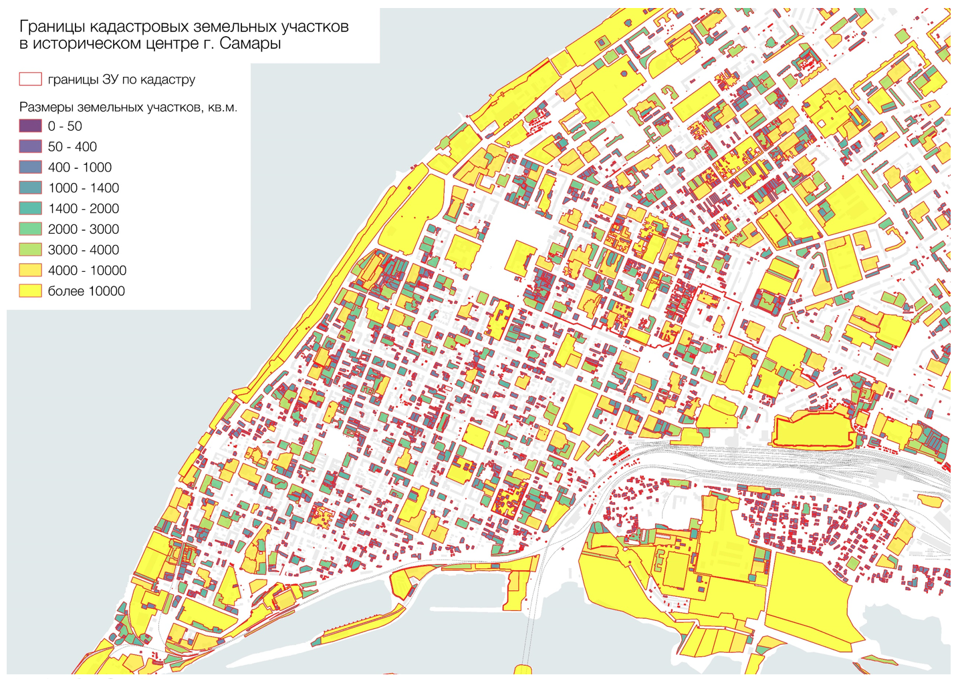
Figure 1. Cadastral plan of Samara historical centre, showing significant amount of unregistered land indicated in white (Karaselnikova et al., 2018).

The weakening of the institute of the Chief City Architect resulting from the rights transition of regulation to the Zoning Rules led to a kind of deregulation. The zoning regulation is currently in its immaturity. In addition, it what’s more has almost the same effect – the decrease of control and weak potential for regulation.
We can demonstrate it on the number of parameters, which are used in zoning regulations. Comparing with American or European regulations that uses hundreds of parameters, most Russian cities have not more than 12-15 parameters, such as height limitation, setbacks from the plot boarders, density limitations as floor area ratio but almost without examples of detailed architectural and design requirements as a list of allowed materials, colors, forms of shapes or glazing etc.
Juridical practice shows that courts settle property rights higher than detailed design regulations. Based on such groundings municipalities simply do not want to take a risk of Zoning Rules cancellations because courts consider them as a violation of property rights of the owners.
So, we have to declare that today’s territory regulation is in some kind of limbo – an intermediate state of between autocratic and democratic modes of management. Residents’ and professionals’ displeasure of city environment becomes more and more significant. And demand for the enforcement of regulations has to be satisfied no matter how – autocratically or by public participation, transparently or secretly.
Moscow is one of the cities with traditionally strong bureaucratic power guard a system of subjective regulation. It is the only city in Russia, which lived without zoning regulations up to 2017 when a very specific document was adopted. The most plots in Moscow Zoning Rules have so called factual limits, which can be changed individually after being reconsidered by The Architectural Council & Land Commission. The possibility to use individual approach for each plot does not support an idea of equal rights for every land user. At the same time any realization of strategic development can be implemented only if it is underpinned by both balanced management and sufficient infrastructural resources.
Professional agenda provides enough floor for the discussion on how to actualize the system of documentation. So-called Soviet general plans were in most cases used to be technical documents, which could hardly be understood by citizens, and even by the vast majority of architects with lack of knowledge in the specific area. They are clear for the limited number of city planners.
A masterplan is supposed to be much more comprehensible for the wide audience to allow people to be involved in urban development agenda. At the same time, the masterplan must in fact be the spatial chapter of socio-economic strategy of the cities. That is why after 10 years of discussion the masterplan is highly probable to become a regulative document.
Meanwhile, there is a high demand for understanding the future image of the environment and detailed regulations of architectural and design features. The problems with extensive western experience implementation of form-based codes and design codes lay in contradictions between different legislative acts.
Whereas masterplan is a tool for setting the objectives and principles of the spatial development of the territory, form-based code principles accentuate materiality of the urban form and introduce the parameters of physical environment as a subject of regulation to the zoning system (Sitkowski et al., 2006; Garde et al., 2015).

3. MORPHOLOGICAL APPROACH
The morphological approach towards urban regulation has been the interest of number of researchers (see, e.g., Conzen, 1960; Bobkova et. Al, 2017; Larkham, 1991). In Russia, the idea of morphological continuity was widely used by the followers of Aleksey Gutnov – the father of Russian contextualism (Gutnov, 1984). From 1973 and till his death in 1986 the Department of perspective research and experimental development in the Institute of General Plan of Moscow worked on the theory of patterns. It showed evolutionary mechanisms of different kinds of the city environment. A Conception of Historical Morphotypes was one of the products of Gutnov’s group. In 1999 His follower Lidia Kozhaeva elaborated this theory and practically transformed it into the Moscow Urban Norms (Kozhaeva, 2011; Kozhaeva, 2012).
In the 1980s contextual approach resulted in a number of realized projects of pedestrian zones in Moscow as Old Arbat, later Stoleshnikov lane & Kuznetski Most. In the 1990s the idea of morphological development had much deeper implementation through reconstruction of a large Moscow neighborhood Ostozhenka, within a kilometer from the Kremlin. The idea of reconstruction was to increase the amount of new development without enlargement of historical scale of the area. Ostozhenka’s 50 ha territory redevelopment started in 1989 with the restoration of the pre-revolutionary boarders of parcels, which vanished after land nationalization in the Soviet period. It was an experiment with parcel reconstruction when there were no even land property rights. New redevelopment lots were formed within the borders of pre-revolutionary households (Figure 2). The commissioner of general plan was The Soviet of Ministers, which wanted to erect the new buildings for itself. After the collapse of the USSR in 1991 the Moscow government adapted this plan for commercial purposes. Each developer had to accept a so-called ‘pair’ – one plot for the commercial development and the other plot for the relocation of the former residents from the obsolete historical buildings to the repaired ones. Developers quickly enquired for the former locals much cheaper apartments in the new districts of Moscow. Thus, Ostozhenka neighbourhood became an example of massive social segregation on the one hand and a sample of soft architectural approach on the other hand. After 30 years of redevelopment this urban fragment of 50 ha raised the amount of construction from 200 000 to 1 000 000 m² without any significant change of scale of traditional middle-rise development (Figure 3).

Figure 2. Parcellation plan of Ostozhenka neighbourhood, Moscow. Source: AB Ostozhenka and A. Skokan & partners. [URL: https://ostarch.ru/main/projects/rekonstrukcija-mikrorajjona--17-ostozhenka].

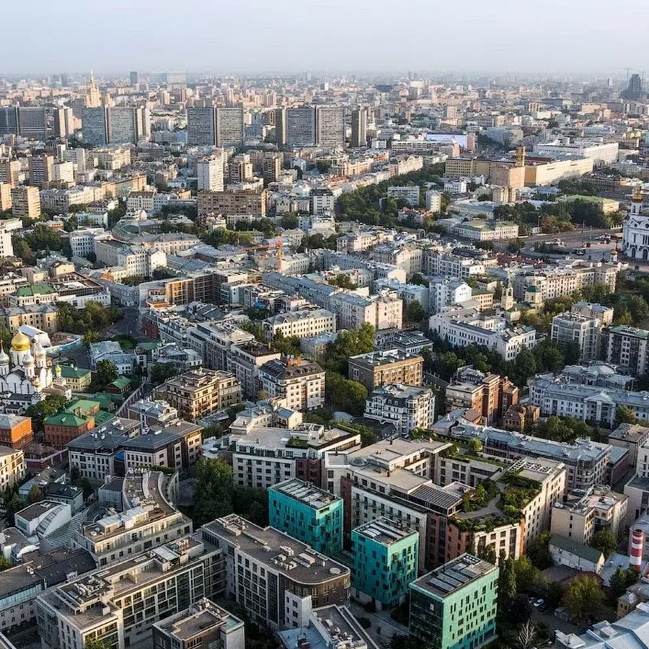

Figure 3. Aerial view of Ostozhenka neighbourhood, Moscow. Source: AB Ostozhenka and A. Skokan & partners. [URL: https://yt3.ggpht.com/a/AATXAJzjlzQMuDRrcQ_6vAeA25eXvGt12896ts-Vxw=s900-c-k-c0xffffffff-no-rj-mo].

4. CONFLICT-LESS RENOVATION
In 2010 architectural office Ostozhenka which developed the renovation of the same-name neighbourhood, developed a conception of so-called Conflict-less renovation of the Regular Historical Russian city. The idea of ironic name for the program “Conflict-less” belongs to Alexander Skokan the head of Ostozhenka. Taking into account that more than 300 Russian towns were replanned with the principle of regularity at the end of the 18th century, urban planners proposed a system of typical implants of renewed historical parcels. Almost each Russian city, except some medieval ones, has rectangular oriented structure with similar types and sizes of historical plots. That is why it is possible to make a matrix of spatial types of plot organizations for understanding the perspectives of redevelopment. The idea is based on the structure of the Volga region city Samara with one of the most intact land-use with traces of old households. The aim of the Conflict-less renovation was to show how to improve the management of redevelopment by pattern language of spatial modules.
Being one of the fastest-redeveloping cities with a population of 1.2 million Samara had a lot of new constructions without any adaptation between the old and the new development. Every new development produced a conflict between developers and the residents.
Our team ‘Robot Architects’ understood that conflict lays not only in the morphological destruction but as well in disturbance of social links and total segregation as well. To solve it we made a project of renovation Block 79 with in a way of social participation (Figure 4). The idea was that morphological implants could be plug in the empty parcels by the new development. But all other parcels with its residents had to be involved in the process of renovation by creating a share enterprise of the residents of the block.
Significant part of the locals have privatized apartments in the dilapidated buildings but do not have registered land rights under them. Most of them live in hard conditions without such amenities as sewage or water supply. Historical Samara which has 130 blocks each of 3 ha has 1100 cesspools. The buildings have not been under reparation for the whole life and the most part of the residents do not have a mentality of the owners with any potential of responsibility.

Figure 4. Redevelopment proposal for Block 79 in Samara by Robot Architects (Stadnikov, Afrikantov, Malakhov). Blue line – borders of parcels. Red – monument of architecture. Yellow – new potential buildings. Beige – reconstruction. Source: personal archive of Vitaliy Stadnikov.

The programme proposed to reconstruct the historical plots’ borders and register the land to the residents with large empty spaces in the center of the block. The inner parts of them have a great potential for the new development. They could be an asset to contribute in the foundation of the community enterprise for the future development. The benefit for the locals is that by the land contribution they could get engineering infrastructure and renovation of their old buildings.
This conception has not been realized yet because of developer’s and official’s resistance, the lack of possibility for community building and without legal support of making such kind of enterprises.

5. SARATOV FBC
Since 2015 KB Strelka, one of leading urban consulting agencies in Russia, started to use morphological approach to regulation while developing the ‘Standards for Built-up Areas’ (Standards, 2018). The commissioner of the Standards was the State Foundation Bank RF, which was founded to support urban development. The Standards for Built-up Areas suppose that the city has a variety of the modes of regulation based on different environmental morphotypes. Another idea is to implement an instrument of Form Based Codes (FBC) for the spatial regulation instead of Functional Zoning Regulation to manage functions through the form (Figure 5).

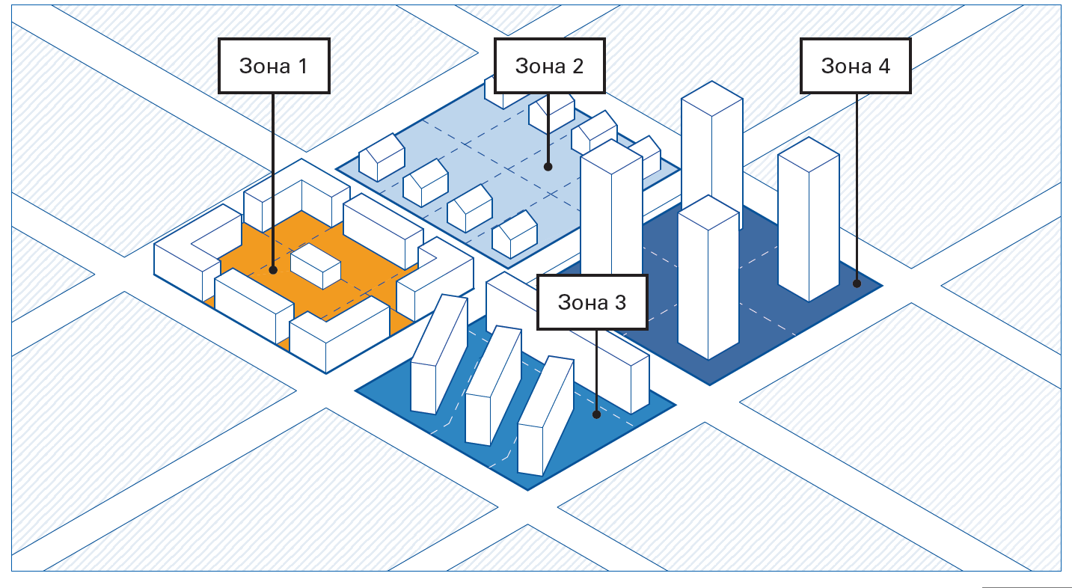
Figure 5. Fragment of form-based code regulations for Saratov, 2018. Source: KB Strelka. [URL; https://xn--d1aqf.xn--p1ai/upload/documents/urban/saratov/opr.pdf].

The project group designed a pilot of FBC which in Russia received the name ‘Volume Spatial Code for the city of Saratov, the industrial center on the Volga River’. It is a strategic plan to regulate the image of the city with a focus on public spaces. That is why instead of classical zoning approach focused on blocs the FBC of Saratov was focused on the regulation of street and public spaces. Such approach resulted in promoting the growth of retail corridors and pedestrian traffic. This strategy was oriented as well on the rise of density and investment attractiveness of the historical urban core with protection of the dimensions of the plots & facades. The Code is still regulating not only land use and buildings but the refurbishment of all types of public spaces: streets, squares and parks.

6. SAMARA REGULATIONS OF HISTORICAL SETTLEMENT
In 2019 Samara got the status of the Historical Settlement and our team developed the ‘Project Protection and Regulations of the Historical Objects’. As I mentioned before, Zones of Historical Protection as well as Zones of Historical Settlement represent a kind of instruments for more specific regulation using proper number of parameters.
For us, Regulations of Historical Settlement, which includes 500 ha, are not the reason of conservation but the way of strategic development, some kind of a masterplan. That is why while producing regulations we have to understand potential, faults of social, transport and engineering infrastructure, and foresee how to tackle them.
Through the land-use analysis we saw that almost half a territory has no registered boarders of the plots, and it causes substantial damage to the taxation. At the same time, the absence of clear tax strategy leads to having a lot of plots on busy public streets which are used to commercial purposes but are subject to residential type of taxation which is much lower. The weakness of transport strategy has never let collecting money from parking spaces. The lack of insights about how the development of retail and business corridors should go, doesn’t allow to exercise the proper taxation from the income of the potential employees. Estimation shows that the lack of such strategy is a cause of under-taxation of billions of Russian rubles yearly.
The Regulations are focused on the following aims: mixed-use, expansion of pedestrian and retail zones, public transport and micro-mobility orientation, development of engineering net with optimization of resource use.
The result is expressed by the zoning map (Figure 6). In this map there is a multifunctional zone which occupies 80% of the territory. Whereas the zone of conversion for the old industrial territories takes 10% of the same. And there are 2 remaining types of protection zones for educational objects & greenery. Multifunctional zone consists of parametrical subzones based on 2 factors: protection of valuable morphotypes in the historic core and providing of redevelopment intensification in the surroundings of the core. The intensification supposes to be in a form of new development on the inner territories of the blocks.

Figure 6. Proposal of Regulations of the Historical Settlement in Samara by Robot Architects + Root development, 2019. Source: Stadnikov, Nikitenko from personal archive of Vitaliy Stadnikov.

Samara Historical Settlement regulations demonstrates more conservative approach. It has the aim close to Form Based Codes to regulate forms of the development. But it uses the traditional zoning as an instrument of implementation.

7. ORENBURG SPATIAL STRATEGY OF THE HISTORICAL CENTER
The next pilot project of Historical settlement regulations of Orenburg was proposed by Atlas bureau with participation of our team. Orenburg is the South-Ural city with a population of 600 000 people. There is a perfect regular plan of the 18th century which is informally called ‘Steppe Palmira’.
The Plan of historical core development consists of 2 parts: Strategy of Spatial Development and Form Based Codes. Strategy of Spatial Development (Figure 7) analyses how to activate the estate market and development, how to reanimate public life, how to return the residents to the historical center. Strategy proposes 3 pilot projects of the redevelopment to create the anchors of public activity. It proposes how to involve hundreds of historical buildings in commercial turnover, and how to redo the system of mobility to enlarge pedestrian traffic for reactivation of retail.
Form Based Codes show the zones of conservation, zones of stabilization, zones of soft and radical growth. FBC has target density for each zone and View Corridors for the city dominants. Every historical morphotype has 3 sceneries: conservation, stabilization and growth. According to its target and value, every zone has their limits of growth. Limits of plots and buildings define their type of use. The Rules for new development and reconstruction have different detailing. For new buildings they concern the position on the plot, the shapes of the buildings & materials used. For the reconstruction and renovation there are very detailed architectural requirements for the share of glass surfaces, for the forms of windows, for the spectrum of colors etc.

Figure 7. Orenburg Spatial Strategy. Bureau “Atlas” with participation of Root Development, 2020. Source: from personal archive of Vitaliy Stadnikov.

Orenburg Spatial Strategy and FBC has a step-by-step plan of realization. It clearly demonstrates how to implement it in legislation.

8. KAZAN STRATEGY
Kazan’, a capital of Tatarstan, has rather similar plan of developing the historical part. The old Kazan’ has been significantly damaged by the programme of relocation in the past 20 years. Now the center of the city looks rather renovated but absolutely deserted in the evening time without residents. Kazan city’s spatial strategy has one distinctive feature. The design team set a task to themselves to take into consideration the way of life, which exists now & which once existed in the past in different parts of the city when Muslim & Russian cultures used co-exist amicably. For this purpose, a team of sociologists held an extensive, thorough survey.

9. CONCLUSION
Eventually we have pointed the following peculiarities of Russian urban regulation practice. Firstly, the building norms, which have been existed since the Soviet time, are rudimental. They can hardly reflex ever-changing requirements of today’s city. There is a great need of a sort of legislative instruments to regulate urban environment more precisely.
Secondly, functional zoning approach cannot provide regulation detailed enough regulation for historical environment. Historical Settlement regulations have become a reason for testing new types of regulations.
Thirdly, documents with transparent urban content like Spatial strategies, Masterplans and Form Based Codes are in great demand today. It is evident that they are in the process of legalization.
We also observe that the transformation of the regulations comes from functional to parametrical ones. Today in some cases there is an understanding for a need to take into account not only physical but also mental features of locals and the traditions as well. As a result of the power distribution in Russia, the most progressive strategies are being implemented successfully in the regions with top-down form of management where region authorities are strong enough to break through the resistance of the old practices resolutely.

- Reference

Bobkova E. et al. (2019) Structure of Plot Systems and Economic Activity in Cities: Linking Plot Types to Retail and Food Services in London, Amsterdam and Stockholm. Urban Science, vol. 3 (3), p. 66.
Bobkova, E., Marcus, L., & Berghauser Pont, M. (2017, July). Multivariable measures of plot systems: Describing the potential link between urban diversity and spatial form based on the spatial capacity concept. In Proceedings of the 11th Space Syntax Symposium (p. 47).
Büdenbender, M., & Zupan, D. (2017). The evolution of neoliberal urbanism in Moscow, 1992–2015. Antipode, 49(2), 294-313.
Conzen M. R. G. (1960). Alnwick Northumberland: a study in town-plan analysis // Institute of British Geographers Publication 27. George Philip, London.
Federal Law of June 25, 2002, N 73-FZ ‘On cultural heritage sites (historical and cultural monuments) of the peoples of the Russian Federation’ (in Russian).
Topical Issues of Land Use Regulation (2020). In Forum of Urban and Regional Development "Tools of Professionals". Perm. https://www.youtube.com/watch?v=Z4QIuRxgg1U&list=PLNlg05dGKXv4Bs-iOLYxYWJuBjvg0NkBB&index=5 (in Russian).
Garde, A., Kim, C., & Tsai, O. (2015). Differences between Miami's form-based code and traditional zoning code in integrating planning principles. Journal of the American Planning Association, 81(1), 46–66.
Gunko, M., Bogacheva, P., Medvedev, A., & Kashnitsky, I. (2018). Path-Dependent Development of Mass Housing in Moscow, Russia. Housing Estates in Europe, 289–311. https://doi.org/10.1007/978-3-319-92813-5_13
Gutnov, A. (1984). The evolution of urban planning. Stroyizdat, Moscow.
Karaselnikova I., Stadnikov V. (2018) Towards the Sustainable Development of Historical Centers. Urban Studies and Practices, 3 (4), 108–132 (in Russian).
Kiss D. (2018) New Norms — Old Modus. Tensions from Socialist Planning Surviving the Regime Change in Hungary. Urban Studies and Practices, vol. 3, no 4, pp. 18–34. DOI: https://doi.org/10.17323/usp34201818-34
Kozhaeva, L. (2011). Morphology of Built Environment in Theory and Practice, part 1. Arkhitekturnyi Vestnik, 2 (119), 42-47 (in Russian).
Kozhaeva, L. (2012). Morphology of Built Environment in Theory and Practice, part 2. Arkhitekturnyi Vestnik, 4(121), (in Russian).
Larkham, P. J. & Jones, A. N. (1991). Glossary of urban form. Historical geography research series no. 26.
Sitkowski, R. J., & Ohm, B. W. (2006). Form-based land development regulations. Urban Law, 38, 163.
Standards for Built-up Areas (2018). Strelka KB (in Russian).
Trutnev, E., Bandorin L. (2007). Urban Planning Code of the Russian Federation: Answers to Problematic Questions of Urban Planning Activities. Institute of Urban Economics Moscow (in Russian).
Trutnev, E., & Safarova, M. (2021). Town planning regulation in a market economy. Litres. (in Russian).
Tsenkova S. (2011) Venturing into Unknown Territory: Strategic Spatial Planning in Post-Communist cities // Urbaniizziv. Vol. 2245. No. 22. P. 83–99 (85).
Tosics I. (2013). A Conceptual Framework of the Post-Socialist Transition of Cities. Policy, Planning, and People: promoting justice in urban development. University of Pennsylvania Press.
Zarecor K., Kulić V. (2018) The President of Our Country is a Real Estate Developer. Urban Studies and Practices, vol. 3, no 4, pp. 12–17. DOI: https://doi.org/10.17323/usp34201812-17
UN-Habitat for the Sustainable Development Goals (2015). https://unhabitat.org/un-habitat-for-the-sustainable-
development-goals/
Zoning regulations approved in 90% of municipalities in Russia = PZZ utverzhdeny v 90% munitsipalitetov Rossii. (2016, November 29). News Agency Construction Business. http://ancb.ru/news/read/3518 (in Russian).
Zupan, D., Smirnova, V., & Zadorian, A. (2021). Governing through stolichnaya praktika: Housing renovation from Moscow to the regions. Geoforum, 120, 155-164.

¹ Vitaly Stadnikov, associate professor, Candidate of Sciences (PhD), National Research University “Higher School of Economic” – Faculty of Urban and Regional Development / Vysokovsky Graduate School of Urbanism, Moscow, Russia, stadnikov@bk.ru. др Виталиј Стадников, ванредни професор, Државни истраживачки универзитет „Виша економска школа“ – Факултет за урбани и просторни развој / Виша школа урбанизма А. А. Високовског, Москва, Русија, stadnikov@bk.ru.

